KPANDO MUNICIPAL ASSEMBLY


NATIONAL DEVELOPMENT POLICY FRAMEWORK
2022-2025

W
MEDIUM-TERM DEVELOPMENT PLAN
(REVISED DRAFT)

PREPARED BY:
MPCU, KpMA

NOVEMBER, 2021



KP/MF-53/VOL 1/56 08/12/2021

SUBMISSION OF THE DRAFT 2022-2025 MTDP
I submit herewith a copy of a Revised Draft 2022-2025 Medium-Term Development Plan in respect of Kpando Municipal Assembly for your necessary action.
Thank you.
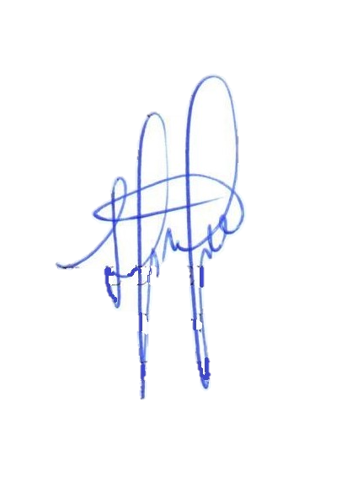

SETSOAFIA KPENU
MUNICIPAL CO-ORD. DIRECTOR
For: MUNICIPAL CHIEF EXECUTIVE
HON. REGIONAL MINISTER
VOLTA REGIONAL CO-ORDINATING COUNCIL
HO

THE DIRECTOR GENERAL
NATIONAL DEVELOPMENT PLANNING COMMISSION
ACCRA

Attention:
The Regional Economic Planning Officer
Volta Regional Co-Ordinating Council
Ho.

FOREWORD
This Medium-Term Development Plan (MTDP) is a masterpiece with heavily loaded research work by the Kpando Municipal Assembly, Electoral areas and Zonal councils with full dedication. The enormous success achieved in the implementation of previous MTDPs has serve as an impetus into the preparation of 2022-2025 Medium Term Development Plan. The MTDP contains new opportunities and perspectives to deal with issues in social, economic, environmental, political, cultural, legal and tourism sectors which initially were considered complex and multi-dimensional. These opportunities were potentially designed to assist in the translation of policies, goals, objectives and strategies into programmes and actions for the benefit of the people, where in particular the comparative advantages of the Municipality over other MMDAs in the Volta Region and the Country at large, the unique culture diversity of the people, and the values and norms were highly considered.
The 2022-2025 Medium-Term Development Plan represents broad and pervasive set of challenges to a more fixed way of perceiving and understanding of the issues. The issues have been assembled to compete for the limited resources in multiple dimensional environments where the idea of evidence about the issues were definite.
This MTDP is well crafted by a team of professional planning officers whose experiences are undoubtedly unquestionable in the field. What is even fascinating about this plan is the fact that it represents home grown proposals to meet the desire and aspiration of the people, especially identifying and designing programmes; projects and deliverables. The chapters are chronologically arranged to suit the guidelines of NDPC. Indeed, MTDP, 2022-2025 is worthy of reading for the reader to assimilate and appreciate all the beautiful new opportunities and potentials introduced to solve the challenges of the people in the Municipality.

TABLE OF CONTENT

TABLE OF CONTENT iv
LIST OF ACRONYMS ix
ACKNOWLEDGEMENTS xii
CHAPTER ONE 1
1.1 Introduction 1
1.2 Status of Plan Implementation 1
1.3 Performance of Development Dimensions 1
1.4 Revenue and Expenditure Performance (2018-2021) 7
1.5 Key Problems/Issues Encountered during Implementation of the DMTDP (2018-2021) 8
1.6 Analysis of Current Sector Development Situation and Profile of the Assembly 8
1.6.1 Assessment of Institutional Capacity 8
1.7 PROFILE OF THE MUNICIPALITY 10
1.7.1 Location and Physical Characteristics 10
1.7.2 Climate 11
1.8.5 Water Sources in the Municipality 13
1.8.6 Water Security 14
1.9 Population 15
1.9.1 Fertility 16
1.9.2 Migration (Emigration and Immigration) 16
1.9.3 Gender Equality 17
1.10 SETTLEMENT SYSTEM: NATURAL AND BUILT ENVIRONMENT 17
1.10.1 Rural/Urban Split 17
1.10.2 Spatial Analysis (Hierarchy of Settlements) 18
1.10.3 Governance 21
1.10.4 Sub-Structures of the Assembly 22
1.10.5 Departments of the Assembly 22
1.11.0 ECONOMIC INFRASTRUCTURE AND SERVICE 23
1.11.1 Kpando Market 23
1.11.2 Torkor Market 23
1.11.3 Natural Resources and Their Utilization 23
1.11.4 Tourism 24
1.11.5 Historical Heritages 24
1.11.6 Banking Services 25
1.11.7 Hospitality Industry 25
1.11.8 Local Economic Development (Led) 25
1.11.9 Challenges Affecting SMEs 25
1.12.3 Agricultural Sector growth 29
1.12.4 Food Production and security 29
Source: MPCU-KpMA, 2021 30
1.12.5 Fishing industry 30
1.13 SOCIAL SERVICES DELIVERY 31
1.13.1 Education 31
1.13.2 Public Basic Education level 31
1.13.3 Public Senior High and Technical School level 31
1.13.4 Private Basic Education level: 31
1.13.5 Private Senior High 31
1.14 HEALTH CARE 32
1.14.1 1 Health Service Delivery Management 32
1.15 ROAD NETWORK 35
1.15.1RoadSafety Measures…………………………………………….……………………37
1.16 Situational Analysis on the District’s Disaster and Hazard Event and the Various Adaptation and Coping Strategies 52
Adaptation: 53
1.17 Summary of Development Issues 53
1.17 Summary of the Chapter 55
CHAPTER TWO 56
DEVELOPMENT ISSUES FOR 2022-2025 56
2.0 Introduction 56
2.1 Prioritized Development Issue 56
2.2 Sustainability Analysis of the Issues 57
2.3 Summary of the Chapter 61
CHAPTER THREE 62
DEVELOPMENT PROJECTIONS, GOALS, OBJECTIVES AND STRATEGIES 62
3.0 Introduction 62
3.1 Projected Development Requirements for 2022-2025 62
Projections for Water facilities 63
3.2 ADOPTION OF MUNICIPAL DEVELOPMENT GOALS, OBJECTIVES AND STRATEGIES 66
3.2.1 Development Focus 66
3.3 Municipal Development Goals, Objectives and Strategies 66
3.4 Strategic Environmental Impact Assessment of the Plan 95
3.5 Summary of the Chapter 96
4.0 CHAPTER FOUR 97
4.1 Introduction 97
4.2 Assumptions and Methodologies for Costing 108
4.3 Programmes Financing 109
4.4 Summary of the Chapter. 113
CHAPTER FIVE 114
ANNUAL ACTION PLAN OF KPANDO MUNICIPAL ASSEMBLY 114
5.0 Introduction 114
5.1 Annual Action Plan Developed as a Basis of the Municipal Assembly Budget 114
CHAPTER SIX 191
IMPLEMENTATION, MONITORING AND EVALUATION 191
6.0 Introduction 191
6.1 Stakeholders Analysis 191
6.2 Monitoring Matrix or Results Framework 193
6.3 Evaluation Arrangement with an Evaluation Matrix 193
6.4 Participatory Monitoring and Evaluation Arrangement 193
6.5 Strategy for Data Collection, Collation, Analysis and Use of Results 194
6.6 Quarterly and Annual Progress Reporting Format 195
Source: MPCU-KpMA, 2021 211
6.7 Summary of The Chapter 212
CHAPTER SEVEN 213
COMMUNICATION STRATEGY 213
7.0 Introduction 213
7.1 Dissemination and Communication Strategy 213
7.2 Public Hearing and Adoption of the Plan 216

LIST OF TABLES
Table 1.1 Performance Review (2018-2021) 1
Table 1.2 Financial Performance (2018 - 2021) 7
Table 1.3 Human Resource Capacity in KpMA 9
Table 1.4 Monitoring and Evaluation Conditions and Capacities in KpMA 9
Table 1.5 Scalogram Analysis 19
Table 1.6 Departments of the Assembly 22
Table 1.7 Rate of fertility/birth recorded by KpMA 33
Table 1.8 Rate of mortality/death recorded in the KpMA 33
Table 1.9 Top causes of OPD in the Municipality 34
Table 1.10 Trend of HIV/AIDS cases 34
Table 1.11 Key Development Issues with Implications for 2022-2025 53

Table 2.1 List of prioritize development issues 57

Table 3.1 Estimated Population for the District 62
Table 3.2 shows the projection of school enrolment in the Municipality. 63
Table 3.3 Projection of School Buildings from 2022 - 2025 63
Table 3.4 Operational Health Facilities from 2022-2025………………………………………63
Table 3.5 Water Provision for 2022-2025………………………………………………………63
Table 3.6 Projection of Population with Access to Improve Sanitation………………………64
Table 3.7 Revenue Projection from 2022-2025…………………………………………………63
Table 3.8 Focus Area, Goals, Policy Objectives and Strategies 67

Table 4.1 Programme of Action (2022-2025) 97
Table 4.2 Indicative Financial Strategy 111

Table 5.1 Annual Action Plan 2022 115
Table 5.2 Annual Action Plan 2023 135
Table 5.3 Annual Action Plan 2024 154
Table 5.4 Annual Action Plan 2025 171

Table 6.1 Analysis of Stakeholders in KpMA 191
Table 6.2 Monitoring and Evaluation Work Plan for KpMA 194

Table 7.1 Communication Plan 214
Table7.2 Maintenance/Asset Plan………………………-……………………………………….170

LIST OF FIGURES
Figure 1.1 Funding Source 8
Figure 1.2 KpMA in National and Regional Context 10
Figure 1.3 Vegetation Map of the Municipality 12
Figure 1.4 Waster facilities in the Municipality 15
Figure 1.5 Population Pyramid of the Municipality 16
Figure 1.6 Structure of the Local Government System 22
Figure 1.7 Tourism Potentials of the Municipality 24
Figure 1.8 Poverty Map of the Municipality 28
Figure 1.9 Major Crop Production areas of the Municipality 30
Figure 1.10 Educational Facilities in the Municipality 32
Figure 1.11 Health Facilities in the Municipality 35
Figure 1.12 Road networks in the Municipality 36
Figure 1.13 Situational map of KpMA 55
Figure 3.1 Graphical Representation of Sanitation Projection…………………………………….65
Figure 3.2 Graphical Representation of Revenue from 2022-2025……………………………….66
Figure 3.3 Future Desire State of KpMA 95
Figure 4.1 Graphical representation of 2022 MTDP projects and activities………………………105
Figure 4.2 Graphical representation of 2023 MTDP projects and activities………………………106
Figure 4.3 Graphical representation of 2024 MTDP projects and activities………………………107
Figure 4.4 Graphical representation of 2025 MTDP projects and activities………………………108

LIST OF ACRONYMS
AAP - Annual Action Plan
AEA - Agricultural Extension Agents
AIDS - Acquired Immune Deficiency Syndrome
APR - Annual Progress Report
BECE - Basic Education Certificate Examination
BAC - Business Advisory Centre
CA - Central Administration
CBO - Community Based Organization
CIDA - Canadian International Development Agency
CLTS - Community Led Total Sanitation
CHPS - Community Health Planning System
CHRAJ - Commission on Human Rights and Administrative Justice
CODA - Coastal Development Authority
CPESDPs - Co-ordinated Programme of Economic & Social Development Policies
CSOs - Civil Society Organizations
DACF - District Assemblies Common Fund
DACF-RFG - District Assembly Common Fund Responsiveness Grant Factor
DAs - District Assemblies
DDF - District Development Facility
DMTDP - District Medium Term Development Plan
DPs - Development Partners
DRR - Disaster Risk Reduction
DUR - Department of Urban Roads
ECG - Electricity Company of Ghana
EHSU - Environmental Health and Sanitation Unit
EMIS - Education Management Information System
EPA - Environmental Protection Agency
FAO - Food and Agriculture Organization
FBOs - Farmer Based Organization
GAWU - General Agricultural Workers Union
GAC - Ghana AIDS Commission
GER - Gross Enrolment Ratio
GES - Ghana Education Service
GOG - Government of Ghana
GES - Ghana Education Service
GETFund - Ghana Education Trust Fund
GHS - Ghana Health Service
GHA - Ghana Highways Authority
GWCL - Ghana Water Company Limited
GSGDA - Ghana Shared Growth and Development Agenda
HRD - Human Resource Department
HIV - Human Immune Virus
ICT - Information Communication Technology
ISD - Information Services Department
IA - Internal Auditor
ICT - Information Communication Technology
IDRS - Integrated Disaster Surveillance and Response
IEC - Intensify Education and Communication
IGF - Internally Generated Fund
IPM - Integrated Pest Management
ISD - Information Services Department
JHS - Junior High School
KpMA - Kpando Municipal Assembly
KG - Kindergarten
LED - Local Economic Development
LI - Legislative Instrument
MEOC - Municipal Education Oversight Committee
MLGDRD - Ministry of Local Government, Decentralization and Rural Development
MTNDPF - Medium-Term National Development Policy Framework
MCE - Municipal Chief Executive
MCD - Municipal Co-ordinating Director
M& E - Monitoring and Evaluation
MoH - Ministry of Health
MHD - Municipal Health Directorate
MP - Member of Parliament
MP-DACF - Member of Parliament District Assemblies Common Fund
MTDP - Medium Term Development Plan
MPCU - Municipal Planning Coordinating Unit
MA - Municipal Assembly
MMDAs - Metropolitan, Municipal and District Assemblies
MWD - Municipal Works Department
MFO - Municipal Finance Officer
MPO - Municipal Planning Officer
MUSEC - Municipal Security Committee
MBA - Municipal Budget Analyst
NABCO - Nation Builders Corps
NADMO - National Disaster Management Organization
NBSSI - National Board for Small Scale Industries
NCCE - National Commission on Civic Education
NDPC - National Development Planning Commission
NGO - Non-Governmental Organization
NHIS - National Health Insurance Scheme
NMTDPF - National Medium Term Development Policy Framework
ODF - Open Defecation Free
OHLGS - Office of Head of Local Government Service
PBB - Programme Based-Budget
PHC - Population and Housing Census
PM& E - Participatory Monitoring and Evaluation
PoA - Programme of Action
PoP - Pencils of Promise
PPD - Physical Planning Department
PPEs - Personal Protective Equipment
PPP - Public Private Partnership
PTR - Pupil Teacher Ratio
PWDs - Persons living with Disabilities
PTA - Parent Teacher Association
RCC - Regional Coordinating Council
RPCU - Regional Planning Co-ordinating Unit
SDGs - Sustainable Development Goals
SEA - Strategic Environmental Assessment
SHS - Senior High School
SME - Small Medium Enterprises
STEM - Science, Technology, Engineering and Mathematics
STMIE - Science, Technology, Mathematics & Innovation
SW/CD - Social Welfare and Community Development Department
TAs - Traditional Authorities
TVET - Technical and Vocational Education Training
UNICEF - United Nations Children’s Fund
WC - Water Closet
ZCs - Zonal Councils

ACKNOWLEDGEMENTS
All praise and Glory be to the Almighty God for the grace and mercies he bestowed on us from the beginning of this exercise to this wonderful day. The entire Municipal Planning Coordinating Unit (MPCU) is most grateful and would like to express our sincerest appreciation to the Lord for His abundant grace and the wisdom to undertake this assignment and to deliver this Development Plan.
The Team’s heartfelt gratitude further goes to Hon. Geoffrey Kodzo Badasu, the Municipal Chief Executive, Hon. Ernest Quist, (Immediate Past MCE), Mr. Setsoafia Kpenu, the Municipal Coordinating Director for the wonderful roles they played in making sure this Plan is prepared and delivered on time.
We also express our thanks to all honorable assembly members, zonal council members, unit committees, the Traditional Authorities, Civil Society representatives, all the agencies and corporate institutions and other stakeholders who gave us the needed data to execute this assignment. We enjoyed working with all of you. We are very grateful. To every other person who supported the preparation of this document, we say thank you. ‘Akpe’
Leading Planning Team Comprised:
- Hon. Geoffrey Kodzo Badasu - Municipal Chief Executive
- Mr. Setsoafia Kpenu - Municipal Coordinating Director
- Mr. Alexander Affrim - Municipal Devt Planning Officer
- Mr. Noah Tali - Municipal Budget Officer
- Mr. Simon Ametepi - Municipal Finance Officer
- Mrs. Hilda Amegatcher - Mun. Dir. of Educ, Youth and Sports
- Mr. Hope Tsifoaka - Municipal Director of Agriculture
- Dr. Samuel Abudey - Municipal Director of Health
- Mr. Divine Gati - Municipal SW/CD Officer
- Mr. Frank Fudzi - Municipal Works Engineer
- Mr. Christopher Affram - Physical Planning Officer
- Hon. Emil Senyo Wordey - Presiding Member
- Togbui Bediaku VIII - Rep. Traditional Council
- Mr. Divine Abotsi - Municipal Environmental Health Officer
- Mrs. Doris Dzebu - NADMO
- Mr. Mark Ahiave - Transport Officer
- Mr. Fiattor Venunye - Internal Auditor
- Miss. Emmanuella Bening - Municipal Statistician
- Mr. Francis Dorkenou - Asst. Municipal Works Engineer
- Miss. Selase Innocentia Tindy - Ghana Enterprise Agency
- Hon. Lawrenda Adiasany - Dev’t Planning Sub.Com. Chairperson
- Amos Tetteh Dordjie - Asst. Physical Planning Officer
- Mr. Abdul Karim Ayatulai - Asst. Development Planning Officer

EXECUTIVE SUMMARY
Section 12 sub-section 2 and 3 of the Local Governance Act 2016, Act 936 and 940 as amended (Republic of Ghana, 2016), mandates District Assemblies to exercise deliberative, legislative and executive functions. The Act also indicate that, a district assembly shall be responsible for the overall development of the area within their jurisdiction and formulate and execute plans, programmes and strategies for the effective mobilization of resources necessary for the overall development of the district. These Development Plans are to be prepared and submitted to the National Development Planning Commission (NDPC) through the Regional Coordinating Councils (RCCs) for approval after the General Assembly has adopted it.

The plan is based on the Medium-Term National Development Policy Framework (2022-2025). This Medium-Term Development Plan (MTDP) of Kpando Municipality is designed to assist the translation of policy goals, objectives and strategies of the Medium-Term National Development Policy Framework (MTNDPF) into programmes and actions to be implemented for the benefit of the populace in the Municipality.
This plan would become the main working tool to assist the Assembly and all Agencies, Departments and Units, Development Partners to efficiently and effectively allocate limited resources to solve the developmental challenges of the Municipality for the period 2022-2025.
The Plan was prepared based on guidelines issued by the National Development Planning Commission (NDPC). Chapter 20 of the 1992 Constitution of the Republic of Ghana made provision for “Decentralization and Local Government” that creates a framework for citizens’ participation in decision-making at the local level. The participatory approaches to development planning are required with the identification of development problems and issues from communities forming the basis of prioritization of development issues.
The identification and design of programmes and projects in the plan were therefore informed by stakeholders’ aspirations which were aligned to reflect the strategic policies and visions of the Government. A participatory process (bottom-up approach to planning) was therefore adopted in the preparation of the plan.
Throughout the drafting of this plan, a series of consultative meetings were held with sub-district structures, traditional authorities, sub-committees of the Assembly, Non-Governmental Organizations (NGO’s), Trade Unions, Civil Society Organizations (CSOs), and departments and units of the Assembly and a cross section of the public. Inputs were also received from relevant stakeholders such as honorable assembly members, zonal council members, unit committee members, community, members, civil society organizations as well as the Private sector. The issues collated from the public hearings held at the three (3) Zonal Councils were analyzed and incorporated in the plan.
The Municipal Planning Coordinating Unit also engaged with corporate agencies and institutions to assess their developmental needs and aspirations during the planning period for possible inclusion in the 2022-2025 MTDP.
Prioritization matrix were used to rank the issues on the following basis:
- The severity and diversity of problems and intended benefits for which reason projects emanating would have an impact on a large proportion of the citizenry especially the poor and the vulnerable.
- The multiplier effect on economic efficiency, while considering socio-cultural acceptability, technical appropriateness among others.
- There is also the need to identify the significant linkage effect on meeting basic human needs and rights based on the principles of participation, accountability, non-discrimination, empowerment and human rights standards.
- The significant effects of problems in sustainable spatial development of designated interspace were also considered.
- That all programmes, activities and projects would ultimately achieve the national goal, which aims at achieving the globally adopted Sustainable Development Goals (SDGs) and the AU Agenda 2063.
- Finally, the projects would have a significant multiplier effect on the local economy and would also promote local economic development which summarizes the core functions of the Assembly as specified by law.
The National Development Policy Framework has five development dimensions namely:
- Economic Development,
- Social Development,
- Environment, Infrastructure and Human Settlements,
- Governance, Corruption and Public Accountability; and
- Implementation, Coordination, Monitoring and Evaluation.
The framework also has five goals which are co-terminus with the broad development areas. It is within these goals that the Municipality must operate based on our peculiarities. These Goals are:
- build a prosperous country;
- safeguard the natural environment and ensure a resilient built environment;
- maintain a stable, united and safe society;
- Mainstream emergency planning and preparedness into Ghana’s development planning agenda at all levels to respond to potential internal and external threats (including COVID-19); and
- Improve delivery of development outcomes at all levels.
The plan has been figuratively structured into seven main chapters. Chapter one (1) focuses on performance review, profile of the Municipality, current situation and a summary of key development problems, gaps and issues identified in the current situation.
Chapter two (2) focuses on prioritization of community needs and aspirations.
Chapter three (3) further focuses on development projections, goals and objectives, and strategies to achieve all these manifold goals and objectives.
Chapter four (4) talks about the composite development programmes whiles Chapter five (5) outlined the annual action plans.
The sixth (6) Chapter concentrates on monitoring and evaluation arrangements and last but not the least, Chapter seven (7) emphasized on communication strategy.

CHAPTER ONE
PERFORMANCE REVIEW / SITUATIONAL ANALYSIS

Introduction
This chapter focuses on the performance of the Assembly in implementing programmes and projects under the Agenda for Jobs, creating prosperity and equal opportunities for all’ between 2018 and 2021 as well as other interventions. It also presents a comprehensive description of the current situation of the Kpando Municipality with their development implications and analyses Management capacity in plan preparation and implementation. The chapter ends with a summary of the key development problems emanating from the situational analysis of the profile.

Status of Plan Implementation
Generally, the assessment showed remarkable progress was made during the implementation of the 2018-2021 Medium Term Development Plan under the Agenda for Jobs, Creating Prosperity and Equal Opportunities for all. In total, there were 332 programmes and projects between 2018-2021 MTDP, out of which 291 were implemented representing 87.7% and 41 programmes and activities representing 12.3% were not yet implemented as at 30th September, 2021.
The ultimate goal of the plan was to build a strong foundation for a smooth take-off of the Accelerated Economic and Social Development through the pursuance of Economic and Social Development, Environment, Infrastructure and Human Settlement whilst enhancing good governance, corruption and public accountability. The Policy measures adopted for achieving the Development Goal above were those of the National Development Strategic Frame Work, Agenda for Jobs, Creating Prosperity and Equal Opportunities for all.

Performance of Development Dimensions
The review has been presented in Table 1.1 which shows the development dimensions, the indicators, the baseline of 2017, the MTDP targets from 2018 to 2021 and the development outcomes which provides data on what has been achieved especially in 2020. In sum, 87.7% percent of the MTDP had been implemented at the end of October, 2021.
Table 1.1 Performance Review (2018-2021)
DEVELOPMENT DIMENSION |  | DISAGGREGATION | BASELINE  2017 | MEDIUM TERM TARGET  2018-2021 | DEVELOPMENT OUTCOME
S/N | ECONOMIC DEVELOPMENT |  |  |  | Year | Data
1 | Total Output of Agricultural  Production | Maize | 12,523 | 13,015 | 2020 | 13,047
1 | Total Output of Agricultural  Production | Rice | 6,374.9 | 7,000 | 2020 | 6,574
1 | Total Output of Agricultural  Production | Cassava | 33,068 | 36,956 | 2020 | 34,808.8
1 | Total Output of Agricultural  Production | Yam | 29,625 | 30,015 | 2020 | 29,975
1 | Total Output of Agricultural  Production | Okra | 5,141.5 | 6,255 | 2020 | 5,621.8
2 | Percentage  of Arable Land Under Cultivation | By category | Maize = 3657.7 | Rice = 1398 | 2020 | Okra=512.8
3 | Number of New  Industries Established | By sector:
3 | Number of New  Industries Established | Agriculture, | 38 | 47 | 2020 | 30
3 | Number of New  Industries Established | Manufacturing, | 4 | 8 | 2020 | 13
3 | Number of New  Industries Established | Traditional craft, | 7 | 10 | 2020 | 11
3 | Number of New  Industries Established | service | 5 | 10 | 2020 | 12
4 | No. of farmers Trained in cassava processing | Male: 96 | 150 | 200 | 2020 | 229
4 | No. of farmers Trained in cassava processing | Female:64
5 | No. of Farmer Based organizations formed | - | 5 | 15 | 2020 | 10
6 | No. of Planting for food and jobs programmes carried out | - | 4 | 10 | 2020 | 7
7 | No. of field demonstrations on crops/field days/study tours to enhance adoption of improved technologies held |  | 9 | 12 | 2020 | 11
SOCIAL DEVELOPMENT
8 | Net Enrolment Ratio (NER) | Kindergarten | 72.40% | 74.50% | 2020 | 79%
8 | Net Enrolment Ratio (NER) | Primary | 87.70% | 74.00% | 2020 | 78%
8 | Net Enrolment Ratio (NER) | JHS | 45.30% | 48.40% | 2020 | 50%
9 | Gender Parity Index (GPI) | Kindergarten | 1.09% | 1.09% | 2020 | 1.09%
9 | Gender Parity Index (GPI) | Primary | 1.07% | 1.04% | 2020 | 1.0
9 | Gender Parity Index (GPI) | JHS | 1.00% | 1.00% | 2020 | 1.0
9 | Gender Parity Index (GPI) | SHS | 1.07% | 1.07% | 2020 | 1.2%
10 | Completion Rate | Kindergarten | Boys: 93.2% | Boys:97.60% | 2020 | 100%
10 | Completion Rate | Kindergarten | Girls: 99.4% | Girls:99.60% | 2020 | 98%
10 | Completion Rate | Primary | Boys: 96.2% | Boys:98.30% | 2020 | 98.20%
10 | Completion Rate | Primary | Girls: 80.2% | Girls:92% | 2020 | 94%
10 | Completion Rate | Presented separately for boys and girls:  JHS | Boys 81.4% | Boys:83% | 2020 | 89%
10 | Completion Rate | Presented separately for boys and girls:  JHS | Girls79.7% | Girls:86.7% | 2020 | 82.50%
10 | Completion Rate |  | Boys 196.7% | Boys:199.0% | 2020 | 199.7%
10 | Completion Rate | SHS | Girls 66.8% | Girls:75.5% | 2020 | 78%
11 | Number of Operational Health Facilities | CHPS | 3 | 10 | 2020 | 7
11 | Number of Operational Health Facilities | Health Center | 1 | 3 | 2020 | 6
11 | Number of Operational Health Facilities | Hospitals | 2 | 4 | 2020 | 2
11 | Number of Operational Health Facilities | Reproductive & Child Health (RCH) | 1 | 2 | 2020 | 0
11 | Number of Operational Health Facilities | Maternity Home | 0 | 2 | 2020 | 1
12 | Proportion Of  Population  With Valid NHIS Card | Total (by sex) | M= 22,791 | 30,564 | 2020 | M= 44.2%
12 | Proportion Of  Population  With Valid NHIS Card |  | F= 31,132 | 38,613 | 2020 | F = 55.8%
13 | Proportion of Population with Access to Basic Drinking Water Sources | District
13 |  | Urban | 42,756 | 47,786 | 2020 | 57.1%
13 |  | Rural | 24,789 | 30,500 | 2020 | 42.9%
14 | Proportion of Population with Access to Improved Sanitation Services | District | 2,568 | 3,568 | 2020 | 31.6%
15 | Number of Births and Deaths Registered | Birth (sex) | M = 1,263 | 1,785 | 2020 | 7,656 M=3,838 F= 3,818
15 | Number of Births and Deaths Registered | Death (sex, age group) | F = 1,234 | 1,050 | 2020 | 493 M=280 F=213
16 | Total Number of Recorded Cases of Child Trafficking and Abuse | Child trafficking (sex) | 7 | 10 | 2020 | 18 M = 17 F = 1
16 |  | Child abuse (sex) | 8 | 5 | 2020 | 9 M = 3 F = 6
17 | Maternal Mortality Ratio (Institutional) | District | 100.7 | 90.5 | 2020 | 298.1
18 | Malaria Case Fatality (Institutional) | Age: Under 5 |  |  |  | 0.3
18 | Malaria Case Fatality (Institutional) | Sex: male | 0.47 | 0.20 | 2020 | 100
18 | Malaria Case Fatality (Institutional) | Female | 0.0 | 0.20 | 2020 | 0
18 | Malaria Case Fatality (Institutional) | Age: over 5 | 38.20 | 35.0 | 2020 | 100
18 | Malaria Case Fatality (Institutional) | Male | - | - | 2020 | 0.53
18 | Malaria Case Fatality (Institutional) | Female | 47,700 | 45.0 | 2020 | 0
18 | Malaria Case Fatality (Institutional) | District |  |  |  | 298.1
19 | Percentage of Road Network in Good Condition | Total | 22% | 40% | 2020 | 79.7%
19 | Percentage of Road Network in Good Condition | Urban | 7% | 30% | 2020 | 54%
19 | Percentage of Road Network in Good Condition | Feeder | !5% | 30% | 2020 | 25.7%
20 | Percentage of Communities Covered by Electricity | Urban | 100% | 100% | 2020 | 100%
20 | Percentage of Communities Covered by Electricity | Rural | 86% | 94% | 2020 | 98%
20 | Percentage of Communities Covered by Electricity | Total | 93% | 97% | 2020 | 99%
21 | Percentage of Annual Action Plan Implemented | District | 88.3% | 86.5% | 2020 | 96%
22 | Reported Cases of Crime | By type;  Murder | 2 | 0 | 2020 | 7
22 | Reported Cases of Crime | Defilement | 23 | 10 | 2020 | 58
22 | Reported Cases of Crime | Robbery | 45 | 10 | 2020 | 15
22 | Reported Cases of Crime | Rape | 1 | 1 | 2020 | 5
23 | Number of Communities Affected by Disaster | Bushfire | 15 | 10 | 2020 | 18
23 | Number of Communities Affected by Disaster | Floods | 18 | 15 | 2020 | 28
23 | Number of Communities Affected by Disaster | Domestic Fire | 1 | 1 | 2019 | 2
GOVERNANCE
24 | No. of town hall meetings with stakeholders held | - | 12 | 12 | 2020 | 11
25 | No. of Capacity Building workshop for staff and Assembly members held | - | 7 | 10 | 2020 | 9
26 | No. of DPCU monitoring activities held | - | 16 | 20 | 2020 | 15
27 | RIAP Prepared and Implemented | √ | 4 | 4 | 2020 | 4
28 | No. of public education and sensitization on rate/ fees / tax payment and Assembly by-laws | - | 6 | 10 | 2020 | 7
ENVIRONMENT
29 | No. of Public education on land use planning, development control carried out | - | 8 | 10 | 2020 | 10
30 | No. of boreholes constructed | - | 5 | 10 | 2020 | 8
31 | No. of Public education organized on disaster prevention and Management | - | 3 | 5 | 2020 | 12
32 | No. of Settlement schemes for Major settlements prepared | - | 3 | 5 | 2020 | 3
INTERNATIONAL AFFAIRS
33 | Facilitate linkages between Ambassadors and High Commissioners and MCE | √ | √ | √ | √ | √

Revenue and Expenditure Performance (2018-2021)
As regards to the Assembly’s revenue generation, funds were received from various sources for the implementation of projects in order for set targets to be achieved. This Section focuses on the funding sources, total estimated cost of the plan, the total amount received and the variance. The table below shows the financial performance from 2018-2020.
Table 1.2 Financial Performance (2018 - 2021)
BUDGET IMPLEMENTED VRS ACTUAL REVENUE - (2018-2021)
SOURCE OF FUNDS | TOTAL ESTIMATED COST OF PLAN | TOTAL AMOUNT RECEIVED | VARIANCE
GoG | 7,010,068.96 | 5,443,812.92 | 1,566,256.04
IGF | 2,585,650.00 | 1,594,265.73 | 991,384.27
DACF | 24,973,929.35 | 8,201,074.12 | 16,772,855.23
DEVELOPMENT PARTNERS | 2,925,265.68 | 2,177,252.55 | 748,013.13
OTHER |  |  | -
TOTAL | 37,494,913.99 | 17,416,405.32 | 20,078,508.67
Source: Finance Department – KpMA, 2021
Figure 1.1 Funding Source

Key Problems/Issues Encountered during Implementation of the DMTDP (2018-2021)
- The estimated cost of the plan was based on actual budgets prepared and approved by the General Assembly of Kpando Municipal Assembly.
- In the year 2020, there was a massive recruitment by LGS; coupled with many recent salary adjustments made the GoG variance negative.
- Covid-19 restrictions also led to the declined in the target for the total revenue generation for the year 2020.
- From the table, revenue-inflow is not matching with planned expenditure – shortfall hence much development agenda unable to be implemented.

Analysis of Current Sector Development Situation and Profile of the Assembly

Assessment of Institutional Capacity
As part of the review of the existing situation of the Assembly, an institutional capacity assessment was carried out to evaluate the Assembly’s strength in delivering development and carrying out monitoring and evaluation functions.
Kpando Municipal Assembly has a total staff strength of 121 comprising 107 GoG staff and 14 IGF staff. Out of this, 85 are males and 36 females. Out if this number, 5 percent are between 20 to 30 years, 40.5 percent fall within 31 to 40 and 38 percent are within 41 to 50. Those within 51 to 60 are 16.5 percent. Table 1.3 shows the staff and their distribution according to qualification.
Table 1.3 Human Resource Capacity in KpMA
Qualifications | GOG |  | IGF |  | Total Staff
Qualifications | Male | Female | Male | Female | Total Staff
PhD | - | - | - | - | -
CA | 1 | - | - | - | 1
MSC/ MPHIL/ MPA/MA/MED | 5 | 1 | - | - | 6
BSc/BA | 21 | 7 | 1 | - | 29
HND | 20 | 1 | - | - | 21
Diploma | 2 | 4 | 1 | - | 7
Certificate | 18 | 17 | - | - | 35
NIL | 10 | - | 5 | 7 | 22
Total |  |  |  |  | 121
Total | 107 |  | 14 |  | 121
Source: HR Department – KpMA, 2021
Again, an assessment of the current Monitoring and Evaluation needs within the Assembly was carried out and have been categorized under human, material and financial resources for which recommendations were made.

Table 1.4 Monitoring and Evaluation Conditions and Capacities in KpMA
Issues | Constraints | Recommendations
Human Resource
Skills | Some members do not have the requisite skills for M and E activities | On the job training in M and E should be provided  Mentoring and Coaching by experienced officers  Sponsor MPCU members in courses based on need
Motivation | Inadequate accommodation for the staffs | Staff accommodation should be provided and expanded as well.
Material
Vehicles | The MPCU does not have a vehicle and/or motorbikes to carry out effective M&E activities | Vehicles or motor bike should be purchased for regular monitoring of Assembly’s projects.
Office Equipment | Inadequate computers and accessories for the Officers | Computers should be provided for all staff to promote effective operation in the Municipality.
Financial
Releases | Delay in release of funds from central government | Assembly should improve on Internally Generated Funds collection.
Source: MPCU - KpMA 2021
Table 1.4 is a summary of the assessment specifying the issues, constraints the relevant recommendations to address them after the management capacity index was obtained.

1.7 PROFILE OF THE MUNICIPALITY

1.7.1 Location and Physical Characteristics
The Municipality is located in the Volta Region of Ghana and lies within Latitudes 6° 55’ N and 7° 05’ N, and Longitude 0° 23’ E. It shares boundaries with Biakoye District in the North Afadzato South to the East and North Dayi District in the South. The Volta Lake, which stretches over 20km of the coastal line, demarcates the western boundary.
The Municipality covers approximately a total land area of 314.07 square kilometers representing 1.5% of the Volta Region with almost 12% of
the land submerged by the Volta Lake. Kpando, the Municipal Capital, is about 70km from Ho, the Regional Capital.
The location of the Municipality places it at a strategic position with potentials in Agriculture, tourism, manufacturing, provision of services; for fast economic growth and development.
Figure 1. 2 KpMA in National and Regional Context
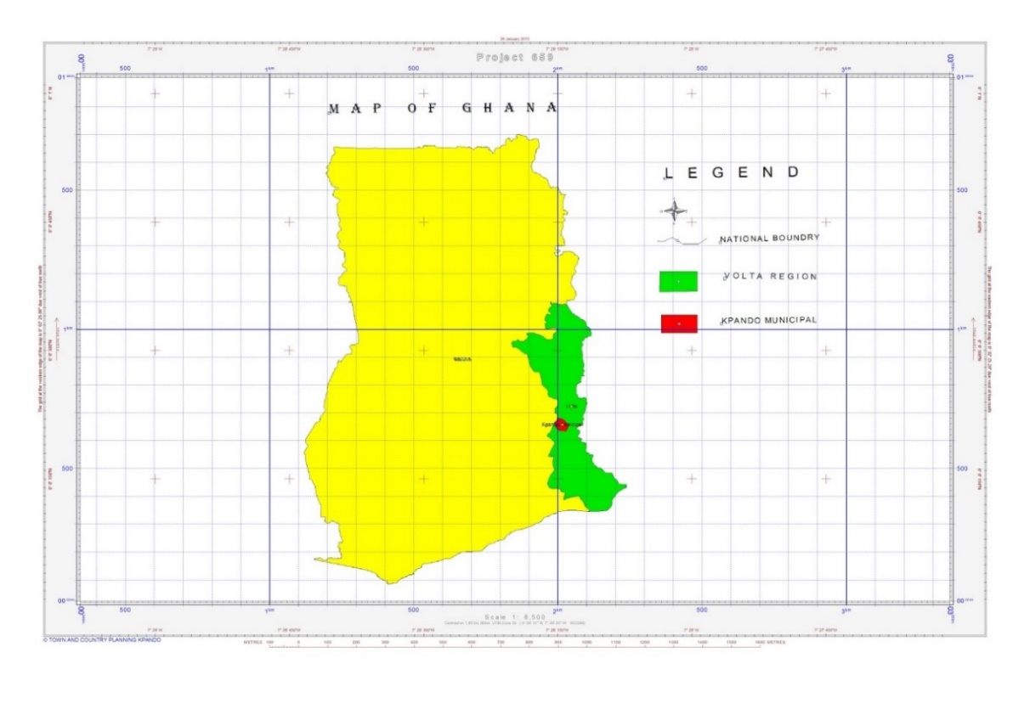 Source: MPCU-KpMA, 2021

1.7.2 Climate
The Municipality falls within the tropical zone and is generally influenced by the South West Monsoon winds from the South Atlantic Ocean and the dry Harmattan winds from the Sahara. There are two rainy seasons, the major one occurs from mid-April to early July and the minor one starts from September to November. Annual rainfall ranges from an average of 900mm to 1,300mm. The mean annual temperature is about 27 Celsius whereas the mean daily temperature ranges from 22 to 33 Celsius. The months of February and March are generally the hottest while July and August are relatively cooler. The average relative humidity is 80 percent.

1.7.3 Vegetation
The vegetation of the Municipality is characterized by guinea savannah woodland. The savannah woodlands consist of grass with scattered trees like acacia, bamboo and baobabs. These are found along the River Dayi Basin. However extensive human activities such as charcoal burning, farming and logging have reduced the vegetation to secondary and savanna.
Extensive exploitation of forest resources caused by various human activities especially in farming communities around Gbefi, Kudzra and other towns has become a threat to the ecosystem. This situation has negative impact on agriculture, water supply, climate change among others.
The vegetation of the Municipality is conducive for animal husbandry, cultivation of root and cereal crops and horticulture

Figure 1. 3 Vegetation Map of the Municipality

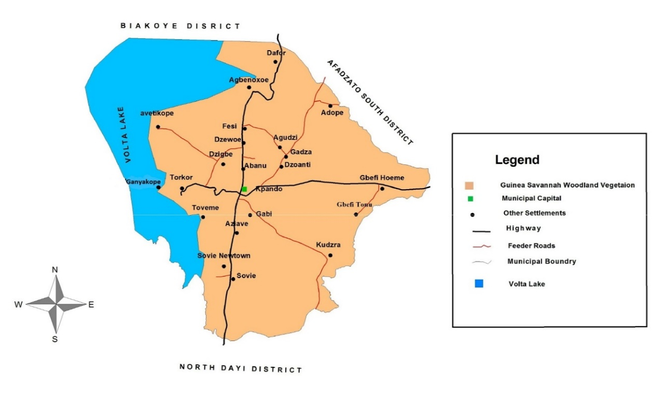 Source: MPCU-KpMA, 2021

1.7.4 Relief and Drainage
The Volta Lake and the River Dayi are the major water bodies that run in the Municipality.
The Volta Lake is the biggest water body in the Municipality. It runs along the western corridor with big potentials for irrigation agriculture, aqua-culture, tourism and fishing. The River Dayi lies to the East and its basin provides a prime farming land for the cultivation of a variety of food crops and vegetables.

1.7.5 Geology and Soils
The Municipality is generally underlined by Buem volcanic rocks which stretch through to Jasikan and Kadjebi Districts. The implication of this type of rock is that it supports surface supplies of underground water and therefore has prospects for boreholes construction. The major soil types that had developed from this parent rock are the Savannah ochrosols (reddish, lightly acidic; more fertile) “oxysol” (heavily drained; yellowish; less fertile and ground water laterites. This is characterized by sandy loamy type of soil with local adaptation. Along the Lake Volta and the River Dayi was dominated by the alluvial silt loam,

1.8 BIODIVERSITY, CLIMATE CHANGE, GREEN ECONOMY AND THE ENVIRONMENT
The Municipality is vulnerable to the effects of climate change because of the dependence of much of its population on agriculture, particularly rain-fed agriculture.
Climate change in the Municipality is manifested through: (i) rising temperatures, (ii) declining rainfall totals and increased variability, (iii) high incidence of weather extremes and disasters.
CLIMATE CHANGE IMPACTS IN THE MUNICIPALITY
    - Agriculture
Agriculture which is one of the largest employers within the Municipality suffers mostly from climate change. Total rainfall amounts are projected to fall or experience great variability which impacts crop production and the livelihoods of many in rural areas. The social fallouts of climate variability will include changes in land tenure arrangements and social relations and migration among others. The rising temperatures and frequent droughts was increase the incidences of bushfires and other environmental problems. Rising temperatures however favors some agriculture activities such as drying of cocoa beans, rice, maize and others.
    - Water
Water levels in the Volta Lake and other water bodies have been reducing and this situation would affect water availability for agriculture, health, sanitation, manufacturing and domestic uses. On the other hand, this situation can lead to storage of water for domestic and industrial use.
    - Impacts on the social sectors
The health and sanitation sectors have already been affected by climate change and will experience further stress in future. Increased incidences of water, air and food borne diseases, excessive heat are some of the effects. For instance, poor sanitation will increase the incidence of malaria and cholera, while poor water supply will increase the incidence of guinea worm, and excessive heat will exacerbate the incidence of cerebral-spinal meningitis.
    - Impact of Climate Change on Infrastructure

The climate change impacts negatively on infrastructure such as roads, power distribution lines, homes, drains and other structures that support life. The natural disasters such as floods, earth tremors, rainstorms and strong winds would become more frequent and devastating than before.

    - Water Sources in the Municipality
Water provision in the Municipality is being carried out by GOG, the KpMA, MP, Ghana Water Company Limited (GWCL) and Community Water and Sanitation Agency (CWSA). GOG through GWCL in 2016 constructed new water system to supply water to some of the major communities in Municipality. This has improved the water situation in some communities such as Dzigbe, Dzewee, Agbenoxoe, Gbefi, Fesi, Dzoanti, Gadza, Gbefi, Sovie, Aziave, parts of Kpando Konda and central Kpando. Even though water extension has been done to the above-mentioned communities, there is more work to be done to increase the coverage to other parts of the Municipality.
    - Water Security
The Municipality has a major water system supplied by GWCL and a number of boreholes and mechanized water systems supplied by CWSA, UNICEF, KpMA and other development partners. This is an indication that water supply in the Municipality is assured. These water systems can supply water to the entire Municipality. However, extension of water to cover every part of the Municipality is yet to be realized. Efforts are currently underway by various stakeholders to ensure the extension of water supply to all parts of the Municipality and also rehabilitate all broken down water systems to promote socio-economic activities in the Municipality.

Figure 1. 4 Waster facilities in the Municipality

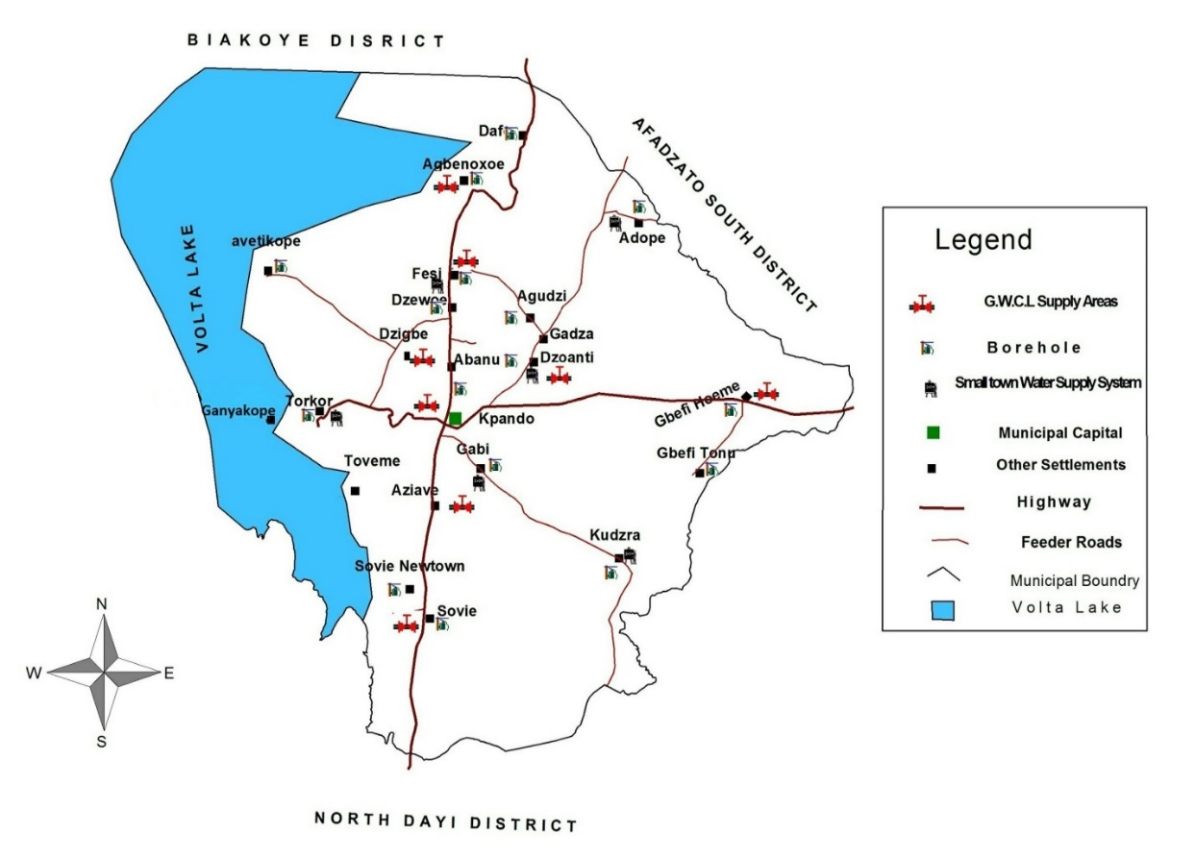
Source: MPUC-KpMA, 2021
  - Population
Population figures from the 2020 PHC by the Ghana Statistical Service puts the total population of the Municipality at 58,552 with males constituting 50.03% whilst females constitute 49.97 %. The population of the Municipality is estimated to be growing at a rate of 2.5% per annum. The population of the Municipality represents 3.5% of the regional population. The Municipality is predominantly urban populated (55.01%) compared to the rural areas (44.99%).

Figure 1. 5 Population Pyramid of the Municipality

Source: Adapted from the 2010 Population and Housing Census
As shown in Figure above, there is a high percentage of the population aged between 0-19 years (55.35%) in the Municipality which implies that the population has a potential to grow for a considerable number of years. Furthermore, the broad base nature of the population depicts that; there is a high concentration of the population (36.1%) in the younger ages (below 15 years). This population structure has a greater tendency of posing the problem of high dependency ratio which could culminate in poor savings attitude and low living standards.

1.9.1 Fertility
According to the 2010 PHC, the Municipality has total fertility rate of 3.0 children per woman aged 15-49 which is lower than the regional average of 3.4 children per woman. The implication of this is that a woman living in the Municipality would have an average of 3.0 children by the end of her reproductive period.

1.9.2 Migration (Emigration and Immigration)
Migration impacts on population size, structure and distribution. Data from the 2010 PHC indicates that migrants constitute 31.7 percent of the total population of the Municipality. More than two-thirds (67.4%) of the migrants in the Municipality were born elsewhere in the Region, followed by 26.9 percent born elsewhere in another region while the remaining 5.8 percent were born outside Ghana.
The majority (29.7%) of migrants born elsewhere in the Region have stayed 1-4 years while the least percentage of the migrants (12.9%) has stayed less than 1 year. Migration into the Municipality is on the ascendency.
Significant numbers of citizens also move to other parts of the country for educational and socio-economic reasons. This is as a result of lack of adequate public infrastructure and job opportunities. It is incumbent on the Assembly to provide access to public infrastructure such as schools and also promote local economic development opportunities as a way of generating job opportunities for residents of the Municipality.

1.9.3 Gender Equality
Gender defines the roles, rights, responsibilities, and obligations of men and women in a given culture, location, society and time. The varying roles of women and men in localities generate different needs and concerns. Over the years, failure to recognize and address these varying needs and concerns as part of development efforts has created adverse effects for females in particular. Therefore, even though decades of development efforts have made significant progress in most aspects of the lives of vulnerable persons, women and men still experience inequality in many areas of their lives such as socio- cultural, economic and political representation. Equality between men and women is a necessary precondition for sustainable development in the Municipality.
It’s important to recognize the different roles, capabilities and needs of women and men and taking account of them before embarking on development interventions to ensure that such policies address the needs of females and males equitably, and attempt to close any socio- cultural, political and economic gaps that exist between them. In order to promote gender equality in the Municipality, the Assembly would carry out programmes and activities under the following:
- Control – ensuring equal control in decision-making over factors of production.
- Participation – ensuring equal participation in decision-making processes related to policymaking, planning and administration.
- Sensitization – attaining equal understanding of gender roles and a gender division of labor that is fair and agreeable.
- Access – ensuring equal access to the factors of production such as land labour and income.
- Welfare – ensuring equal access to material and social welfare (food, water, income, education, medical care).

  - SETTLEMENT SYSTEM: NATURAL AND BUILT ENVIRONMENT
    - Rural/Urban Split
The rural/urban classification of localities is population based. This means that a settlement with a population size of 5000 or more is classified as urban and settlement with less than 5000 people is considered rural. Based on this classification, Kpando Municipality is predominantly rural populated with (52.2%) compared to the Urban areas (47.8%). The Municipal capital, Kpando and Torkor, are the two urban settlements in the Municipality.
    - Spatial Analysis (Hierarchy of Settlements)
The distribution of settlements in the Municipality is dictated by some physical and economic factors including accessibility to socio-economic infrastructure and natural resource endowment. The hierarchy of services and infrastructure are interrelated to the growth and size of settlements. The bigger settlements tend to develop along the trunk road that traverses the Municipality.
Naturally the size of a settlement tends to determine the level of services and infrastructure available. In the Municipality, some settlements with population lower than others perform higher functions. Kpando is the only settlement in the Municipality performing the highest level of functions. There is high concentration of socio-economic infrastructure and services such as health, education, communication, etc. in the first level function in the hierarchy of settlements in Kpando and Torkor. There is however least concentration of such facilities and services in the second and third levels of settlements in the Municipality. There is therefore the need to ensure even distribution of services and infrastructure in the other levels of settlements in order to:
- Ensure access to basic services and infrastructure;
- Curb the incidence of rural-urban migration.
Table below presents details of the scalogram analysis of the Municipality in terms of the major communities in the Municipality and the services and infrastructure availability

Table 1. 5 Scalogram Analysis
NAME OF LOCALITY | POP. | PRE-SCH | PRIMARY | JHS | SHS/VOC | HERBALIST | CHEMICAL STORE | PHARMACY | MATERNITY HOME | CHPS COMPOUND | HEALTH CENTRE | HOSPITAL | BOREHOLES | PIPED WATER | PUBLIC LATRINE | POLICE POST | POLICE STATION | CIRCUIT COURT | MAGISTRATE COURT | FIRE STATION | POST OFFICE | TELEPHONE | BANK | INSURANCE | MARKET | GUEST HOUSE | HOTEL | RESTAURANT | ELECTRICITY | LORRY PARK | FILLING STSTION | AGRIC EXTENSION | NO. OF FUNCTIONS | TOTAL CENT. SCORE | RANK
Weight |  | 1 | 2 | 3 | 4 | 1 | 2 | 3 | 4 | 5 | 6 | 7 | 1 | 2 | 1 | 1 | 2 | 1 | 2 | 1 | 1 | 1 | 1 | 1 | 1 | 1 | 2 | 1 | 1 | 1 | 1 | 1
Kpando | 28,525 | X | X | X | X | X | X | X |  | X | X | X | X | X | X | X | X | X | X | X | X | X | X | X | X | X | X | X | X | X | X | X | 30 | 1,571.48 | 1ST
Torkor | 6,430 | X | X | X |  | X | X |  | X |  | X |  | X | X | X | X |  |  |  |  |  | X |  |  | X | X |  |  | X | X | X | X | 18 | 546.59 | 2ND
Sovie Old Town | 3,220 | X | X | X | X | X | X |  |  | X | X |  | X | X |  |  |  |  |  |  |  | X |  |  |  | X |  |  | X |  | X | X | 15 | 338.15 | 3RD
Gbefi Hoeme | 2,645 | X | X | X |  | X | X |  |  | X |  |  | X | X |  |  |  |  |  |  |  | X |  |  |  |  |  |  | X |  |  | X | 10 | 111.49 | 6TH
Fesi | 2,119 | X | X | X |  | X | X |  |  | X |  |  | X | X |  |  |  |  |  |  |  | X |  |  |  |  |  |  | X |  |  | X | 11 | 111.49 | 6TH
Dzoanti | 1,896 | X | X | X |  | X | X |  |  |  |  |  | X | X |  |  |  |  |  |  |  | X |  |  | X |  |  |  | X |  |  | X | 11 | 119.82 | 5TH
Gbefi Tornu | 1,703 | X | X | X |  | X | X |  |  |  |  |  | X | X |  |  |  |  |  |  |  | X |  |  |  |  |  |  | X |  |  | X | 10 | 86.49 | 10TH
Kudzra | 1,624 | X | X | X |  | X | X |  |  |  | X |  | X | X |  |  |  |  |  |  |  | X |  |  |  |  |  |  | X |  |  | X | 11 | 106.49 | 9TH
Aziavi | 1,599 | X | X | X |  | X |  |  |  |  |  |  | X | X |  |  |  |  |  |  |  | X |  |  | X |  |  |  | X |  |  | X | 10 | 109.82 | 8TH
Agbenorxoe | 1,184 | X | X | X |  | X | X |  |  | X | X |  | X | X |  |  |  |  |  |  |  | X |  |  |  |  |  |  | X |  |  | X | 12 | 131.49 | 4TH
Sovie new | 1,017 | X | X | X |  | X | X |  |  |  |  |  | X | X |  |  |  |  |  |  |  |  |  |  |  |  |  |  | X |  |  | X | 9 | 77.40 | 11TH
Agudzi | 806 | X | X | X |  | X |  |  |  |  |  |  | X |  |  |  |  |  |  |  |  | X |  |  |  |  |  |  | X |  |  | X | 8 | 67.40 | 12TH
NO. OF SETTLEMENT |  | 12 | 12 | 12 | 2 | 12 | 10 | 1 | 1 | 4 | 5 | 1 | 12 | 11 | 2 | 2 | 1 | 1 | 1 | 1 | 1 | 11 | 1 | 1 | 3 | 3 | 1 | 1 | 12 | 2 | 3 | 12
CENT. INDEX |  | 100 | 100 | 100 | 100 | 100 | 100 | 100 | 100 | 100 | 100 | 100 | 100 | 100 | 100 | 100 | 100 | 100 | 100 | 100 | 100 | 100 | 100 | 100 | 100 | 100 | 100 | 100 | 100 | 100 | 100 | 100
WEIGHTED CENT. INDEX |  | 8.33 | 8.33 | 8.33 | 50.00 | 8.33 | 10.00 | 100 | 100 | 25.00 | 20.00 | 100 | 8.33 | 9.09 | 50.00 | 50.00 | 100 | 100 | 100 | 100 | 100 | 9.09 | 100 | 100 | 33.33 | 33.33 | 100 | 100 | 8.33 | 50.00 | 33.33 | 8.33

    - Governance
The Assembly was elevated to a Municipal Status with the passage of L.I. 2073 in 2012. The Assembly is composed of 19 Elected Members and 9 Government Appointees, the Municipal Chief Executive and the Member of Parliament for the Kpando Constituency.
The Assembly is by law, the highest Political, Administrative, and Planning Authority in the Municipality with deliberative, legislative and executive powers. The Assembly has responsibility for the overall development of the Municipality.
Below the Assembly are three (3) Zonal Councils namely Kpando, Gbefi and Sovie and Unit Committees in every community.
The General Assembly elects a Presiding Member from among themselves by two-third majority. He presides over the meetings of the Assembly for a two-year term. The Assembly has an Executive Committee presided over by the Municipal Chief Executive (MCE) who is appointed by the President with prior approval of not less than 2/3 majority of members of the Assembly present and voting at a meeting.
The Local Governance Act (936) of 2016 spells out in greater details the specific functions of the Assembly in areas of health, public works, rehabilitation, maintenance, agriculture, roads, physical developments, sanitation etc. For the purpose of the work of the Assembly, and to subject the issues of development to a wider discussion, the Executive Committee has five (5) statutory sub-committees composed of Members of the Assembly. These are as follows:
- Finance and Administration Sub-committee
- Development Planning Sub-committee
- Social Services Sub-committee
- Works Sub-committee
- Justice and Security Sub-committee

Some of the legal frameworks governing the operations of the Assembly are:
- Local Governance Act, 936 (2016)
- The National Development Planning Systems (Regulation) L.I 2232 (2016)
- Civil Service Law PNDC Law 327 (1993) etc.
- Public Financial Management Act, 2016 (Act 921)
- Land use and Spatial Planning Act, 2016 (Act 925)
- Financial Administration Regulation, 2004
- Local Government (Depts. of District Assemblies) (Commencement) Instruments, 2009 (L.I.1961) etc.

Figure 1. 6 Structure of the Local Government System
Regional Coordinating Councils
Metropolitan Assemblies
District Assemblies
Municipal Assemblies
Sub-Metropolitan District Councils
Town Councils
Zonal Councils
Urban/Town/Area Councils
Unit Committees

    - Sub-Structures of the Assembly
In order to deepen the decentralization process, the Kpando Municipal Assembly is demarcated into three (3) Zonal Councils. The zonal councils were recently supplied with office equipment while some level of renovation was carried out on them. The Gbefi and Sovie councils are currently operating from temporal structures and would require the provision of permanent structures.
    - Departments of the Assembly
The Assembly is expected to have 13 Departments. These Departments support the Assembly in the discharge of its functions. Some of the departments such as Natural Resources Conservation, Forestry, Game and Wildlife Division, Transport and Urban Roads are yet to be fully established in the Municipality. The Departments of the Assembly are listed in table 9 below as stipulated in the Local Governance Act 936, 2016.
Table 1. 6 Departments of the Assembly
S/NO | DEPARTMENT OF THE ASSEMBLY
1 | Central Administration
2 | Finance Department
3 | Department of Education, Youth and Sports
4 | Department of Health
5 | Department of Agriculture
6 | Physical Planning Department
7 | Department of Social Welfare and Community Development
8 | Natural Resources Conservation Dept Forestry Game and Wildlife Division
9 | Works Department
10 | Transport Department
11 | Disaster Prevention and Management Department
12 | Road Department
13 | Trade and Industry Department.
Source: Local Governance Act 936(2016)
  - ECONOMIC INFRASTRUCTURE AND SERVICE
    - Kpando Market
Kpando Market is the largest in the Municipality. It stretches over 1.5 hectares of land. The market has an extensive sphere of influence that goes beyond the Municipality’s boundaries covering Jasikan, Hohoe, Ho and Biakoye M/DAs, and parts of Eastern and Greater Accra Regions. The market operates every five days. The market counts as one of the major sources of revenue to the Assembly
    - Torkor Market
It is the second largest market in the Municipality. The market was developed from the fishing industry and was a buoyant commercial center in the 1980s and 1990s. One of the greatest challenges facing the smooth operationalization of the market and which also affect the economic potentials of the Municipality is the frequent breakdown of the Pontoon linking the Municipality and Afram Plains District
Other challenges impeding the smooth operationalization of the market are poor and inadequate market infrastructure, inadequate sanitation facilities, water, lighting, security, poor drainage system, deplorable condition of the lorry park and the Kpando-Torkor road. The Assembly has instituted plans to commence redevelopment of the Market.

1.11.3 Natural Resources and Their Utilization
The Municipality’s natural resources include Tourist Potentials, water bodies, sand and clay deposits, quarry and grassland, highlands, plantation reserves etc. These resources serve mainly as sources of livelihood and employment for majority of the people in the Municipality

    - Tourism
The Municipality has great potentials in this sector of the economy, some of these impressive tourism potentials include natural environmental heritage, historical heritage, cultural heritage and other attractions. Among the natural attractions is the climate, mountains, hills and the scenic beauty of the Volta Lake together with its numerous Islands which provides a broad base for the development of eco-tourism, recreation and water resorts.
    - Historical Heritages
Among the historic heritage is Kpando being an archaeological site and relics of the German colonial Administration. The German administered Kpando as a station under German Togoland Colony and the remains of the stones, bricks forts, residential and administrative offices are located at Kpando Todzi. The Kpando Todzi residences were later used by officials of the post-colonial government until it was locked up in 1990s. The Forts however currently serves as the Kpando Prison. Other potentials in the Municipality are the production of handicrafts, Grottoes at Agbenorxoe and Kpando Aziave. The major constraint in this sector is low investment in the development of the sector
Figure 1. 7 Tourism Potentials of the Municipality
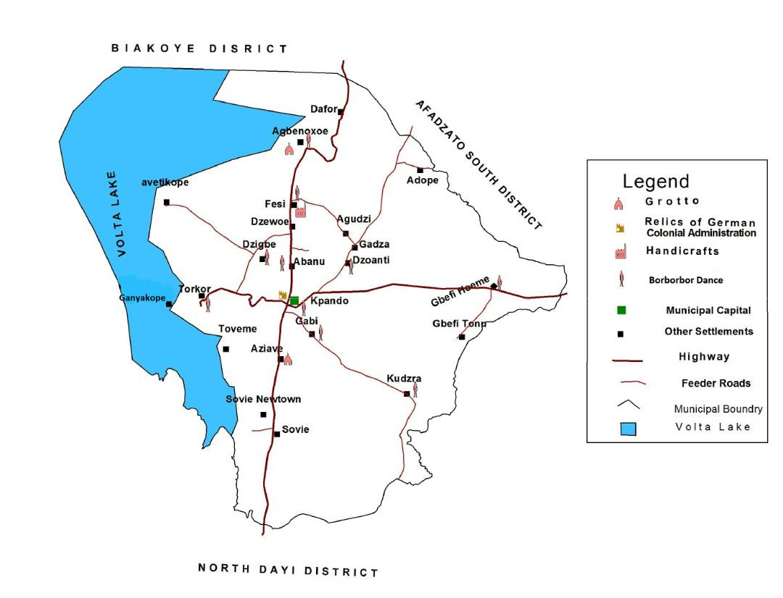
Source: MPUC-KpMA,2021

1.11.6 Banking Services
The Municipality is serviced by two (2) Commercial Banks namely, GCB Bank and Agricultural Development Bank as well as three (3) Rural Banks and a number of micro financial institutions
that provide credit facilities to the general public. The existence of these financial institutions is expected to make access to capital easy for the development of SMEs and other economic activities, however, over the years SMEs have been unable to access funds to expand their businesses. It is therefore incumbent on the Assembly to find a way of addressing these challenges.

1.11.7 Hospitality Industry
The hospitality industry has improved considerably with the development of Guest houses and hotels. Some of the facilities in the Municipality are Same Sisters, Ash Town Guest House, Catherine lodge, Johnson Inn and Hotor Hotel all located in Kpando.

1.11.8 Local Economic Development (Led)
Local Economic Development is a process by which public, business and non-governmental sector partners work collectively to create better conditions for economic growth and employment creation within a local area.
The KpMA has over the years made significant efforts at reducing poverty and improving the lives of its citizenry. In spite of the progress made in tackling poverty, citizens are still faced with high levels of poverty, and unemployment. At the same time, there are challenges in meeting the needs of the people mostly due to lack of resources.
Addressing these unpleasant phenomena urgently requires a new approach to development that focuses on fully harnessing the economic potentials and resources of the local areas for job creation and consequently improved living standards. The broad objective is to build up the economic capacity of the Municipality to improve its economic status and the quality of life for all.
This objective falls in line with the Government’s policy of ‘’One District, One Factory’’, planting for food and jobs programme etc.
The KpMA therefore would promote policies and interventions to promote the establishment of SMEs as a base for industrial development.

1.11.9 Challenges Affecting SMEs
- Inability to coordinate LED activities at the Municipal level
- Weak private sector to engage public sector for LED
- Poor entrepreneurial culture among citizens
- Poor and inadequate infrastructure such as roads, water, power etc.
- Lack of market information
- Inadequate business management and skills training
- Inadequate basic machinery to enhance productivity

1.11.10 Strategies for the promotion of LED Activities
The Assembly would partner appropriate Government agencies, private sector, donors, NGOs and other agencies to:
- Provide urban and rural infrastructure (roads, energy, markets, water, storage facilities, processing facilities etc.) to enhance quality service at the local levels.
- Identify and exploit existing and potential natural resources, expertise and facilitate access to financial resources for LED.
- Equip local economic actors with the requisite skills, knowledge and attitudes and build capacity of LED institutions at all levels.

1.11.11 Funding Arrangements to Support LED
The following funding mechanisms are expected to help promote LED activities in the Municipality:
- Central Government support for LED activities such as the ‘’One District One Factory programme, One Million dollar per Constituency policy and other GoG policies.
- KpMA will develop and integrate LED activities into its budgets and annual action plans.
- KpMA will enter into possible Public – Private Partnership (PPP) ventures that would support LED.
- KpMA will seek support from its sister city partners in LED related activities.
- KpMA will seek funding from development partners and donors to support LED activities

1.11.12 Potential LED areas in the Municipality
- Development and redevelopment of irrigation facilities in the Municipality to promote the production of vegetables and other crops.
- Establishment of farm mechanization center with availability of tractors, ploughs, combined harvesters etc.
- Promotion of large-scale rice production and establishment of rice milling centers
- Development of storage/ warehouse facilities
- Development of Agro processing facilities to process palm oil, cassava, cashew etc)
- Promotion of Aqua culture and establishment of fish processing facilities
- Promotion of large-scale production of cash crops such as s cashew etc.
- Development of Fruits and vegetable processing facilities to process mangoes, pawpaw, pineapple, okro etc.
- Development of an art village to promote pottery making, kente weaving, beads making, wood processing/ carving etc.
- Promotion of Animal Husbandry e.g goat, sheep, piggery, pottery production etc.
- Tourism development with the presence of Volta Lake, historical, cultural heritages
- Revival of tile and bricks industry.

  - ECONOMY OF THE MUNICIPALITY
    - Social and Economic Characteristics
Over the past years, considerable effort has been made to improve socio-economic conditions of the people in the Municipality through poverty reduction strategies and other related interventions. However, a lot still remains to be done as the socio-economic conditions of the majority of the people is still characterized by poverty resulting from income inequality, low living standards and poor quality of life.
Access to certain basic public infrastructure and services is still inadequate especially in rural areas. There are also major disparities in the social conditions between different segments of the population. Generally, the lowest living standards are recorded in the rural areas.In the urban and peri-urban communities, some adverse social consequences of uncontrolled urbanization are beginning to manifest themselves
    - Analysis of Poverty Incidence, Depth of Poverty and Inequality.
The Ghana Poverty Mapping report of the Ghana Statistical Service (2015) revealed that there exist high variations in the levels of poverty among the 25 districts in the region. More than half (13 out of 25) of the districts have poverty incidence higher than the regional average of 33.3 percent. The incidence of poverty is highest in Adaklu (89.7%), whereas Kpando recorded between 40.0-49.9. The lowest poverty headcount is observed in Akatsi South District (10.5%). Severity of poverty of Kpando Municipality stands at 5.2.

Adaklu District has the highest depth of poverty (46.9%), whereas Kpando recorded figures between 11.1 The lowest depth of poverty is recorded in Akatsi South District (2.6%).
Kpando Municipal recorded inequality value of (44.4) which is above the regional value of 43.7.

When it comes to estimated number of poor persons Kpando recorded values between 17,113 people. Analysis of the above trend at the Municipal indicated that most of the estimated number of poor persons in the Municipality are persons who lives in rural communities and are engaged in subsistence Agriculture. Other factors that determine the level and incidence of poverty in the Municipality includes:
- Demographic Characteristics (age, sex, marital status, and household size): There is a clear tendency for poverty measures to increase with the age of the household head. The same observation holds in terms of household size, with larger households being much more likely to be poor than smaller ones. Individuals who have never been married (and tend to be younger, better educated, and with a smaller number of children if they have any) are less likely to be poor, as to those who are separated or divorced.
- Education Level of the Head and the Spouse: As expected, the probability of being poor decreases with the education level of the household head, from primary, to secondary, and college/post graduate studies. Households’ poverty also decreases with the education level of the spouse.
- Industrial Classification of the Head: The highest probability of being poor is among persons working in agriculture, followed by manufacturing and construction as compared to those working in the formal sectors.
- Employment Status of the Head: Then lowest rates of poverty are observed among public sector workers, followed by wage earners in the private formal sector, the self-employed in non-agricultural activities, the wage earners in the private informal sector, the households with non-working heads, and finally the self-employed in agriculture.
- Migration and Land Ownership: The poverty headcount index has slightly lower among household who have migrated than among those that did not migrate since birth, which represents a reversal of the situation of the early 1990s.
- Vulnerability poverty tend to be higher among vulnerable groups of persons such as persons living with disabilities, diseases etc.
- Vulnerable group: (PWD) = 517, Male 258 and Female = 259
- Marginalized group: (Aged) = 83, Male 32 and Female = 51
Figure 1. 8 Poverty Map of the Municipality
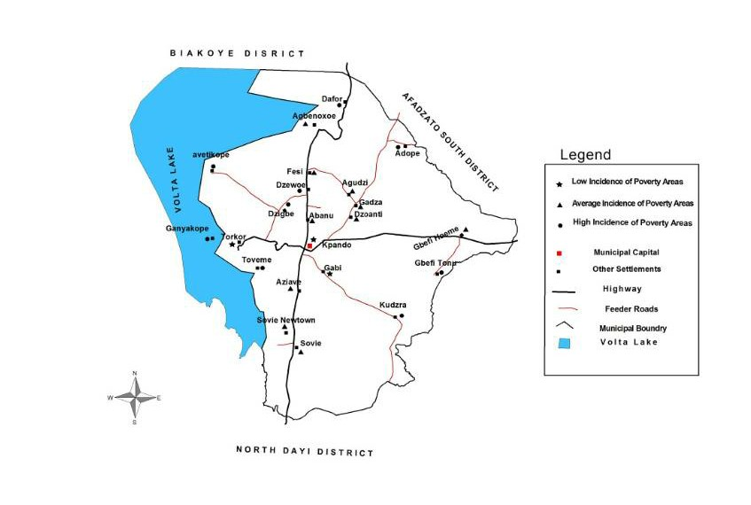

The Assembly is therefore expected to put in place measures to ensure reduction in poverty in the Municipality. Some of the measures to be supported or implemented by the Assembly in this regard includes:
- Provision of adequate public infrastructure such as water, health and educational facilities etc.
- Support the implementation of social intervention programmes such as LEAP, school feeding, NHIS, planting for food and jobs programme, Free SHS etc.
- Intensify managerial, vocational and technical, entrepreneurial skills training programmes for persons in the Municipality especially vulnerable groups such as PWDs.
- Support local economic development programmes such as One District One factory programme and also create the enabling environment for the growth of private sector.
- Facilitate access to credit facilities to SMEs
- Facilitate access to start up kits for SMEs
- Involvement of vulnerable groups in decision making processes of the Assembly

1.12.3 Agricultural Sector growth
The economy of the Municipality is dominated by agricultural activities and it is estimated that about 32.0% (2010 census) of the active population is engaged either directly or indirectly in this sector. The climatic condition in the Municipality favorably supports variety of crops and livestock production. Crop production is characterized by small farms land holdings with average farm size of less than a hectare. Farmers use simple farming tools and techniques, shifting cultivation practices and over reliance on rain-fed agriculture. About 62% of farmers in the Municipality are subsistent food crop growers, 17% are involved in tree crop farming, and 3% are in industrial crop production and about 18% in livestock farming. The major constraint confronting commercial production of crops is accessibility to markets and lack of processing and storage facilities.

1.12.4 Food Production and security
Food crops such as maize, rice, plantain, cassava, yam, and other vegetables especially garden eggs, okra and pepper are mostly grown on subsistence level. There are however a handful of farmers who are into the commercial production of vegetables such as pepper, garden eggs and okro. Annual production varies with the rainfall pattern and the level of soil condition and production technology. The increasing cost of farm inputs, unstable prices and the low soil fertility accounts for the decreasing profit margin of agricultural sector workers with low productivity. Crop production is largely rain-fed, and traditional technology of production continues to dominate the sector with peasant farmers using simple tools such as hoes and cutlasses. The figure below shows the major crop production in the Municipality.

Figure 1. 9 Major Crop Production areas of the Municipality
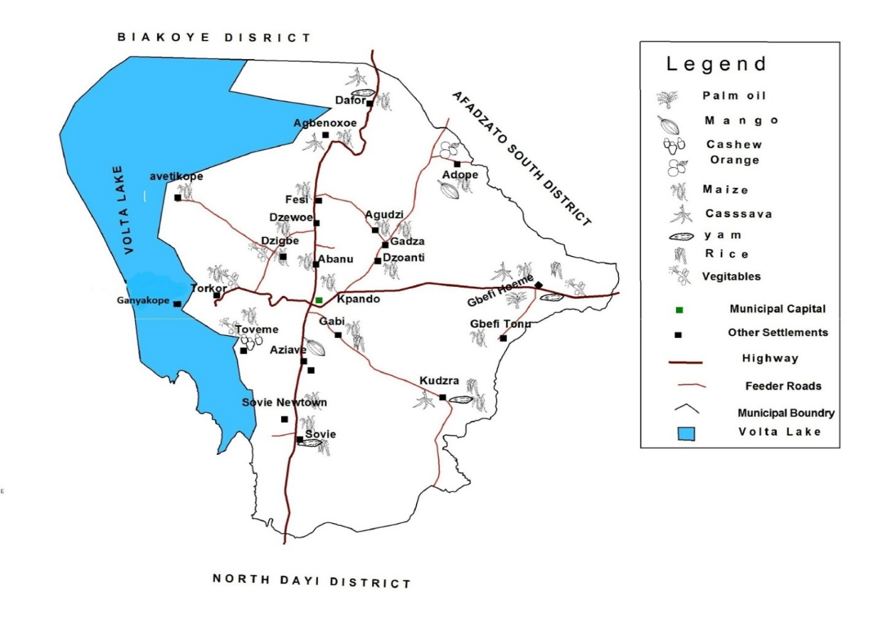

Source: MPCU-KpMA, 2021

1.12.5 Fishing industry
The creation of the Volta Lake in 1964 created potentials for the fishing industry to flourish with an estimated catch of 40,000 tonnes per year providing employment for a large number of the population. Fishing is the dominant occupation for thousands of people living in communities along the Volta Lake. The major fishing communities include Kpando Torkor, Dafor Tornu etc. There are a number of other smaller fishing communities along the lake. Some fishing also takes place on the River Dayi
Unfortunately, fishermen along the Volta Lake are becoming increasingly poorer over the years and livelihoods dependent on fishing alone is accordingly becoming unsustainable. Recent poverty studies on the Volta Lake (Braimah, 2001; Fabio et al, 2002) have shown that those in fishing communities along the lake who have escaped poverty and considered to be in the better income class are those who have pursued other livelihood activities in addition to fishing. The outcome of this finding should therefore be considered in designing interventions to address this development. Aqua culture or fish farming was introduced into the Municipality in the early part of the 80s. However, this enterprise is still on a very small scale in the Municipality.

1.13 SOCIAL SERVICES DELIVERY
The Social Services of the Municipality consist of Education, Health, Nutrition, Child Protection, Water and Social Protection services delivery.

1.13.1 Education
Schools in the Municipality are grouped into five circuits to ensure effective supervision.

1.13.2 Public Basic Education level
There are, One Hundred and Ten (110) Public schools in the Municipality. This comprises of Thirty-Nine (39) Kindergartens, Forty (40) Primary, Thirty-one (30) Junior High Schools and One (1) Community Inclusive Special School.

1.13.3 Public Senior High and Technical School level
There are Two (2) Senior High Schools and Two (2) Technical Institutes in the Municipality.

1.13.4 Private Basic Education level:
There are Fifty-Nine (59) Private Schools. This comprises of Twenty-Three (23) Kindergartens, Twenty-Two (22) Primary and Fourteen (14) Junior High Schools.

1.13.5 Private Senior High
There is no Private Senior High School in the Municipality.

Figure 1. 10 Educational Facilities in the Municipality
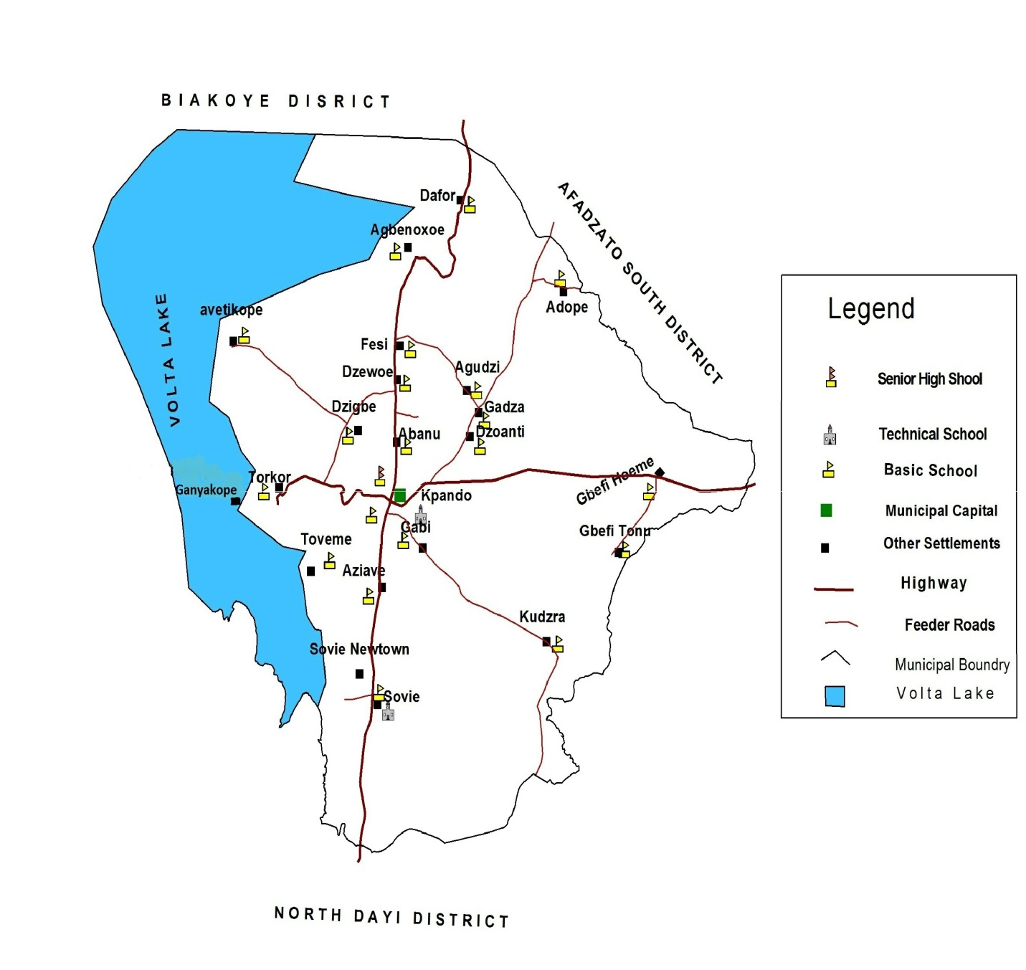
Source: MPCU-KpMA, 2021

1.14 HEALTH CARE

1.14.1 1 Health Service Delivery Management
Health care provision in the Municipality is structured into three main levels which are the Municipal, Sub-Municipal and the Community levels. The Community level care is provided at CHPS zones. This level of service is complemented by extended outreach services to communities by service providers at the sub- municipal level, also by boat clinic services to the Island communities of the Municipality and by the traditional birth attendants. The nature of the service at the community level is mainly health promotion, prevention of diseases and some curatives services.
The Sub-Municipal service includes some curative with focus on minor ailments. This service is offered by Health Centers.
The Municipality has Eleven (11) Health Facilities, these includes Two (2) Hospitals, Seven (7) CHPS Compounds. This level also offers preventive services as well as health promotion.
The third level of service is the secondary (hospital) level. This is offered by two hospitals namely Margaret Marquart Catholic Hospital (Municipal Hospital) and St Patrick Hospital. The first is owned by the Catholic Church whilst the second is a private facility.
Table 1. 7 Rate of fertility/birth recorded by KpMA
Rate of Fertility/Birth | Period
Age Range | 2017 | 2018 | 2019 | 2020 | 2021 | Total
10-14 | 5 | 5 | 9 | 121 | 13 | 152
15-19 | 247 | 234 | 302 | 268 | 194 | 1,245
20-24 | 392 | 406 | 397 | 469 | 385 | 2,049
25-29 | 475 | 535 | 507 | 546 | 404 | 2,467
30-34 | 428 | 428 | 406 | 463 | 371 | 2,096
35-40 | 303 | 362 | 335 | 357 | 284 | 1,641
Total | 1,850 | 1,970 | 1,956 | 2,224 | 1,651 | 9,650
Source: MHD KpMA, 2021
Table 1.8 Rate of mortality/death recorded in the KpMA
Rate of mortality | Period
Age Range | 2017 | 2018 | 2019 | 2020 | 2021 | Total
Under 5 | 41 | 31 | 24 | 25 | 17 | 138
5-14 | 11 | 8 | 8 | 35 | 4 | 66
15-19 | 3 | 5 | 3 | 4 | 4 | 19
20-34 | 29 | 22 | 20 | 14 | 13 | 98
35-49 | 48 | 42 | 43 | 46 | 48 | 227
50-59 | 44 | 55 | 42 | 57 | 42 | 240
60-69 | 45 | 65 | 60 | 61 | 42 | 273
70 & above | 77 | 78 | 94 | 73 | 61 | 383
Total | 298 | 306 | 294 | 315 | 231 | 1,444
Source: MHD KpMA, 2021
Table 1.9 Top causes of OPD in the Municipality
Causes | Period
Diseases | 2017 | 2018 | 2019 | 2020 | 2021 | Total
Malaria | 19,440 | 13,741 | 13,007 | 9,262 | 9,185 | 65,635
Tuberculosis | 9 | 9 | 68 | 61 | 42 | 189
HIV/AIDS | 0 | 0 | 0 | 183 | 118 | 301
Measles | 0 | 0 | 0 | 0 | 0 | 0
Cholera | 0 | 0 | 0 | 0 | 0 | 0
Chicken pox | 202 | 87 | 75 | 75 | 126 | 565
Yellow Fever | 1 | 2 | 4 | 2 | 2 | 11
Typhoid Fever | 1,371 | 1,483 | 1,684 | 2,896 | 2,651 | 10,085
COVID-19 | 0 | 0 | 0 | 77 | 89 | 166
Source: MHD KpMA, 2021.
Table 1.10 Trend of HIV/AIDS cases
Year | Tested |  |  |  |  | Positive
Year | M | F | Total | Percentage (%) Male | Percentage (%) female | M | F | Total | Percentage (%) Male | Percentage (%) female
2017 | - | - | -
2018 | - | - | -
2019 | - | - | -
2020 | 2,787 | 5,199 | 7,986 | 34.9% | 65.1% | 45 | 138 | 183 | 24.6% | 75.4%
2021 | 1,538 | 2,594 | 4,132 | 37.2% | 62.8% | 31 | 87 | 118 | 26.3% | 73.7%
Source: MHD KpMA, 2021

Figure 1. 11 Health Facilities in the Municipality
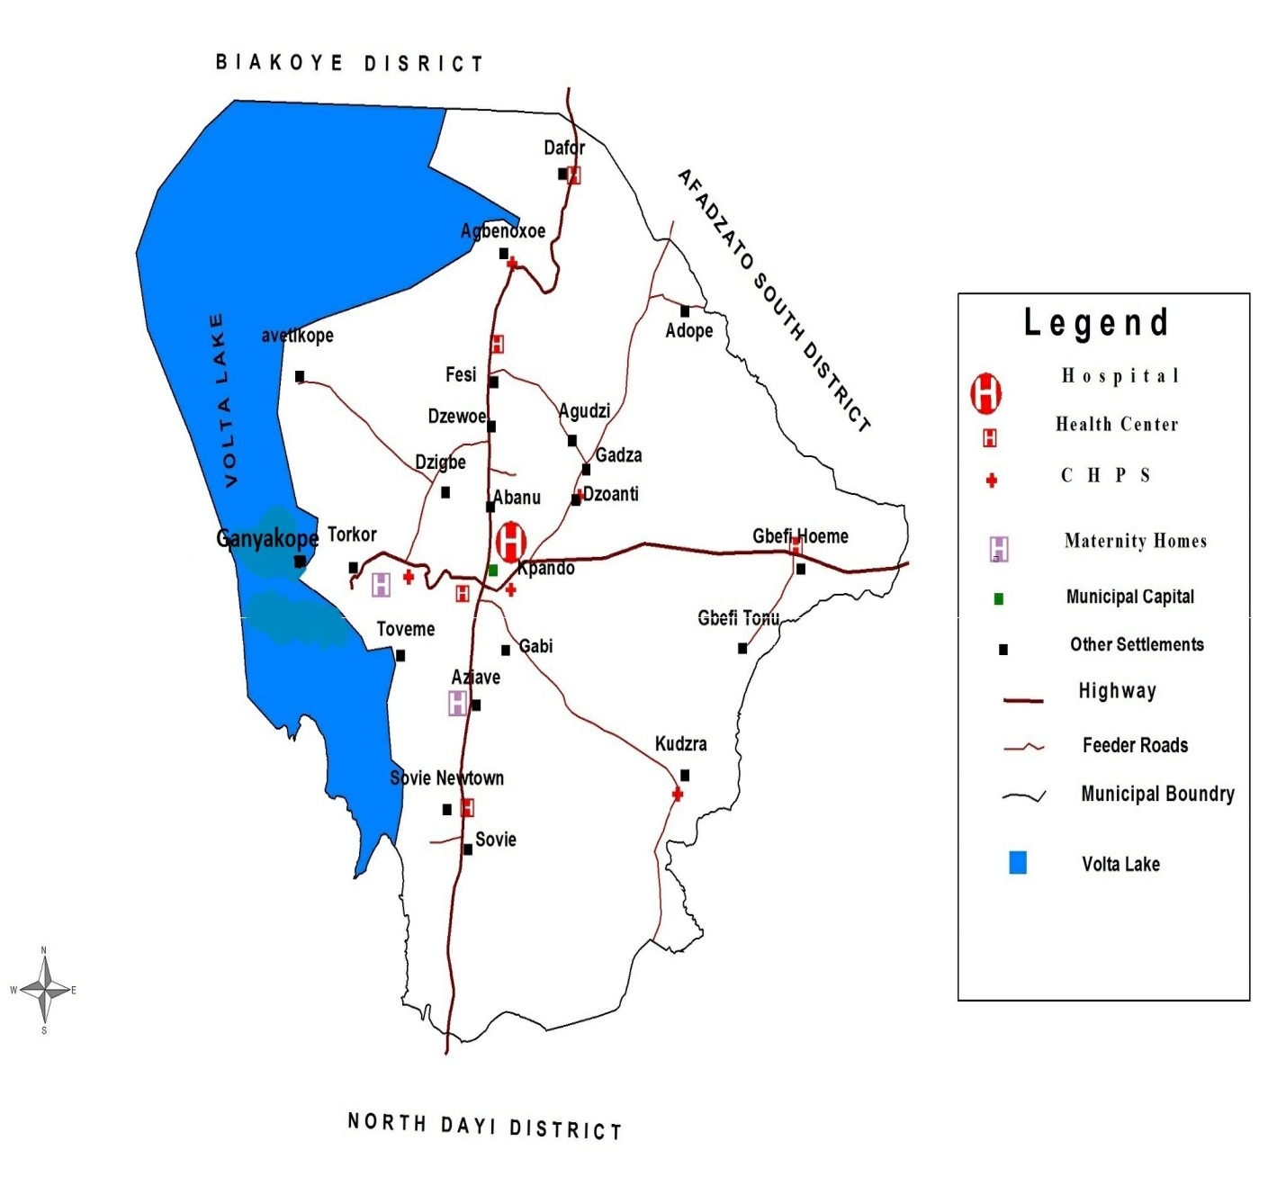

Source: MPCU-KpMA, 2021

1.15 ROAD NETWORK

The Municipality has approximately a total road network of 242 kilometers (km). Forty-Eight (48) km of that are paved and 194 unpaved roads. The conditions of the paved roads are as follows:
- 22km is in good state
- 5km is in fair state
- 15km is in bad state
The conditions of the unpaved roads are as follows:
- 45km is in good state
- 36km is in fair state
- 114km is in poor state
The 114km which are Un-engineered road network in the Municipality requires urgent maintenance to facilitate free movement of goods, services and persons in the Municipality in order to promote economic activities.
Figure 1. 12 Road networks in the Municipality
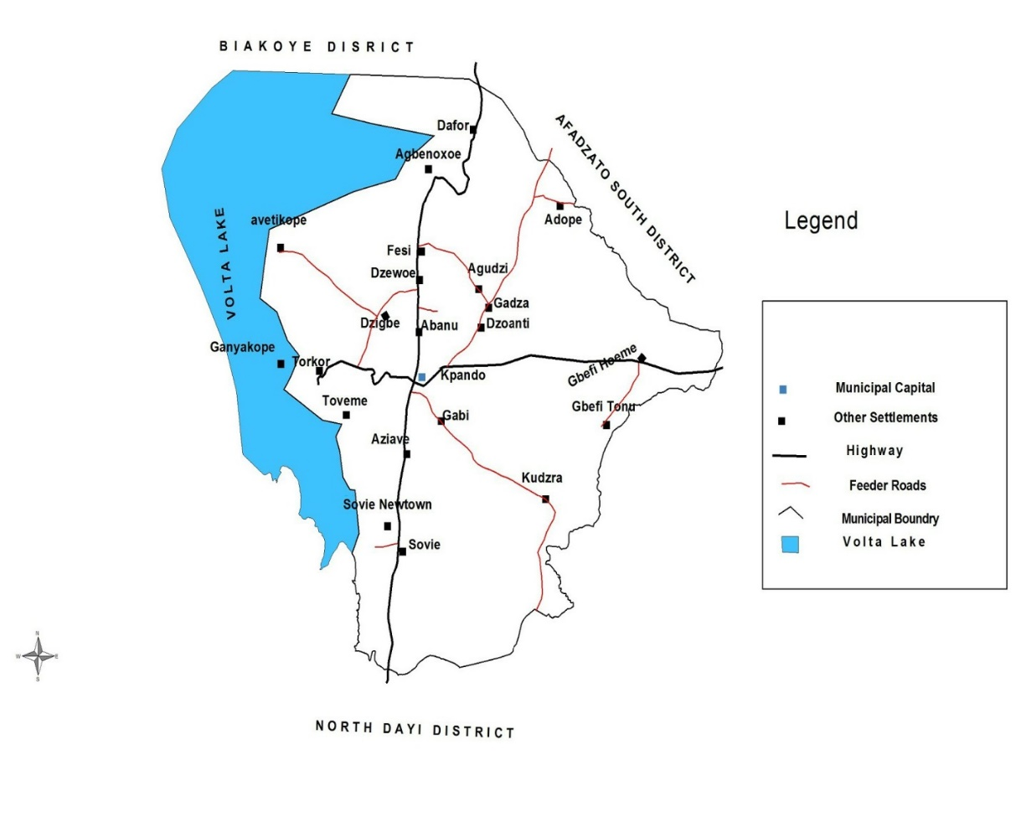

ROAD SAFETY MEASURES
Road safety rules are designed in the best interest of the road users and pedestrians. Some of these measures to ensure road safety in the Municipality are outlined below:
- Construction of speed humps/ramps on major roads
- Maintenance of traffic lights in the municipality
- Construction of zebra crossing on major roads
Other safety measures for drivers, tricycle and motor riders are as follows:
- Do not drink whilst driving
- Do not use mobile phone whilst driving
- Obey traffic regulations or signals
- Always anticipate
- Avoid distractions
- Do not cross the speed limits
- Commercial and private vehicles must be service regularly
- Maintain lane discipline
- Drivers must be careful during bad weather
- Maintain a safe distance
- Overtake from the right
- Give way for emergency vehicles

1.16 Situational Analysis on the District’s Disaster and Hazard Event and the Various Adaptation and Coping Strategies
The Municipality is prone to a wide variety of natural and human-induced disasters. Occurrences such as floods, fires and water pollution cause losses to livelihoods, property and lives. Mitigation measures are a relatively low in the Municipality and the Municipality is inadequately equipped and prepared to cope with the impacts of most of these disasters. Reducing disaster risk through preventive measures has therefore become a central concern for sustainable development in the Municipality. It is important that the Municipality adopt cost-effective policies in collaboration with agencies like NADMO and GNFS to lower risk and allocate appropriate resources for disaster mitigation. The Municipality is prone to some of the following natural and man-made disasters.
Floods:
Floods are among the most devastating natural hazards in the Municipality especially in communities along the Volta Lake. While the primary cause of flooding is high rainfall, there are many human-induced contributory causes such as: land degradation; deforestation of catchment areas; poor land use planning, zoning, and control of flood plain development; inadequate drainage systems etc. Assembly had adopted regular desilting of storm drains and rivers in Municipality to ensure less cases of flood events in the Municipality.
Coping:
- People living in flood prone areas will have to secure the foundations of their houses with sand bags,
- Regular desilting of cutters within the Municipality,
- Re-enforces building with cements,
- Create channels to direct flood water from buildings to natural water channels,
- Keep the environment clean; and
- Do not rubbish into water bodies.
Adaptation:
- To relocate to higher grounds
- Maintain and keep areas around boreholes, under wells and other water sources clean
Fires: Bush and Domestic fires caused by human activities are becoming more frequent in the Municipality. These fires destroy biodiversity and reduce the regeneration capacity of the vegetation. Although the fires cause few deaths, valuable resources are lost, thereby contributing to poverty. Fires also affect air quality and generate greenhouse gases. Assembly through the office of NADMO has been educating farmers about the need to desist from activities that will leads to push fire.
Coping:
- Creating of fire belt around villages and farms to combat bush fire; and
- Educating the communities not to start bush fire

Adaptation:
- Creating of wind belt around communities by planting and growing trees.

1.17 Summary of Development Issues
Table 1.13 is a combo of all the development issues emanating from the vivid analysis of the current situation and has implications for the planning period.
Table 1.11 Key Development Issues with Implications for 2022-2025
Agenda for Jobs 2022-2025
Development Dimension | Focus Areas | Issues
Economic Development | - Private Sector Development | - Limited access to capital for businesses  - Limited skills for business development
Economic Development | - Tourism development | - Inadequate development of tourism potentials  - Low interest in Tourist development
Economic Development | - Agriculture | - Low productivity of livestock and poultry products.  - Limited technological application  - Inadequate market infrastructure
Social Development | - Health Services | - Inadequate health facilities in the Municipality  - Inadequate resources for COVID-19 management  - Challenges in access to health education and management
Social Development | - Education | - Inadequate vocational schools  - Inadequate school infrastructure especially at primary level  - Inadequate educational infrastructure  - Limited wash facilities in schools
Social Development | - Sanitation | - Poor sanitation and hygiene in schools  - Poor sanitation and waste management  - Noise pollution in Urban areas  - Absence of skip bins in the Communities
Social Development | - Vulnerability | - Inadequate access to social protection by the vulnerable/ PWDs  - Limited attention to gender equality and women empowerment.  - Unemployment especially among the youth
Environment, Infrastructure and Human Settlement | - Transport infrastructure | - Poor road conditions in the Rural Communities  - Poor maintenance and absence of street lights  - Absence speed humps on our road
Environment, Infrastructure and Human Settlement | - Climate change | - Negative impact of climate change  - Poor drainage system
Environment, Infrastructure and Human Settlement | - Human settlement | - Lack or absence of layouts in the Municipality  - Poor adherence to human settlement planning
Environment, Infrastructure and Human Settlement | - Disaster management | - Inadequate disaster prevention, preparedness and response
Governance, Corruption and Accountability | - Local government and decentralization | - Limited IGF generation due to delay in revaluation and other constraints  - Low levels of representation of women in governance in decision making  - Non-performance of zonal councils
Governance, Corruption and Accountability | - Human resources management | - Inadequate capacity of staff in specialized areas  - Absence of residential accommodation for staff
Implementation, monitoring and evaluation | - Planning  - Budgeting | - Inadequate logistics especially vehicles and office equipment
Implementation, monitoring and evaluation | - Monitoring and Evaluation | - Limited capacities for the conduct of evaluations  - Poor record keeping and documentation

Figure 1. 13 Situational map of KpMA
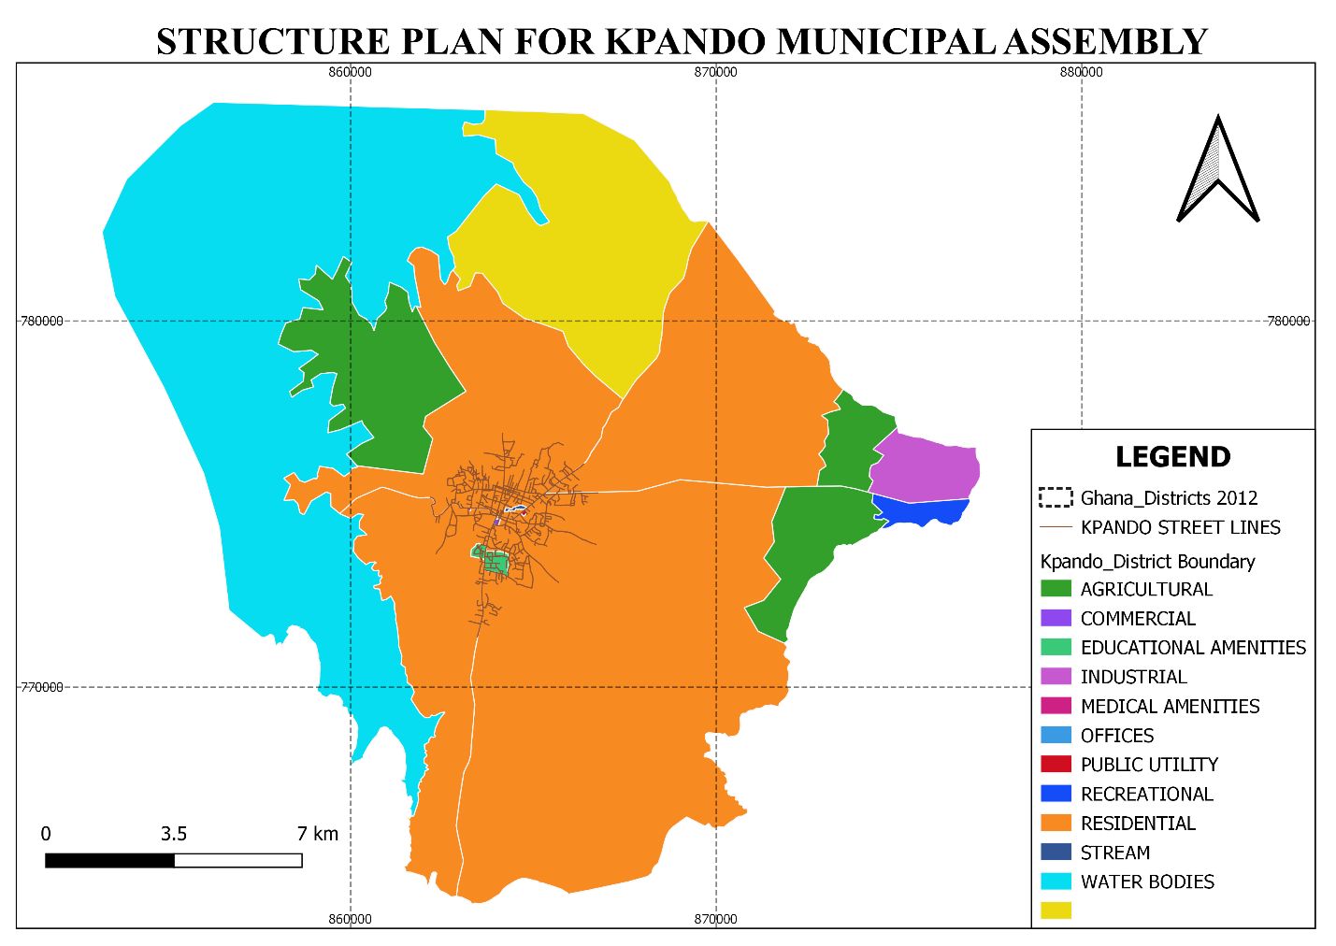Source: Physical planning Department KpMA, 2021.

1.17 Summary of the Chapter
The chapter presented a comprehensive performance review of 2018-2021 MTDP, a summary of the current profile of the Municipality. Development should ultimately respond to people’s problems, needs, aspirations and priorities. The Municipality’s consultations revealed several needs and aspirations with respect to the various sectors. The summary of all development issues existing in the Municipality and have been presented in the next chapter

CHAPTER TWO

DEVELOPMENT ISSUES FOR 2022-2025

2.0 Introduction
The previous chapter was a review of MTDP 2018 to 2021 and the current situation of Kpando Municipality. This chapter links the prioritized development issues to the relevant development dimensions of the National Medium-Term Policy Framework.
Public participation is an essential and integral part of effective development planning process which promotes inclusiveness and broad ownership of the plan. Section 3, subsections 1, 2 and 3 of the National Development Planning (System) Act, 1994 (Act 480) spells out the main tenets of participation. Further guidelines on participation are contained in the Popular Participation Action Plan Manual prepared by Inter-Ministerial Coordinating Committee (IMCC) and under Section 40 of the Local Governance Act, 2016 (Act 936).

2.1 Prioritized Development Issue
The new framework, presents five development dimensions which are;
- Economic Development
- Social Development
- Environment, Infrastructure and Human Settlements
- Governance, Corruption and Public Accountability
- Implementation, Coordination, Monitoring and Evaluation
The five goals in the framework are as follows;
- Build a prosperous country
- Safeguard the natural environment and ensure a resilient built environment
- Maintain a stable, united and safe society
- Mainstream emergency planning and preparedness into Ghana’s development planning agenda at all levels to respond to potential internal and external threats (including COVID-19)
- Improve delivery of development outcomes at all levels
Before the issues were finally arrived at and linked to the new framework to ensure that the Assembly continues with relevant on-going projects and programmes and in accordance with Chapter 6, Article 35 (7) of the 1992 Constitution of the Republic of Ghana, all the electoral area Action Plans were collated with needs and aspirations therein harmonized. The Community needs and aspirations were linked to the identified development gaps from the performance review to establish a relationship between them. Prioritization matrix method was used to rank the issues in order of prioritization.

These issues were further subjected to the analysis of the Potentials, Opportunities, Constraints and Challenges of KpMA to help in identifying issues with potentials and opportunities to be addressed as priorities while factoring other measures to address those with constraints and challenges identified. The impacts of the issues considered as priorities were evaluated along the following adopted criteria;
- The relevant issue had significant linkage effect on meeting basic human needs and satisfied human rights approach to programming.
- The issues also have significant multiplier effect on economic efficiency where its associated interventions should affect the Municipal economy in positive manner
- Efforts were made to ensure that interventions would impact on the general public as well as the aged and PWDs. The interventions proposed were to ensure balanced development, judicious use of natural endowment as well as cultural and social acceptability.
- Issues on gender dimensions were considered critical, therefore relevant interventions would be implied to get positive feedback.
- Climate change issues were also not left out so that the already degraded environment would be salvaged.
- Aside from the few mentioned above, other cross cutting issues have also been adequately taken care of, these are gender, the environment, nutrition, HIV and AIDS as well as COVID-19.

2.2 Sustainability Analysis of the Issues
Issues with positive impacts were further subjected to strategic environmental analysis, sustainability analysis for internal consistency and compatibility to determine how the prioritized development issues would support each other to make implementation successful. Issues with positive relationships were identified to be addressed in a holistic manner, negative ones were to be reconsidered.
Table 2.1 presents the ranked issues of all the Nineteen (19) electoral areas and three (3) zonal councils within the Municipality from the consultative engagements. These were done to enable the team formulate sustainable projects and programmes with the SEA fully integrated into the plan.
Table 2. 1 List of prioritize development issues
DEVELOPMENT DIMENSIONS | LIST OF PRIORITISED DEVELOPMENT ISSUES
Economic Development | - Revenue under-performance  - Weak coordination among departments responsible for economic management  - Limited capacity of MSMEs  - Limited access to credit for MSMEs who could not formalized their businesses  - Inadequate entrepreneurial skills and business development services
Economic Development | - weak farming practices  - Low quality and inadequate agricultural infrastructure  - Inadequate database on farmers and production  - Inadequate agribusinesses along the value chain  - Ageing farmer population  - Lack of workshops for the Youth on employable skills  - Assembly should acquire landbank & a warehouse for Agriculture purposes
Social Development: | Education Sector  - Inadequate education at all levels  - Inadequate school infrastructure especially at primary level  - Low participation of females in learning of science and mathematics  - Inadequate teacher motivation  - Weak linkage between educational needs, care giving and health needs of children with disabilities  - Inadequate furniture for School children and Teacher in the Community  - Inadequate toilet facilities in schools in the Municipality  - Inadequate Streetlights in Schools in the Community  - Insufficient water and toilet facility at all the Public Schools in the Municipality  - Inadequate logistics at GES to ensure effective monitoring of service delivery  - Inadequate supervision of teachers  - Inadequate teaching and learning materials  - Inadequate logistics at GES to ensure effective monitoring of service delivery
Social Development: | Health Sector  - Limited knowledge of HIV and AIDS/STIs, especially among vulnerable groups  - Inadequate nutrition education  - Inadequate financial support for family planning programmes  - Periodic shortage of essential drugs at the hospital  - Lack of require Health personnel e.g Doctors  - Lack of poly clinic in the Municipality  - Inadequate Health facilities in the Municipality
Social Development: | Social Welfare and Community Development Sector  - High incidence of child marriage  - High cases of teenage pregnancy  - Inadequate investments in young people  - High unemployment rate among the youth  - High poverty among vulnerable households including those with disabilities  - Persistent violation of the rights of vulnerable groups including Persons with Disabilities, the aged (especially elderly women), persons living with HIV and other conditions  - Inadequate and inequitable access to and support for inclusive and special education for PWDs and people with special needs at all levels  - Inadequate representation of PWDs in public and political  Leadership
Environment, Infrastructure and Human Settlement | Environmental Health  - Poor attitude of citizenry towards the environmental sanitation  - Low sanitation and waste management  - Inadequate investment in sanitation sector  - Poor hygiene practices especially at Zongos and some Rural areas  - Inadequate access to improved toilet facilities especially at rural areas and zongos  - Poor Attitude of Citizenry towards Environmental Management  - Inadequate skip bins in the Municipality  - Increasing forest degradation  - Air and noise pollution, especially in urban areas  - Indiscriminate use of weedicides  - Over-exploitation and inefficient use of forest resources  - Low institutional capacity to adapt to climate change and undertake mitigation actions  - Negative impact of climate variability and change  - Indiscriminate use of harmful chemicals to trap fish  - Inadequate human and logistical capacity in transport system  - Inadequate road infrastructure in the Municipality  - Inadequate security check points in the Municipality  - Inadequate boreholes the Communities  - Inadequate Drainage system in the Municipality
Governance, Corruption and Accountability | - Low participation of women and PWDs in local elections  - Weak linkage between local government and traditional authorities  - Weak spatial planning capacity at the local level  - Inadequate exploitation of local opportunities for economic growth and job creation  - Limited capacity for revenue mobilization  - Inadequacy of and delays in central government transfers  - Limited implementation of fiscal decentralization policy  - Limited and unsustain implementation of some programmes and projects  - Limited collaboration with relevant institutions  - Low public education on child mobility.
Emergency Planning and Response (Including Covid-19 Recovery Plan) | - Inadequate knowledge on disasters  - Poor early warning systems  - Poor coordination among key institutions  - Inadequate infrastructure for emergency response  - Logistical management challenges  - Weak social protection system for victims of disasters  - Inadequate sensitization of the public on COVID-19  - Weakened immune systems due to reduced exposure  - Increased vulnerability due to reduced incomes and  - Limited capacity for water delivery
Implementation, Coordination, Monitoring and Evaluation | - Inadequate capacity for plan preparation and implementation by departments  - Delay in the release of approved funds  - Inadequate Internally Generated Funds (IGF)  - Weak collaboration in the design and implementation, M&E of government programmes and projects  - Weak linkages between CSO/NGO plans and MTDPs  - Weak coordination of programmes and projects  - Inadequate financial, logistical and human resource  - Untimely release of funds for M&E activities  - Lack of statutory budgetary allocation for M&E  - Inadequate evaluations at all levels

2.3 Summary of the Chapter
The chapter presented a summary of all development issues emanating from the previous chapter, and also outlined the prioritized development issues raised by the Communities during Stakeholders engagement on community needs and Aspiration assessment.

CHAPTER THREE

DEVELOPMENT PROJECTIONS, GOALS, OBJECTIVES AND STRATEGIES

3.0 Introduction
Following from the earlier chapter which dealt with the prioritized development issues, this section focuses on the development goals, objectives and strategies to achieve development targets. The chapter contains the projected development requirements as per the identified prioritized issues, goals, objectives and strategies.

3.1 Projected Development Requirements for 2022-2025
Population is both a factor and determinant of development, thus a major determinant in the provision and distribution of municipal services such as water and sanitation facilities, health and education as well as infrastructure development. There is always the need for a threshold population to sustain services. Access to these services is key hence the need to create a reliable interconnectivity in space so geographical access to facilities and equity in the distribution of services will be achieved. The table below show the projected population for 2022 to 2025.
Table 3.1 Estimated Population for the District
Year | Male | Female | Total
Baseline 2021 | 2,9294 | 2,9258 | 58,552
2022 | 30,777 | 30,739 | 61,516
2023 | 31,547 | 31,508 | 63,055
2024 | 32,335 | 32,295 | 64,630
2025 | 33,143 | 33,103 | 66,246
Source: MPUC KpMA, 2021
In view of this, the Assembly as part of efforts would embark on renovations and construct of school buildings in order to meet the projected increment in school enrolment. From the Education directorate, three (3) schools need to be renovated and expanded to take care of the growing population

Table 3.2 shows the projection of school enrolment in the Municipality.
Years | Expected Pupils in KG (3-5 years) | Expected Pupils in Primary (6-12) | Expected Pupils in JHS (13-18 Years) | Expected Students (SHS)
2021 | 2,725 | 7,354 | 3,356 | 5,533
2022 | 2,769 | 7,876 | 3,678 | 4,863
2023 | 2,838 | 8,073 | 3,770 | 4,985
2024 | 2,908 | 8,275 | 3,884 | 5,110
2025 | 2,981 | 8,482 | 3,961 | 5,238
Source: GES KpMA
Table 3.3 Projection of School Buildings from 2022 - 2025
Years | Expected Number of KGs | Expected Number of  Primary Schools | Expected Number of JHS
2021 | 1 | 1 | 1
2022 | 1 | 1 | 1
2023 | 1 | 1 | 1
2024 | 1 | 1 | 1
2025 | 1 | 1 | 1
Source: Education Directorate – KpMA, 2021
Table 3.4 Projection on Operational Health Facilities from 2022 - 2025
Years | CHIPs Compound | Health Centers | Hospitals | Maternity Homes
2021 | 8 | 5 | 2 | 1
2022 | 3 | 1 | 0 | 0
2023 | 0 | 0 | 0 | 1
2024 | 1 | 0 | 0 | 0
2025 | 1 | 1 | 1 | 0
Source: Health Directorate – KpMA, 2021

Projections for Water facilities
Data available indicates that there are 110 boreholes currently available in the Municipality. There are also three (3) pipe schemes. These pipe schemes are running at low capacities due to the obsolete nature of their infrastructure. The Assembly has therefore projected to undertake rehabilitation of these pipe schemes.

Table 3.5 Water Provision Standards
Facility/Type | Population Threshold
Hand dug well | 73 – 300
Borehole | 300
Small Town Pipe System | 500
Pipe System | Above 5000
Source: MPCU 2021
The reconstruction of Kpando water system by the Government of Ghana was completed and the system is currently supplying potable water to Kpando, Sovie, Gbefi and other major settlements. What is much needed is rehabilitation of non-functioning boreholes. Projections made for the provision of water facilities in the Municipality is summarized below:
Water Facilities
- Borehole Construction------------------ 20
- Pipe scheme construction-------------- 10
- Limited Mechanized System---------- 4
- Bore hole rehabilitation---------------- 46

Table 3.6 Projection of population with access to improve sanitation
Years | Total No. of Skip bins in the KpMA | Total No. of Assembly’s Refuse Container | Rehabilitation of Refuse Containers | Institutional Latrine | Total No. of public urinals in the KpMA
2021 | 10 | 16 | 14 | 29 | 6
2022 | 13 | 18 | 16 | 31 | 7
2023 | 17 | 20 | 18 | 33 | 8
2024 | 20 | 22 | 20 | 35 | 9
2025 | 22 | 24 | 22 | 37 | 10
Source: MEHU – KpMA, 2021

Figure 3.1 Graphical Representation of Sanitation Projections from 2022-2025

Table 3.7 Revenue Projections from 2022-2025
Sources / Year | 2021 | 2022 | 2023 | 2024 | 2025
GOG | 82,005.00 | 181,540.00 | 208,771.00 | 240,086.65 | 276,099.65
IGF | 807,600.00 | 834,240.00 | 959,376.00 | 1,103,282.40 | 1,268,774.76
DACF | 10,576,490.00 | 10,219,460.00 | 11,752,379.00 | 13,515,235.85 | 15,542,521.23
DDF | 714,768.00 | 1,232,000.00 | 1,416,800.00 | 1,629,320.00 | 1,873,718.00
Donors | 95,897.00 | 95,600.00 | 109,940.00 | 126,431.00 | 145,395.65
Total | 12,276,760.00 | 12,562,840.00 | 14,447,266.00 | 16,614,355.90 | 19,106,509.29
Source: Budget Unit- KpMA, 2021

Figure 3.2 Graphical Representation of Projected Revenue For 2022-2025

Source: Municipal Budget Unit

3.2 ADOPTION OF MUNICIPAL DEVELOPMENT GOALS, OBJECTIVES AND STRATEGIES

3.2.1 Development Focus
Development focus is the key issue that needs to be pursued in order to eliminate development problems and bring about improved living conditions of the people in the Municipality. Based on broader consultation, and considering the major development challenges, the development focus/theme of the Municipality within this Medium Term is “to stimulate local Economic development through investment in productive infrastructural development and the development of human capital of the Municipality

3.3 Municipal Development Goals, Objectives and Strategies
The table below shows the prioritized issues compiled under the development dimensions, together with the focus areas. It also shows the objectives and also all the strategies that correspond to them. It is also a breakdown of all the issues to be dealt with in the planning period.

Table 3.8 Focus Area, Goals, Policy Objectives and Strategies
FOCUS AREA | GOALS | POLICY OBJECTIVE | STRATEGIES
STRONG AND RESILIENT ECONOMY | Build a Prosperous Country | Ensure improved fiscal performance and sustainability | - Strengthen revenue administration to eliminate revenue leakages and diversify revenue sources (SDG Target 16.6, SDG Targets 16.5, 16.6, 17.1, SDG Targets 17.1, 17.3)  - Strengthen economic planning and forecasting capacities at Municipal and sub-Municipal levels (SDG Targets 11.a, 17.18, 17.19)  - Strengthen budget coordination and transparency at all levels
INDUSTRIAL TRANSFORMATION | Build a Prosperous Country | Ensure improved skills development for industry | - Transform the apprenticeship training model from a supply-driven approach to a market-demand model (SDG Targets 4.3, 4.4, 4.7)  - Develop a database of trained apprentices and artisans in collaboration with employers and trade unions (SDG Target 17.18)
PRIVATE SECTOR DEVELOPMENT | Build a Prosperous Country | Enhance business enabling environment | - Optimize the registration processes and cost implications for establishment of new businesses
PRIVATE SECTOR DEVELOPMENT | Build a Prosperous Country | Support entrepreneurs and MSME development | - Create an entrepreneurial culture, especially among the youth (SDG Targets 4.4, 8.3, 8.6)  - Optimize the provision and management of resources including infrastructure and facilities for entrepreneurship training and business development services (SDG Target 8.6, 8.3, 9.3)  Encourage formation of, cooperatives and associations to facilitate easy access to credit.
PRIVATE SECTOR DEVELOPMENT | Build a Prosperous Country | Enhance domestic trade | - Develop modern markets and retail infrastructure in every district to enhance domestic trade (SDG Target 17.15)
AGRICULTURE AND RURAL DEVELOPMENT | Build a Prosperous Country | Create an enabling agribusiness environment | - Build the capacity of actors along the value chain in negotiations, standards, regulations, trade facilitation skills and procurement of services (SDG Targets 4.4, 17.9)  - Link smallholder and commercial producers to industry (SDG Targets 2.3, 2.c)  - Develop market support services for selected horticulture, food and industrial crops to enhance production for export (SDG Target 2.3)  - Develop and strengthen FBOs for better access to services  4.1.9 Strengthen land administration system especially for women and PWDs
AGRICULTURE AND RURAL DEVELOPMENT | Build a Prosperous Country | Improve public-private investments in the Agricultural sector | Support the development of exportable agricultural commodities in Municipality (SDG Targets 1.1, 1.2, 17.11)
AGRICULTURE AND RURAL DEVELOPMENT | Build a Prosperous Country | Modernize and enhance agricultural production systems | - Strengthen extension services (SDG Target 2.a)  - Intensify and increase access to mechanization along the agricultural value chain (SDG Targets 2.3)  - Promote commercial farming (SDG Targets 2.3, 2.4)  - Develop the capacity of farmers to use meteorological information (SDG Target 12.8)  - Promote integrated pest management (IPM) approaches  - Sustain investments in rice production and processing
AGRICULTURE AND RURAL DEVELOPMENT | Build a Prosperous Country | Improve post-harvest management | - Enhance post-harvest management protocols on storage, transportation, processing, packaging and distribution of agricultural produce (SDG Target 12.3)  4.4.3 Provide support for small and medium-scale agro-processing enterprises (SDG Targets 1.2, 1.4, 2.3, 2.4, 2.a, 2.c, 8.3, 9.3, 9.4)  4.4.4 Ensure continuous expansion and upgrading of road infrastructure connecting farms to marketing centres (SDG Targets 1.4, 2.3, 2.c)  - Facilitate the provision of storage infrastructure with drying systems at district level (SDG Targets 2.3, 12.1, 12.3, 12.a)  - Implement commodities trading centres (i.e., modern farmers’ markets) across all MMDAs focusing on grain, vegetable and tuber marketing (SDG Target 2.c)  Establish Agriculture and Food Systems sub-committee
AGRICULTURE AND RURAL DEVELOPMENT | Build a Prosperous Country | Enhance the application of science, technology and innovation | - Promote the application of information and communication technology (ICT) in the agricultural value chain (SDG Targets 2.4, 2.c, 5.b, 9.c, 17.8)  - Establish a database on all farmers (SDG Targets 16.9, 17.18)  - Improve dissemination of information on food prices and weather forecasts (SDG Target 12.8)
AGRICULTURE AND RURAL DEVELOPMENT | Build a Prosperous Country | Promote agriculture as a viable business among the youth | - Support youth to venture into agri-business along the value chain (SDG Targets 2.1, 2.3, 8.6)  - Facilitate access to agricultural financing for youth (SDG Target 8.3)  - Design and implement special programmes to build the capacity of the youth in agriculture (SDG Target 4.4)
AGRICULTURE AND RURAL DEVELOPMENT | Build a Prosperous Country | Promote livestock and poultry development for food security and income generation | - Continue implementation of the Rearing for Food and Jobs programme to increase production and processing of livestock including poultry.  - Intensify disease control and surveillance, especially for zoonotic and scheduled diseases (SDG Target2.3)
TOURISM AND CREATIVE INDUSTRY DEVELOPMENT | Build a Prosperous Country | Diversify and expand the tourism industry for economic development | - Expand the tourism sector through investment, innovation, and pursuit of service excellence  - Promote public-private partnerships for investment in the tourism (SDG Target 17.17)  - Develop available and potential sites to meet international standards and promote local tourism and (SDG Target 8.9)  - Encourage community initiatives in tourism development  - Promote the establishment of tourism clubs in all educational institutions (SDG Target 12.b)  - Improve road networks to tourist centres

SOCIAL DEVELOPMENT
FOCUS AREA | GOAL | POLICY OBJECTIVE | STRATEGIES
EDUCATION AND TRAINING | CREAT OPPORTUNITY FOR ALL | Enhance equitable access to, and participation in quality education at all levels | 1.1.1. Continue implementation of free SHS to include TVET for all children (SDG Targets 4.1, 4.3, 4.a)  1.1.2. Enhance quality of teaching and learning environment at all levels (SDG Targets 4.1,4.2, 4.6, 4.c)  1.1.3. Promote the ‘right age enrolment’ in schools (SDG Targets 4.1, 4.2)  - Accelerate the implementation of early childhood development policy on education (SDG Targets 4.1, 4.2)  1.1.9. Improve the gender parity at senior high school and tertiary level (SDG Targets 4.1,4.2, 4.3, 4.5, 4.b)  1.1.10. Expand school infrastructure and facilities at all levels (SDG Target 4.a, 4.c)  - Demystify and promote teaching and learning of science, technology, engineering, and mathematics (STEM) and ICT education among girls in basic and secondary education (SDG Target 4.1, 4.b)  1.1.17. Institute special incentive scheme for teaching and non-teaching staff especially in deprived areas and teachers of PWDs
EDUCATION AND TRAINING | CREAT OPPORTUNITY FOR ALL | Promote inclusive education | 1.3.1. Ensure inclusive education for PWDs and people with special needs (SDG Targets 4.1, 4.2, 4.5, 4.a)  - Promote inclusive education with health and care-giving arrangements for PWDs  - Institute a scholarship scheme for PWDs in higher education, including vocational training and information and communications technology, technical, engineering and scientific programmes (SDG Target 4.b)
EDUCATION AND TRAINING | CREAT OPPORTUNITY FOR ALL | Ensure a safe and supportive environment for the re-entry of dropouts into school | 1.4.1. Facilitate the re-entry of dropout boys and girls back into school  - Promote the re-entry of adolescent mothers into school after childbirth  1.4.5. Strengthen the delivery of counseling services in schools  1.4.6. Promote social education and acceptance of re-entry policy among stakeholders in schools and communities
EDUCATION AND TRAINING | CREAT OPPORTUNITY FOR ALL | Strengthen school management systems | 1.6.2. Continue the Implementation of programme for teacher development, actualization and professionalization (SDG Target 4.c)  - Ensure adequate supply of teaching and learning materials (SDG Target 4.2, 4.c)  - Promote quality EMIS data collection and use at the community and district levels (SDG Target 16.16)  - Strengthen PTA and School Management Committees (SMC) in public schools.  1.6.9. Strengthen supervision, management, and accountability at all levels of education
EDUCATION AND TRAINING | CREAT OPPORTUNITY FOR ALL | Ensure sustainable financing of education | 1.7.3. Ensure the allocation of funds to implement the inclusive education policy (SDG Target 4.b, 16.5)
HEALTH AND HEALTH SERVICES | CREAT OPPORTUNITY FOR ALL | Ensure accessible, and quality Universal Health Coverage (UHC) for all | - Accelerate implementation of Community-based Health Planning and Services (CHPS) policy (SDG Targets 3.8, 3.c, 16.6)  - Build Planning and monitoring capacity among health sector workers (SDG Targets 3.8, 3.c, 16.6)  - Expand, upgrade and equip health facilities with private sector involvement (SDG Targets 3.8, 3.c)  - Revamp emergency medical preparedness and response services across the country (SDG Target Mainstream gender and disability in the provision of healthcare services (SDG Target 3.8)  - 3.7, 3.8, 3.d)  - Promote use of ICT and e-health strategies in healthcare delivery and improve quality and coverage of healthcare data (SDG Targets 3.8, 3.d)  - Scale up disease prevention strategies (SDG Targets 3.8, 3.c, 3.d)  - Facilitate the provision of resource persons such as sign language interpreters in healthcare delivery.
HEALTH AND HEALTH SERVICES | CREAT OPPORTUNITY FOR ALL | Strengthen healthcare delivery management system | - Strengthen and improve coverage and quality of healthcare data capturing system and research in both public and private sectors (SDG Targets 3.8, 3.c 17.18)  - Strengthen partnership with the private sector and community in provision of health services (SDG Targets 3.8, 17.17)  - Build capacity for monitoring and evaluation in the health sector (SDG Target 3.c, 16.6)  - Increase the strength of support staff to health facilities.
HEALTH AND HEALTH SERVICES | CREAT OPPORTUNITY FOR ALL | Reduce disability, morbidity, and mortality | - Strengthen maternal, new-born care, child and adolescent services (SDG Targets 3.1, 3.2)  - Strengthen prevention and management of malaria cases (SDGs Targets 3.3, 16.6)  - Improve diagnosis, patient education, and counselling services for TB  - Scale up community-based hypertension management project (SDG Target 3.4)  - Intensify and sustain immunization for all children under 2 (SDG Target 3.2)  - Strengthen Integrated Disease Surveillance and Response (IDRS) at all levels (SDG Target 3.8, 16.6)  - Focus health delivery services on primary prevention and early detection of chronic disease conditions (SDG Targets 3.8, 3.d)
HEALTH AND HEALTH SERVICES | CREAT OPPORTUNITY FOR ALL | POLICY OBJECTIVE | STRATEGIES
HEALTH AND HEALTH SERVICES | CREAT OPPORTUNITY FOR ALL | Reduce non-communicable diseases | - Implement the non-communicable diseases (NCDs) control strategy (SDG Targets 3.4, 3.5)  - Increase health promotion to reduce accessibility and exposure especially among vulnerable groups i.e., children, youth, poor etc. (SDG Targets 3.4, 3.5)
HEALTH AND HEALTH SERVICES | CREAT OPPORTUNITY FOR ALL | Reduce the incidence of new HIV, AIDS/STIs and other infections, especially among vulnerable groups | - Expand and intensify HIV Counselling and Testing (HTC) programmes (SDG Targets 3.3, 3.7)  - Intensify comprehensive education on HIV/AIDS and STIs, including reduction of stigmatization (SDG Target 3.7)  - Intensify behavioral change strategies, especially for high-risk groups for HIV/AIDS and TB (SDG Targets 3.3, 3.7)  - Strengthen collaboration among HIV/AIDS, TB and sexual and reproductive health programmes (SDG Targets 3.3, 3.7)  - Intensify efforts to eliminate mother-to-child transmission of HIV (MTCTHIV) (SDG Targets 3.3, 3.7)
FOOD AND NUTRITION SECURITY (FNS | CREAT OPPORTUNITY FOR ALL | Promote nutrition specific and sensitive programmes and interventions | - Adopt strategies to reduce infant and adult malnutrition including scaling up proven, cost-effective, nutrition-sensitive, and nutrition-specific interventions (SDG Target 2.2)  - Promote nutrition education and sensitization (SDG 2.1, 2.2)  - Ensure strong and sustained environment and resources for breastfeeding promotion and protection and promote Infant and Young Child Feeding including early initiation, exclusive and two years of breastfeeding; enforce legislation on breast milk substitutes promotion and the fortification of foods rich in iron and vitamin A (SDGs Targets 3.1, 3.2)  - Support complementary feeding programmes and enhance quality of children’s diets (SDGs Targets 3.1, 3.2)  - Implement measures and interventions to reduce anaemia and stunting (SDGs Targets 2.2, 3.1, 3.2)  - Improve nutrition outcomes among adolescent girls and women in their reproductive age (SDG Target, 2.1, 2.2)
FOOD AND NUTRITION SECURITY (FNS | CREAT OPPORTUNITY FOR ALL | Strengthen and sustain food systems and increase food self-sufficiency | - Support the production of diversified, nutrient-rich food and consumption of nutritious foods especially among women (SDG Targets 2.1, 2.2, 2.4)  - Incentivize participation in the fruits and vegetable value chain (SDG Targets 2.1, 2.2, 2.4)  - Institute measures to reduce food loss, waste and avoidance practices (SDG Targets 2.c, 12.3)  - Educate and improve access of all moderate and severely food insecure households to social protection programmes (SDG Target 2.1, 2.2)  - Support small-scale farmers to reduce post-harvest losses (SDG Target 2.1, 2.2, 2.3)
POPULATION MANAGEMENT AND MIGRATION FOR DEVELOPMENT | CREAT OPPORTUNITY FOR ALL | Improve population management | - Intensify public education on population issues and strategies (SDG Target 3.7)  - Ensure population data collection with all levels of disaggregation.
POPULATION MANAGEMENT AND MIGRATION FOR DEVELOPMENT | CREAT OPPORTUNITY FOR ALL | Improve maternal and adolescent reproductive health | - Strengthen the integration of family planning education in adolescent reproductive healthcare services (SDG Target 3.7, 5.6)  - Provide Adolescent corners at CHPS zones.  - Eliminate child marriage (SDGs Targets 5.3)  - Reduce teenage pregnancy (SDG Targets 3.7, 5.3)
POPULATION MANAGEMENT AND MIGRATION FOR DEVELOPMENT | CREAT OPPORTUNITY FOR ALL | Harness the demographic dividend | - Promote advocacy for increased investment in youth development. (SDG Targets 16.7, 17.17)  - Place entrepreneurship skills development at the core of job creation
REDUCING POVERTY AND INEQUALITY | CREAT OPPORTUNITY FOR ALL | Eradicate poverty and address vulnerability to poverty in all forms and dimensions | - Enforce the complementarity of existing social protection interventions through effective referral systems (SDGs Target 1.3, 1.5, 10.2)
REDUCING POVERTY AND INEQUALITY | CREAT OPPORTUNITY FOR ALL | Reduce income disparities within and across socio-economic groups and geographical areas | - Expand economic opportunities and infrastructural development in rural areas and deprived zones (SDG Targets 9.1, 11.a)  - Strengthen the implementation of the Ghana local economic development (LED) policy and private sector participation (SDG Targets 17.5, 17.17)
WATER AND ENVIRONMENTAL SANITATION | CREAT OPPORTUNITY FOR ALL | Enhance access to improved and sustainable environmental sanitation services | - Scale-up sensitization campaigns to promote proper handwashing and hygiene practices particularly among children (SDGs Target 6.2)  - Enforce building regulation (including accessibility standards for PWDs) on the provision of toilet facilities in all public building  - Develop innovative financing mechanisms and scale up private sector participation and investments in the sanitation sector (SDG Targets 6.2, 17.3, 17.5)  - Promote National Total Sanitation Campaign (SDG Target 6.2)  - Accelerate the implementation of the “Toilet for All” programme (SDG Targets 6.1, 6.2)  - Monitor and evaluate implementation of sanitation plan (SDG Target 16.6)
WATER AND ENVIRONMENTAL SANITATION | CREAT OPPORTUNITY FOR ALL | Promote efficient and sustainable wastewater management | - Improve liquid waste management (SDG Targets 6.3, 6.a, 6.b)
CHILD PROTECTION AND DEVELOPMENT | CREAT OPPORTUNITY FOR ALL | Prevent and protect children from all forms of violence, abuse, neglect and exploitation | - Develop and implement plans of action to address issues of child trafficking, “streetism” and other neglected conditions (SDG Targets 8.7, 16.2)  Implement and enforce the comprehensive support mechanisms for victims of domestic violence including child victims  - Increase awareness on the effects of child labour  - Institute child protection committees in all communities  - Establish, refurbish and resource juvenile and family courts.
CHILD PROTECTION AND DEVELOPMENT | CREAT OPPORTUNITY FOR ALL | Promote the rights and welfare of children | - Increase community engagements and behavioral change campaigns to promote positive parenting attitudes and practices among parents and caregivers  - Enhance the inclusion of children with disability and special needs in all spheres of child development (SDG Targets 4.5, 4.a, 10.2, 11.2)  - Scale up District Integrated Social Services Programmes for children (especially multi-dimensionally poor), families and vulnerable adults (SDG Target 10.2)
CHILD PROTECTION AND DEVELOPMENT | CREAT OPPORTUNITY FOR ALL | Improve and strengthen the policy and legal environment, institutions and systems for child and family welfare | - Strengthen the Department of Social Welfare and Community Development to implement child related policies and regulations (SDG Targets 16.2, 16.6)  - Strengthen mainstreaming of child development and protection issues into development plans and budgets of the Assembly (SDG Targets 5.c, 16.2)
GENDER EQUALITY | CREAT OPPORTUNITY FOR ALL | Attain gender equality and equity in political, social and economic development | - Implement measures to promote change in socio-cultural norms and values inhibiting gender equality (SDG Targets 5.1, 5.2, 5.3, 10.2)  - Increase education and advocacy on Sexual and Gender-Based Violence and other Harmful Cultural Practices  - Institute measures to sensitize, empower and build capacities of women to participate in leadership and decision making at all levels (SDG 5.5)  - Address special issues and concerns of women with disability (WWDs) (SDG Targets 5.c, 10.2)  - Strengthen existing and advocate for the creation of more gender partnerships  Improve access to education, health, and skills training in income-generating activities for vulnerable women (SDG Targets 3.8, 4.5)
GENDER EQUALITY | CREAT OPPORTUNITY FOR ALL | Promote economic empowerment of particularly women | - Promote services that contribute to increasing income, women's empowerment, and the transformation of women’s gender relations in the extractive industry  - Increase technical and financial support to women-owned businesses and start-ups  Encourage women artisans and other tradespeople, including farmers, to form associations to facilitate their access to information and other support (SDG Targets 1.4, 5.c)
GENDER EQUALITY | CREAT OPPORTUNITY FOR ALL | Strengthen gender mainstreaming, coordination and implementation of gender related interventions in all sectors. | - Intensify an effective system for gender research and the generation and use of gender statistics for planning, budgeting, targeting and monitoring and evaluation  - Develop capacities of stakeholders for effective gender mainstreaming  - Establish effective coordination and monitoring mechanisms for gender mainstreaming  - Strengthen gender-responsive budgeting and financing (SDG Target 5.c)
SPORTS AND RECREATION | CREAT OPPORTUNITY FOR ALL | Enhance sports and recreational infrastructure for all | - Develop and maintain para-sports and disability friendly recreational infrastructure  - Ensure compliance with Disability Act in the provision of sports and recreational facilities (SDG Targets 1.3, 16.b)  - Enforce development of designated sports and recreational land use in all communities (SDG Target 16.6)
SPORTS AND RECREATION | CREAT OPPORTUNITY FOR ALL | Build capacity for sports and recreational development | - Strengthen organization of Municipal competitive sporting events at all levels (SDG Target 16.6)  - Promote formation of sports clubs and academies in all communities and educational institutions (SDG Target 4.7)  - Promote gender equity in sports (SDG Target 5.c)  - Promote sports in school curricula (SDG Target 4.7)
YOUTH DEVELOPMENT | CREAT OPPORTUNITY FOR ALL | Improve coordination for youth development | - Strengthen coordination of youth-related institutions and programmes (SDG Targets 16.6, 17.14)
YOUTH DEVELOPMENT | CREAT OPPORTUNITY FOR ALL | Promote effective participation of the youth in socioeconomic development | Strengthen career guidance counselling for the youth (SDG Target 4.4  - Facilitate access to quality post-basic education skills training to enhance employability of the youth (SDG Targets 4.3, 4.1)  - Develop and implement apprenticeship and employable skill training for out-of-school youth and graduates (SDG Targets 4.4, 8.6)  - Support the youth to participate in modern and climate-smart agriculture (SDG Target 8.6)  - Implement specific climate responsive interventions and support the youth to harness opportunities in the green economy. (SDG Targets 16.7)  - Promote youth participation in all forms of creativity and innovative activities
YOUTH DEVELOPMENT | CREAT OPPORTUNITY FOR ALL | Promote youth participation in politics, electoral democracy, and governance | - Inculcate the values of patriotism, volunteerism, and community services in young people as part of their civic responsibility, including those aged 6-14  - Promote peacebuilding and conflict resolution among the youth
SOCIAL PROTECTION | CREAT OPPORTUNITY FOR ALL | Strengthen social protection for the vulnerable | - Strengthen coordination among implementers of social protection programmes  - Implement viable and sustainable economic livelihood schemes for vulnerable people, including persons with disabilities (SDG Targets 1.4, 2.3, 14.b).  - Strengthen monitoring, evaluation and targeting of social protection for all vulnerable persons, including formal sector workers  - Institute public sensitization against stigma, abuse, discrimination, and harassment of vulnerable people (SDG Targets 16.2, 16.3, 16.b  - Strengthen and expand the coverage of existing social protection programmes to include all vulnerable people (SDG Target 1.3, 5.4, 10.4)
DISABILITY-INCLUSIVE DEVELOPMENT | CREAT OPPORTUNITY FOR ALL | Promote equal opportunities for Persons with Disabilities in social and economic development | - Develop and implement productive social inclusion interventions to empower PWDs  - Create avenues for Persons with Disabilities to acquire credit or capital (SDG Targets 1.4, 8.10)  - Promote effective implementation, monitoring and evaluation of the disbursement of 3% District Assemblies Common Fund to Persons with Disabilities (SDG Target 16.6)  - Facilitate the right of PWDs to access sexual and reproductive health services and family planning information
DISABILITY-INCLUSIVE DEVELOPMENT | CREAT OPPORTUNITY FOR ALL | Eliminate discrimination in all forms and protect the rights and entitlements of Persons with Disabilities | - Enforce the rights of persons with disabilities to retain their fertility (CRPD Art 23 (1c))  - Sensitize the general public on disability and its related issues and the rights and entitlements of persons with disabilities  - Build capacities of parents and caregivers of children with disabilities (SDG Target 5.4)
DISABILITY-INCLUSIVE DEVELOPMENT | CREAT OPPORTUNITY FOR ALL | Promote participation of Persons with Disabilities in politics, electoral democracy, governance and leadership | - Provide an enabling environment for PWDs to effectively and fully participate in national development. (SDG Targets 10.2, 16.7; CRPD Art 29(2))  - Institute measures to strengthen political inclusion of persons with disabilities in national governance systems (SDG Targets 10.2, 16.7)  - Build the capacity of PWDs to participate effectively in governance and democracy including politics and electoral processes (SDG Targets 10.2, 16.7; CRPD Art 29(1))
DISABILITY-INCLUSIVE DEVELOPMENT | CREAT OPPORTUNITY FOR ALL | Strengthen institutions and systems that ensure the protection, inclusion and capacity building of Persons with Disabilities | - Update and migrate data on PWDs into a disaggregated database to facilitate planning, implementation and M&E of programmes and projects for PWDs (SDG Target 17.18)
EMPLOYMENT AND DECENT WORK | CREAT OPPORTUNITY FOR ALL | Promote job creation and decent work | - Strengthen and promote schemes that support skills training, internship and modern apprenticeship (SDG Targets 8.3, 8.6)  - Implement labor-intensive interventions in line with local economic development agenda (SDG Target 8.3)  - Promote entrepreneurship and financial support for persons with disabilities (SDG Target 8.3)  - Facilitate equal opportunities for men, women and persons with disability (SDG Target 8.5)
ENVIRONMENT, INFRASTRUCTURE AND HUMAN SETTLEMENTS
FOCUS AREA | GOAL | POLICY OBJECTIVE | STRATEGIES
PROTECTED AREAS | Safeguard the natural environment and ensure a resilient built environment | Improve forest and protected areas | - Maintain the integrity of forest conservation areas through protection and law enforcement  - Map and assign conservation status through bye-laws to mangrove forests, wetlands and sensitive marine areas in district spatial plans (SDG Target 14.1, 14.2,14.3, 14.5, 15.9)  - Strengthen involvement of local communities in the management of forests and wetlands through mechanisms such as co-management systems (SDG Targets 6.a, 6b)  - Strengthen environmental governance and enforcement of environmental regulations (SDG Targets 16.6, 16.b)  - Promote and develop mechanisms for stakeholder participation in the forest and wildlife management (e.g., CREMAs and Community Forest Areas)
WATER RESOURCES MANAGEMENT |  | Promote sustainable water resources development and management | - Undertake tree planting along banks of all major water bodies and tributaries to reduce silting and pollution from human activities (SDG Targets 6.5, 6.6)  - Enforce appropriate legislation to protect wetlands (SDG Targets 6.6, 15.1)
ENVIRONMENTAL POLLUTION |  | Reduce Environmental Pollution | - Intensify enforcement of regulations on noise and air pollution, including open burning (SDG Targets 11.6, 16.b)  - Intensify public education on indiscriminate disposal of waste (SDG Target 11.6)
DEFORESTATION, DESERTIFICATION AND SOIL EROSION |  | Combat deforestation, desertification and soil erosion | - Implement the green infrastructure recommendation in the Municipal Spatial Development Framework  - Strengthen the involvement of traditional authorities and CSOs in combating deforestation and desertification
DEFORESTATION, DESERTIFICATION AND SOIL EROSION |  | Promote sustainable use of forest and wildlife resources | - Promote and develop mechanisms for transparent governance, equity sharing and stakeholder participation in the forest, wildlife and wood fuel resource management (e.g., CREMAs)  - Improve incentives and other measures to encourage users of environmental resources to adopt less exploitative and non-degrading practices in agriculture
DEFORESTATION, DESERTIFICATION AND SOIL EROSION |  | Enhance institutional capacity and coordination for effective climate action | - Intensify capacity development in climate change  - Establish and operationalize data systems on climate change
CLIMATE VARIABILITY AND CHANGE |  | Enhance climate change resilience | - Develop capacity to facilitate the access to the Green Climate Fund ($30 billion Global Fund) for climate change purposes (SDG Targets 13.a, 16.8)  - Promote climate-resilience policies for women and other vulnerable groups in agriculture (SDG Targets 1.5, 13.1, 13.2, 13.b, 16.6)  - Develop climate-responsive infrastructure (SDG Target 9.1)  - Mainstream climate change in national development planning and budgeting processes (SDG Targets 11.b, 13.2)  - Enhance knowledge on climate change to minimize its impacts
TRANSPORTATION: AIR, RAIL, WATER AND ROAD |  | Improve efficiency and effectiveness of road transport infrastructure and services | - Expand and maintain the municipal road network  - Strengthen health and safety standards in planning, design, construction, operations and maintenance for road transport  - Ensure environmental assessment of all transport sector policies, plans, programmes and projects  - Enhance collaboration with service providers (i.e., water, telecons and energy/electricity) in the development of road network  - Mainstream green infrastructure, climate change and sustainability issues into the transport sector activities
TRANSPORTATION: AIR, RAIL, WATER AND ROAD |  | Enhance safety and security for all categories of road users | - Incorporate pedestrian safety facilities in planning, design, construction and maintenance of road infrastructure (SDG Targets 3.6, 9.1, 11.2)  - Improve street lighting, road markings and road signage
SCIENCE, TECHNOLOGY AND INNOVATION |  | Mainstream science, technology and innovation in all socio-economic activities | - Apply science, technology and innovation in implementation of policies, programmes and projects (SDG Target 17.8)
SCIENCE, TECHNOLOGY AND INNOVATION |  | Ensure availability of clean, affordable and accessible energy | - Promote the use of solar energy for all government and public buildings (SDG Targets 7.2, 7.3, 7.a)
HUMAN SETTLEMENTS DEVELOPMENT AND HOUSING |  | Promote sustainable spatially integrated development of human settlements | - Ensure preparation and implementation of Spatial Development Frameworks, Structure Plans and Local Plans for MMDAs (SDG Targets 11.3, 11.7, 11.a)  - Undertake regular monitoring and sensitization on spatial planning and management  - Intensify the use of Geographic Information System (GIS) in spatial/land use planning at all levels  - Develop database for spatial planning and management  - Enhance capacity for spatial planning in MMDAs  - Enforce building codes and standards at all levels
RURAL DEVELOPMENT MANAGEMENT |  | Enhance quality of life in rural areas | - Promote rural enterprise development, financial inclusion, service delivery, capacity building and local economic development (SDG Targets 2.a, 11.a)  - Expand and improve basic infrastructure such as potable water, sanitation, electricity, road networks, schools, health facilities, low-cost housing (SDG Targets 1.b, 6.1,6.2, 11.1, 11.a)  - Facilitate sustainable use and management of natural resources to support the development of rural communities and livelihoods (SDG Targets 11.3, 2.2)
URBAN DEVELOPMENT MANAGEMENT |  | Promote resilient urban development | - Implement the five-tier hierarchy of urban centers (SDG Targets 11.3, 11.a)  - Mainstream security and disaster prevention into urban planning and management systems (SDG Target 11.b)  - Create awareness on greening of human settlements (SDG Targets 11.7, 12.8)  - Promote public-private partnerships in the development and maintenance of urban infrastructure (SDG Targets 11.3, 17.17)
DRAINAGE AND FLOOD CONTROL |  | Address recurrent  devastating floods | - Promote the construction of storm drains in cities and towns (SDG Targets 9.a, 11.3)  - Ensure adherence to zoning policies and building regulation  - Ensure regular desilting of storm drains and rivers
INFRASTRUCTURE MAINTENANCE |  | Promote effective maintenance culture | - Institute a robust maintenance scheme for roads, public office buildings and other critical infrastructure. (SDG Targets 9.a, 11.2)  - Establish timely and effective preventive maintenance plan for all public infrastructure (SDG Target 9.a)  - Develop asset register on infrastructure conditions
LAND ADMINISTRATION |  | Promote efficient and effective land administration | - Promote the production of reliable maps and site plans to ensure security of land tenure  - Promote sustainable land management (SLM) interventions using the integrated landscape management (ILM) approach (SDG Target 12.2)
ZONGOS AND INNER CITIES DEVELOPMENT |  | Improve basic social infrastructure and services, and livelihood conditions of Zongo and Inner-City Communities | Provide basic social infrastructure and services in Zongo and Inner-City communities (SDG Targets 11.1, 11.2, 11.3, 11.6, 11.7, 11.a, 11.c)
GOVERNANCE, CORRUPTION AND PUBLIC ACCOUNTABILITY
FOCUS AREA | GOAL | POLICY OBJECTIVE | STRATEGIES
DEMOCRATIC GOVERNANCE | Goal: Maintain a stable, united and safe society | Deepen Democratic Governance | - Promote the ownership of development process and transparency at the local level.  - Strengthen the capacity of women and vulnerable groups to participate in decision making
LOCAL GOVERNANCE AND DECENTRALISATION | Goal: Maintain a stable, united and safe society | Deepen political, financial and administrative decentralization | - Ensure the election of District Chief Executives (DCEs) and formalize performance appraisal of MMDCEs (SDG Targets 16.7, 16.8, 16.a; Ecowas Protocol Art. Art. 23)  - Strengthen sub-district structures (SDG Targets 16.6, 16.7, 16.a)  - Institute mechanism for effective inter-service/inter-sectoral collaboration and cooperation at district levels (SDG Targets 16.6, 16.7)  - Institute mechanisms to encourage women’s and PWDs participation in local governance.
LOCAL GOVERNANCE AND DECENTRALISATION | Goal: Maintain a stable, united and safe society | Improve decentralized planning | - Create enabling environment for implementation of Local Economic Development (LED) and Public-Private Partnership (PPP) policies at district level (SDG Targets 17.14, 17.17; ECOWAS Protocol Art. Art. 23)  - Strengthen the implementation of planning and budgeting provisions in LI 2232 and the Public Financial Management Act 2016 (Act 921) (SDG Targets 16.5, 16.6, 16.a)  - Strengthen collaboration between MMDAs and Development Authorities to ensure effective plan implementation, monitoring and evaluation  - Strengthen MMDA collaboration in the design, implementation, and monitoring and evaluation of government flagship projects.
LOCAL GOVERNANCE AND DECENTRALISATION | Goal: Maintain a stable, united and safe society | Strengthen fiscal decentralization | - Enhance revenue mobilization capacity and capability of MMDAs (SDG Targets 16.6, 17.1)  - Strengthen PPPs in IGF mobilization (SDG Targets 17.16, 17.17)  - Improve service delivery at MMDA level (SDG Targets 16.6, 16.a); Ecowas Protocol Art. Art. 23)  - Digitize and harmonize automation of revenue mobilization and collection at the MMDA level
LOCAL GOVERNANCE AND DECENTRALISATION | Goal: Maintain a stable, united and safe society | Improve popular participation at regional and district levels | - Promote effective stakeholder involvement in development planning process, local democracy and accountability (SDG Target 16.7, 11.3; Ecowas Protocol Art. Art. 23)  - Promote the ownership of development process and transparency at the local level (SDG Target 16.6,7)
PUBLIC ACCOUNTABILITY | Goal: Maintain a stable, united and safe society | Deepen transparency and public accountability | - Enhance participatory budgeting, revenue and expenditure tracking at all levels (SDG Targets 16.6, 16.7)  - Strengthen feedback mechanisms in public service delivery (SDG Targets 16.6, 16.7; Ecowas Protocol Art. Art. 23)  - Strengthen partnership with the media to enhance cohesion on national issues (SDG Targets 16.10, 17.14, 17.17); Ecowas supplementary protocol Art.1)
PUBLIC INSTITUTIONAL REFORM | Goal: Maintain a stable, united and safe society | Build an effective and efficient government machinery that supports citizens’ participation | - Implement a Client Service Charter for public institutions (SDG Targets 16.67, 16.a)  - Improve accountability in the public service (SDG Targets 16.6, 16.a)  - Strengthen NCCE to continuously educate and sensitize citizens on their rights and responsibilities. (SDG Targets 16.6, 16.a)  - Improve documentation within the public sector (SDG Targets 16.6, 16.10, 16.a)
PUBLIC POLICY MANAGEMENT | Goal: Maintain a stable, united and safe society | Enhance capacity for policy formulation and coordination | - Intensify the use of Strategic Environmental Assessment (SEA) in public policy processes, plans and programmes (SDG Targets 11.6, 16.6)  - Promote coordination, harmonization and ownership of the development process (SDG Target 17.14)
HUMAN SECURITY AND PUBLIC SAFETY | Goal: Maintain a stable, united and safe society | Enhance security service delivery | - Improve relations between law enforcement agencies and the citizenry (SDG Targets 16.7, 16.10)
CORRUPTION AND  ECONOMIC CRIMES | Goal: Maintain a stable, united and safe society | Promote the  fight against  corruption and  economic crimes | - Ensure effective implementation of the National Anti-Corruption Action Plan (NACAP) (SDG Targets 16.5, 16.b; Ecowas Protocol Art. 23)
CIVIL SOCIETY,  AND CIVIC  ENGAGEMENT | Goal: Maintain a stable, united and safe society | Improve participation of civil society in national development | - Improve and sustain implementation of programmes and projects  - Promote community activism at the local level  - Strengthen engagement with traditional authorities in development and governance processes (SDG Targets 16.7, 16.10, 17.14, 17.17; Ecowas Protocol Arts. 23,28)  - Facilitate participation of religious bodies in development planning and implementation process (SDG Targets 16.7, 16.10, 17.14, 17.17); Ecowas Protocol Arts. 23,28)
CIVIL SOCIETY,  AND CIVIC  ENGAGEMENT | Goal: Maintain a stable, united and safe society | Promote discipline in all aspects of life | - Implement interventions to promote attitudinal change and instils patriotism in the citizenry, especially amongst children and the youth (SDG Target 4.7; Ecowas Protocol Arts. 23)
DEVELOPMENT COMMUNICATION | Goal: Maintain a stable, united and safe society | Ensure responsive governance and citizen participation in the development dialogue | - Integrate development communication at all levels of governance (SDG Targets 16.7, 16.10)  - Promote ownership and accountability for implementation for development and policy programmes (SDG Targets 16.7, 16.10)  - Ensure the Implementation of Popular Participation Action Plans

EMERGENCY PLANNING AND RESPONSE (INCLUDING COVID-19 RECOVERY PLAN)
FOCUS AREA | GOAL | POLICY OBJECTIVE | STRATEGIES
HYDROMETEOROLOGICAL | Goal: Mainstream emergency planning and preparedness into Ghana’s development planning agenda at all levels to respond to potential internal and external threats (including COVID-19) | Promote proactive planning and implementation for disaster prevention and mitigation | - Strengthen early warning and response mechanisms for disasters  - Support data gathering, preparation of hazards/ risk maps and sensitization on natural hazards and human induced disasters  - Develop monitoring mechanism for disaster prevention and mitigation plan  - Monitor and regulate the activities of sand winners  - Enforce legislation related to disaster risk reduction (DRR)  - Mainstream disaster planning into development plans  - Integrate gender sensitivity in disaster management
HYDROMETEOROLOGICAL |  | Enhance coordination among key institutions | - Institute periodic planning and review sessions among key stakeholders  - Strengthen the participation of civil society in disaster risk management  - Sensitize stakeholders on disaster risk reduction legislation  - Establish and enforce appropriate byelaws
HYDROMETEOROLOGICAL |  | Minimize anthropogenic threats | - Enforce the Standard Operating Procedures of Gas Station facilities
HYDROMETEOROLOGICAL |  | Minimize the incidence of organize crime | - Ensure the economic empowerment of women and children
HYDROMETEOROLOGICAL |  | Ensure safety of life, property and social wellbeing | - Create awareness on the consequences of ethnic and chieftaincy conflicts
HYDROMETEOROLOGICAL |  | Enhance relief operations and humanitarian welfare | - Design and implement post disaster social protection programmes  - Adopt innovative and responsive mechanisms in humanitarian relief operation  - Enhance resilience of communities
HYDROMETEOROLOGICAL |  | Ensure resilient and innovative tourism and arts industry | - Strengthen and institutionalize hygiene management as part of safety and security measures in the sector  - Encourage the consumption of Made in Ghana goods  - Encourage Public-Private Partnership (PPP)
HYDROMETEOROLOGICAL |  | Sustain agriculture and rural development | - Enhance extension service delivery (E-extension; extension information; logistics)  - Improve food storage facilities  - Promote youth involvement in the agricultural food chain  - Expand domestic production to meet the food supply gap  - Encourage diversification of farmers’ income
HYDROMETEOROLOGICAL |  | Promote innovative and alternative learning | - Enhance alternative ways of teaching and learning  - Enhance capacity of teachers for effective remote learning
HYDROMETEOROLOGICAL |  | Ensure secured health systems | - Intensify Information, Education and Communications (IECs) on COVID prevention and response
HYDROMETEOROLOGICAL |  | Sustain food and nutrition security | - Protect, promote and support optimum infant and young children feeding practices  - Ensure continuity of essential nutrition services and provision of nutrition support to the vulnerable groups
HYDROMETEOROLOGICAL |  | Strengthen the social protection system to include emergency preparedness and response | Expand existing social interventions including Livelihood Empowerment Against Poverty (LEAP) programme
HYDROMETEOROLOGICAL |  | Improve water and sanitation services | - Sustain good hygiene practices (i.e., hand washing with soap and water, etc.)  - Increase awareness creation on attitudinal change  - Institute punitive actions to stop open defecation

IMPLEMENTATION, COORDINATION, MONITORING AND EVALUATION
FOCUS AREA | GOAL | POLICY OBJECTIVE | STRATEGIES
IMPLEMENTATION AND COORDINATION | Goal: Improve delivery of development outcomes at all levels | Strengthen plan preparation, implementation and coordination at all levels | - Ensure that planning activities of government institutions are in line with the Coordinated Programme (CPESDP) and MTNDPF  - Strengthen and improve resource mobilization for plan implementation  - Implement L.I. 2232 of Act 480  - Strengthen planning, implementation and coordination capacities at all levels  - Strengthen coordination between CSOs, NGOs, DPS and local authorities  - Develop software to facilitate easy access and identification of all projects at the national and sub-national level
MONITORING AND EVALUATION | Goal: Improve delivery of development outcomes at all levels | Strengthen monitoring and evaluation systems at all levels | - Develop and operationalize an automated national M&E system  - Increase investments in the development and use of M&E results  - Strengthen M&E technical and logistical capacities at all levels  - Develop effective participation and communication arrangements for M&E results  - Ensure uniform reporting at all levels
PRODUCTION AND UTILISATION OF STATISTICS | Goal: Improve delivery of development outcomes at all levels | Strengthen production and utilization of statistics | - Enhance investment in human capacity development and office infrastructure for statistics production
KNOWLEDGE MANAGEMENT AND LEARNING | Goal: Improve delivery of development outcomes at all levels | Enhance knowledge management and learning | - Encourage exchange visits and peer leaning among MDAs, RCCs and MMDAs  - Digitize records and retrieval processes  - Build capacity for data management at all levels

These objectives were used to develop the POA and have been linked to the SDGs and the AU Agenda. Again, the strategies enabled the design of activities, programmes and projects in the respective AAPs. Figure 3.1 shows the future desired state of the Municipality on attainment of the goals and objectives outlined.

Figure 3.3 Future Desire State of KpMA
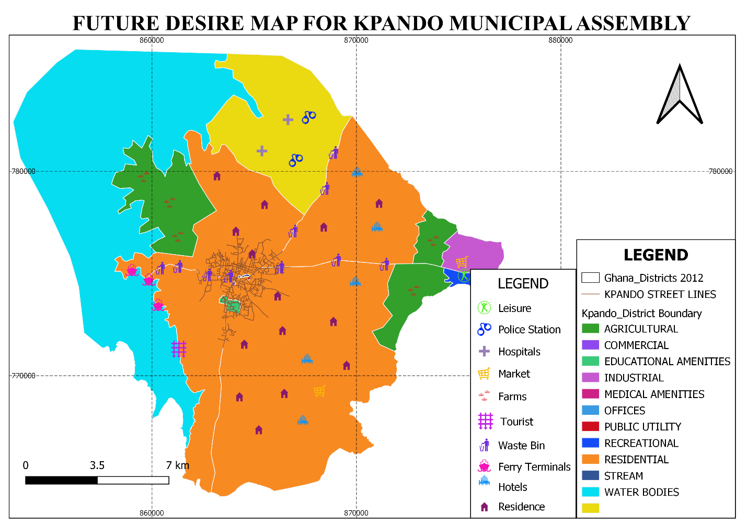Source: Municipal Physical Planning Department.

3.4 Strategic Environmental Impact Assessment of the Plan
Having set the objectives, they were measured against a set of criteria namely, livelihood, health, vulnerability/ climate change as well as institutional issues in a compound matrix. Kpando Municipal Assembly’s objectives.
The identified broad activities were applied to various elements of the environment namely; natural resources, social and cultural conditions, economy and institutional issues. The intention is to identify areas of conflict in order to implement an environmentally sustainable plan to achieve a green, prosperous and sustainable development. A separate report has been prepared for the Strategic Environmental Assessment.
Where there are indications of negative impacts on the environments, efforts to curb them have been estimated and included in the planned activities. They include public education, behavioral change programmes as well as landscaping and tree planting for physical projects.

3.5 Summary of the Chapter
This chapter emphasized on projection for facilities to match the population within the planning period. It categorically shows development goals, objectives and strategies to attain these development issues while identifiable environmental sustainability issues to ensure sustainable development.

4.0 CHAPTER FOUR
COMPOSITE DEVELOPMENT PROGRAMMES

4.1 Introduction
This part of the Plan focuses not only on Programme of Action (PoA) for the Four-Year Plan, but also contains Strategic Environmental Impact Assessment of the prioritized development Programme, Financial, Spatial and Structure Plan for the Planned Period.
Kpando Municipal Assembly has adopted relevant programmes and sub-programmes that can fit well to address all the developmental needs identified in line with the PBB. A composite Programme of Action (POA) covering the four years was formulated based on the goals, objectives programmes and sub-programmes, time frame and cost. It also shows programme status and implementing institution or department. The needs of the electoral and zonal council areas informed the preparation of the POA within the four years with the aim of solving the development lapses identified. Also, national and spatial impacts were identified while taking cognizance of revenue inflows. Mitigation measures for addressing environmental issues in the SEA have been integrated into all the final priority programmes and the specific source of funding has been indicated, that is IGF, GoG or others.

Table 4.1 Programme of Action (2022-2025)
Objectives | Programme (PBB) | Sub-Programme (PBB) | Timeframe  (Year) |  |  |  | Cost |  |  |  |  |  | Programme Status |  | Implementing Inst./Dept.
Objectives | Programme (PBB) | Sub-Programme (PBB) | 22 | 23 | 24 | 25 | GoG | IGF |  |  | Others |  | New | Ongoing | Lead | Collabo
Goal: Build an Economically Viable Local Economy
To support SMEs in business development | Economic Development | Trade, Industry and Tourism Services | X | x | x | x | 292,000.00 | 118,600.00 |  |  |  |  |  | x | NBSSI | CA & MPUC
To diversify and expand the tourism industry for economic development | Economic Development | Trade, Industry and Tourism Services | X | x | x | x | 364,000.00 |  |  |  |  |  | x |  | NBSSI | CA & MPUC
Improve production efficiency and yield | Economic Development | Agric Services and Management | X | x | x | x | 275,000.00 | 160,000.00 |  |  |  |  |  | x | Agric Dept. | Central Admin
Modernize and enhance agricultural production systems | Economic Development | Agric Services and Management | X | x | x | x | 140,000.00 |  |  | 420,000.00 |  |  | x |  | Agric Dept. | Central Admin
Create an enabling agribusiness environment | Economic Development | Trade, Industry and Tourism Services | X | x | x | x | 215,000.00 | 180,000.00 |  |  |  |  |  | x | BAC/NBSSI | Central Admin
Improve post-harvest management | Economic Development | Agric Services and Management | X | x | x | x | 496,000.00 | 140,000.00 |  |  |  |  |  | x | Agric Dept. | Central Admin
To provide modern market facilities | Economic Development | Agric Services and Management | X | x | x | x | 880,000.00 | 148,000.00 |  |  |  |  | x |  | Agric Dept. | MWD
To promote livestock and poultry development for food security and incomes | Economic Development | Agric Services and Management | X | x | x | x | 740,000.00 | 184,000.00 |  | 416,000.00 |  |  | x |  | Agric Dept. | Central Admin
Goal: Enhance Human Capital Development and Social Protection
To reduce new cases of communicable diseases | Social Services Delivery | Public Health Services and Mgt | X | x | x | x | 2,172,000.00 |  | 60,000.00 |  |  |  | x |  | MHD | Central Admin
To improve access to quality educ at all levels | Social Services Delivery | Educ, Youth & Sports and Lib Serv | X | x | x | x | 3,640,000.00 |  | 90,360.00 |  |  |  | x |  | MED | MWD
Promote inclusive education | Social Services Delivery | Education, youth & sports and Library services | X | x | x | x | 155,000.00 |  | 60,000.00 |  |  |  |  | x | MED | Central Admin
Promote literacy and lifelong learning | Social Sp;ervices Delivery | Education, youth & sports and Library services | X | x | x | x | 285,000.00 |  | 64,000.00 |  |  |  |  | x | MED | Central Admin
Strengthen healthcare delivery management system | Social Services Delivery | Public Health Services and management | X | x | x | x | 360,000.00 |  | 84,000.00 |  |  |  | x |  | MHD | Central Admin.
Reduce disability, morbidity, and mortality | Social Services Delivery | Public Health Services and management | X | x | x | x | 95,000.00 |  | 56,000.00 |  |  |  | x |  | MHD | Central Admin
Reduce the incidence of new HIV, AIDS/STIs and other infections, especially among vulnerable groups | Social Services Delivery | Public Health Services and management | X | x | x | x | 164,000.00 |  | 36,800.00 |  |  |  | x |  | MHD | Central Admin.
Promote nutrition specific and sensitive programmes and interventions | Social Services Delivery | Public Health Services and management | X | x | x | x | 376,000.00 |  |  |  |  |  | x |  | MHD | Central Admin
Reduce non-communicable diseases | Social Services Delivery | Public Health Services and management | X | x | x | x | 198,000.00 |  | 44,000.00 |  |  |  | x |  | MHD | Central Admin
To increase access to health services delivery | Social Services Delivery | Public Health Services and Mgt | X | x | x | x | 244,000.00 |  | 60,000.00 |  |  |  | x |  | MHD | Central Admin
To improve envtl san services and management | Social Services Delivery | Envtl Health and Sanitation Services | X | x | x | x | 412,000.00 |  | 62,240.00 |  |  |  |  | x | MEHU | Central Admin
To provide skin bins for the communities | Social Services Delivery | Envtl Health and Sanitation Services | X | x | x | x | 110,640.00 |  |  |  |  |  | x |  | MEHU | MPPD  MWD
Improve access to safe, reliable and sustainable water supply services for all | Social Services Delivery | Environmental Health and sanitation Services | X | x | x | x | 145,600.00 |  | 36,000.00 |  |  |  |  | x | MEHU | Central Admin.
Promote efficient and sustainable waste water management | Social Services Delivery | Environmental Health and sanitation Services | X | x | x | x | 140,000.00 |  |  |  |  |  |  | x | MEHU | Central Admin.
To strengthen child protection. & Family welfare systems | Social Services Delivery | Social Welfare and Comm. Services | X | x | x | x | 170,400.00 |  | 32,000.00 |  |  |  | x |  | SW&CD | Gender Desk Off
To promote gender equality all levels of decision-making and devt | Social Services Delivery | Social Welfare and Comm. Services | X | x | x | x | 118,400.00 |  | 38,600.00 |  |  |  | x |  | SW&CD | Central Admin
Enhance the wellbeing and inclusion of the aged in national development | Social Services Delivery | Social Welfare and community services | X | x | x | x | 165,000.00 |  | 48,000.00 |  |  |  |  | x | SW&CD | CA & Gender Desk Officer
Promote economic empowerment particularly for women | Social Services Delivery | Social Welfare and community services | X | x | x | x | 124,000.00 |  | 22,000.00 |  |  |  |  | x | SW&CD | Gender Desk Officer
To strengthen social protection for the vulnerable | Social Services Delivery | Social Welfare and Comm. Services | X | x | x | x | 185,000.00 |  | 35,000.00 |  |  |  |  | x | SW&CD | Gender Desk Officer
To promote the full part. of PWDs in socio-eco devt | Social Services Delivery | Social Welfare and Comm. Services | X | x | x | x | 620,000.00 |  |  |  |  |  |  | x | SW&CD | Central Admin
To promote the creation of decent jobs through apprenticeship & voc. Training | Social Services Delivery | Social Welfare and Comm. Services | X | x | x | x | 186,500.00 |  | 60,000.00 |  |  |  |  | x | SW&CD | Culture  BAC
Goal: Create a Resilient Natural and Human Settlement
To promote climate change resilience | Environmental Management | Disaster Prevention and Mgt | X | x | x | x | 960,800.00 |  | 280,000.00 |  |  |  |  | x | Agric Dept. | Central Admin
To improve plng for disas prev. and mitigation | Environmental Management | Disaster Prevention and Mgt | X | x | x | x | 672,600.00 |  | 184,000.00 |  |  |  |  | x | NADMO | Central Admin
Promote sustainable water resources development and management | Environmental Management | Natural Resource Conservation and Management | X | x | x | x | 620,000.00 |  | 280,000.00 |  |  |  |  | x | NADMO | Central Admin
To improve effic & effect. of road infra & serv | Infra Deliv & Mgt | Urban Roads and Transport Services | X | x | x | x | 4,340,000.00 |  | 360,000.00 |  |  |  | x |  | MWD | Central Admin
To improve security through street lighting | Infra Deliv & Mgt | Public Works, Rural Hous. & Water Mgt | X | x | x | x | 4,120,000.00 |  | 540,800.00 |  |  |  |  | x | MWD | Central Admin
To promote sustainable, spatially integrated, balance and orderly physical development | Infra Deliv & Mgt | Spatial Planning | X | x | x | x | 986,800.00 |  | 148,320.00 |  |  |  |  | x | MPPD | MWD  NADMO
Goal: Ensure Inclusive Governance for All
To deepen participation in the decentralized process | Management & Administration | General Administration | X | x | x | x | 1,980,500.00 |  | 282,500.00 |  |  |  |  | x | Central Admin | Other Depts.
To improve efficiency in IGF mobilization efforts | Management & Administration | Finance | X | x | x | x | 984,000.00 |  | 320,000.00 |  |  |  |  | x | MFD | Central Admin
To increase the active part of women in governance at all level | Management & Administration | Planning, Budgeting, M & E | X | x | x | x | 660,040.00 |  | 166,400.00 |  |  |  | x |  | Central Admin | SW&CD
To improve the capacity of staff of the Assembly | Management & Administration | Human Resource | X | x | x | x | 560,000.00 |  | 172,800.00 |  |  |  |  | x | HRD | Central Admin
To provide adequate residence & office accommodation for staff | Management & Administration | Human Resource | X | x | x | x | 880,000.00 |  | 192,600.00 |  |  |  |  | x | HRD | MWD
Implementation, Monitoring and Evaluation
To strengthen the planning, budgeting, M&E systems | Management & Administration | Planning, Budgeting, M & E | X | x | x | x | 680,400.00 | 260,000.00 |  |  |  |  | x |  | Central Admin | Other Depts.

Figure 4.1: Graphical representation of 2022 MTDP Projects and Activities
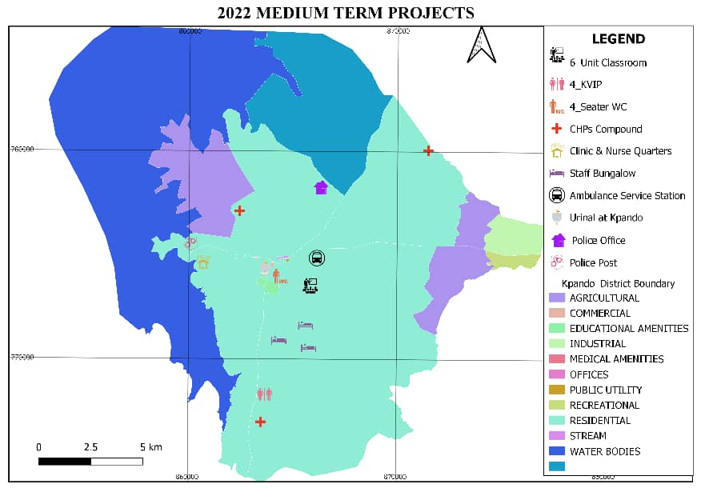Source: MPCU KpMA 2021

Figure 4.2: Graphical representation of 2023 MTDP Projects and Activities
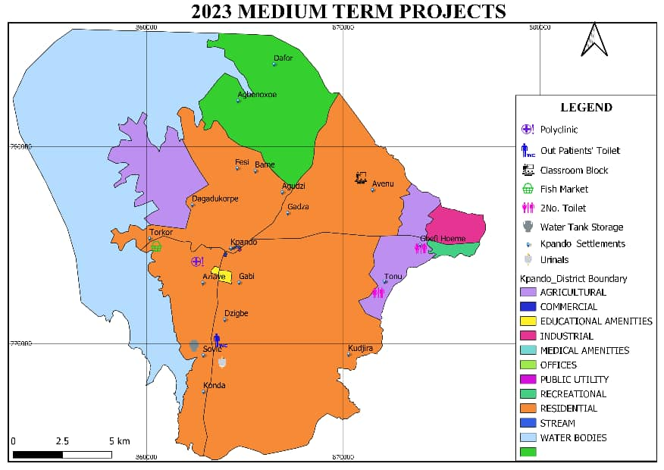Source: MPCU, KpMA 2021

Figure 4.3: Graphical representation of 2024 MTDP Projects and Activities
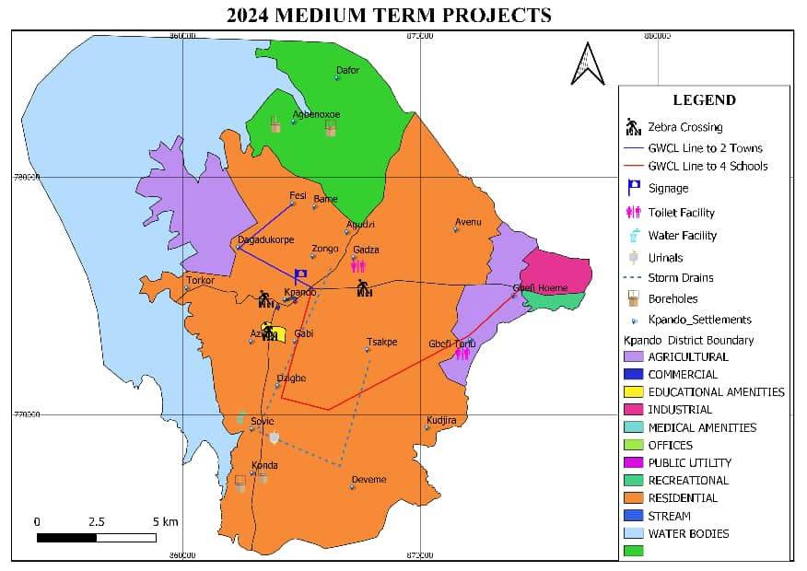Source: MPCU, KpMA 2021

Figure 4.4: Graphical representation of 2025 MTDP Projects

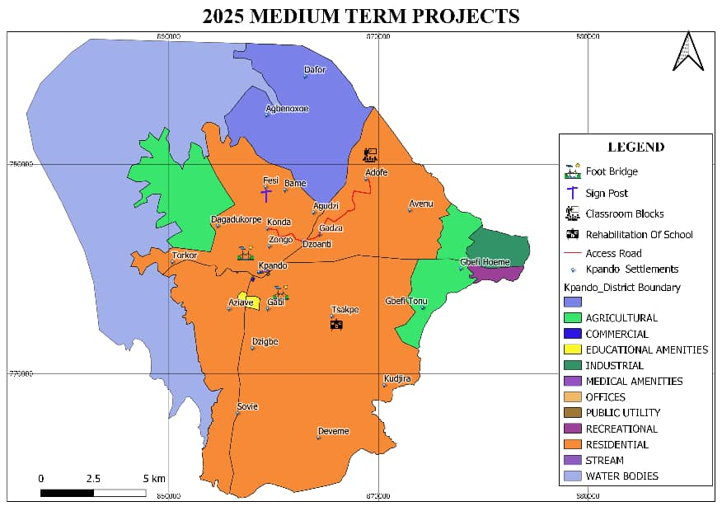

Source: MPCU, KpMA 2021

4.2 Assumptions and Methodologies for Costing
The first, is the availability of land for physical projects, the flow of resources, especially those from external sources and the general economic conditions prevailing in the economy. First, all ongoing activities were considered together with mandatory projects to be implemented towards achieving the stated goals.
The costing was also done based on current prices which were projected over the years and relative to the prevailing inflation rate. The next had to do with the duration of the particular project and the flow of resources to execute same. The broad activities were broken down and costed individually, after which the individual costs are merged to obtain a single figure per activity. The cost of the total plan is obtained after all cost for the years is obtained. The activities were subsequently phased out based on prioritization.

4.3 Programmes Financing
The Programme of Action (PoA) will be funded from GoG, IGF or Donors. The Annual Action Plan for 2022 can be found in Table 5.1 while that for 2023, 2024 and 2025 can be found in Tables 5.2, 5.3 and 5.4 respectively. Table 4.2 shows the total cost of implementation of the four-year plan per the outlined programmes of the Municipality. The total amount needed for the plan implementation is GH¢40,720,700.00. The expected total revenues from GoG is GH¢885,900.00, IGF is GH¢3,860,900.00, DACF is GH¢20,914,300.00, DACF-RFG is GH¢11,207,100 and Donor stand at GH¢689,600 respectively making a total of GH¢37,557,800.00 The difference therefore stands at GH¢3,162,900.00 revenue mobilization strategies would include;
- Continue the valuation and revaluation of taxable properties,
- Improvement in IGF collection with the use of ICT and task force
- Keeping a proper and updated revenue database,
- Institute a reward system for collectors,
- Prosecution of defaulters,
In order to maintain a regular balance between revenue and expenditure, management would ensure that expenditure falls within the budget estimates. Again, IGF would be used when GoG and other funds are not released.

Figure 4.1 Estimated Revenue Source for the Plan Implementation

Source: Mpcu-KpMA, 2021

Table 4.2 Indicative Financial Strategy
Development Dimension | Programme (PBB) | Programme  Cost | Expected Revenue & Source of Funding |  |  |  |  | Total | Gap | Mechanisms to Fill Gap
Development Dimension | Programme (PBB) | Programme  Cost | GoG | IGF | DACF | DACF-RFG | DPs | Total | Gap | Mechanisms to Fill Gap
Economic | Economic  Development | 5,168,600.00 | 190,600.00 | 630,400.00 | 1,930,400.00 | 930,000.00 | 689,600.00 | 4,371,000.00 | 797,600.00 | - Revaluation of taxable properties  - Retraining of revenue staff  - Regularly update revenue database  - Use of ICT in collection  - Reward system for collectors  - Prosecution of defaulters
Social | Social Services  Delivery | 10,919,540.00 | 180,500.00 | 534,000.00 | 6,234,500.00 | 3,456,700.00 | - | 10,405,700.00 | 513,840.00
Environment, Infrastructure and Human Settlement | Environmental  Management | 4,997,400.00 | 120,000.00 | 620,000.00 | 2,689,400.00 | 900,000.00 | - | 4,329,400.00 | 668,000.00
Environment, Infrastructure and Human Settlement | Infrastructure  Delivery and  Management | 12,495,920.00 | 184,800.00 | 950,000.00 | 5,860,000.00 | 4,980,400.00 |  | 11,975,200.00 | 520,720.00
Governance, Corruption and Public Accountability,  Implementation, Coordination, M&E | Management and  Administration | 7,139,240.00 | 210,000.00 | 1,126,500.00 | 4,200,000.00 | 940,000.00 |  | 6,476,500.00 | 662,740.00
Total |  | 40,720,700.00 | 885,900.00 | 3,860,900.00 | 20,914,300.00 | 11,207,100 | 689,600 | 37,557,800.00 | 3,162,900.00
Source: MPCU – KPANDO MUNICIPAL, 2021

Figure 4.1 shows the locations of the proposed projects to be implemented within the planned period.
Figure 4.1 Proposed Projects in KpMA from 2022 to 2025

4.4 Summary of the Chapter.
This chapter summarized the assumption and methodology used for costing the goals, objectives, strategies and finally ends the chapter with the finding sources for all the programmes outlined in the table.

CHAPTER FIVE

ANNUAL ACTION PLAN OF KPANDO MUNICIPAL ASSEMBLY

5.0 Introduction
This chapter follows from the development programmes in the previous chapter which covers the entire planning period. The 2022 Annual Action Plan has been detailed out in this chapter together with those for 2023, 2024 and 2025. It shows the Annual Action Plan developed as a basis for the Budget as well as provides information for physical planning.

5.1 Annual Action Plan Developed as a Basis of the Municipal Assembly Budget
The composite POA has been faced out into composite AAPs to be implemented by the Assembly in collaboration with stakeholders. These AAPs are SMART (G), meaning they are Specific, Measurable, Achievable, Realistic and Relevant as well as Time-bound. The (G) components also ensures that the gender dimensions of development have been adequately catered for. This includes activities for monitoring and evaluation as well as communication. Again, it includes efforts made at attaining a green economy where all physical projects come with landscaping to control the negative effects of construction on the environment. Moreover, a maintenance plan has been attached as Annex 3 with the intention of improving the Assembly’s culture of maintenance of assets and infrastructure.
The Action Plans for the various years has been added. The AAPs will be the first in the preparation of Annual Budget Estimates to be followed by the preparation of the procurement plan before the budget will be uploaded onto the Ghana Integrated Financial Management Information System (GIFMIS) before expenditure on projects can be made.
The components of the Annual Action Plan which can be found in Table 5.1 are the programmes and sub-programmes of Kpando Municipal Assembly, the broad activities with their locations, quarterly time schedules as well as the cost involved. It spells out the source of funds for the project, whether from IGF, GOG or a Donor. It highlights the implementing agency and the collaborating departments.

Table 5.1 Annual Action Plan 2022
No | Programme (PBB) | Sub-Programme  (PBB) | Broad Activities | Location | Timeframe |  |  |  | Cost |  |  | Programme Status |  | Implementing Institution/Dept.
 |  |  |  |  | 1Q | 2Q | 3Q | 4Q | GoG | IGF | Others | New | Ongoing | Lead | Collabo
 | Economic Dev’t | Trade, Indus. and Tourism Serv | Organize 1No tourism promotion event | Municipal Wide | x | x | x | X |  | 5,000.00 |  |  | x | BAC | MPCU
 | Economic Dev’t | Trade, Indus. and Tourism Serv | Community base training in value addition, marketing and customer relation | Municipal wide | x |  |  |  | 3,000.00 | 5,000.00 |  | X |  | BAC | MPCU
 | Economic Dev’t | Trade, Indus. and Tourism Serv | Promote Volta Trade and Investment Fair | Municipal Wide |  |  |  | x | 23,000.00 | 7,890.00 |  | X |  | BAC | MPCU
 | Economic Dev’t | Trade, Indus. and Tourism Serv | Community base training in soap & Dettol making, cosmetic, pomade, powder & bleach | Municipal wide | x | x | x | X | 5,000.00 | 4,000.00 |  | X |  | BAC | DDA
 | Economic Dev’t | Trade, Indus. and Tourism Serv | Community Based Training in Value Addition | Municipal Wide | x | x | x | X | 6,000.00 |  |  | X |  | BAC | MPCU
 | Economic Dev’t | Trade, Indus. and Tourism Serv | Support cultural activities to promote domestic tourism | Municipal Wide | x | x | x | X | 7,000.00 |  |  |  | x | BAC | MPCU
 | Economic Dev’t | Trade, Indus. and Tourism Serv | Promote Marketing and Customer Relation | Municipal Wide | x | x | x | X | 7,500.00 |  |  |  | x | BAC | MPCU
 | Economic Dev’t | Agricultural Serv and Mgt | Enhanced farmers’ access to agricultural inputs (fertilizer, agro-chemicals and veterinary medicines) | Municipal Wide | x | x | x | X | 3,000.00 | 5,000.00 |  |  | x | Dept. of Agriculture | AEAs
 | Economic Dev’t | Agricultural Serv and Mgt | Enhanced farmers' access to improved technology | Municipal Wide | x | x | x | x | 10,000.00 |  | 10,000.00 |  | x | Dept. of Agriculture | AEAs
 | Economic Dev’t | Agricultural Serv and Mgt | Organize stepdown trainings and train staff and MDA on extension management | Trade Fair |  |  |  | x | 2,500.00 | 3,000.00 | 10,000.00 | x |  | Dept. of Agriculture | AEAs
 | Economic Dev’t | Agricultural Serv and Mgt | Facilitate farmers to access seeds and planting materials under planting for food and jobs programmes. | Municipal Wide | x | x | x | x | 2,000.00 |  |  | x |  | Dept. of Agriculture | AEAs
 | Economic Dev’t | Agricultural Serv and Mgt | Improved preparation of annual crop budget for major crops | Municipal Wide | x | x | x | x | 5,000.00 |  |  | x |  | Dept. of Agriculture | AEAs
 | Economic Dev’t | Agricultural Serv and Mgt | Staff (AEAs, District Extension Officers, District Crops Officers; etc) trained on PFJ modalities and good agricultural practices (GAPs) | Municipal Wide |  | x |  | x |  | 3,000.00 |  | X |  | Dept. of Agriculture | AEAs
 | Economic Dev’t | Agricultural Serv and Mgt | Procure office logistics (Vehicle, motorbikes and computers | Municipal Wide | x | x | x | x | 120,000.00 |  | 100,000.00 |  | x | Dept. of Agriculture | AEAs
 | Economic Dev’t | Agricultural Serv and Mgt | Train farmers on post-harvest management to value chain actors | Municipal Wide | x | x | x | x | 10,000.00 |  |  | x |  | Dept. of Agriculture | AEAs
 | Economic Dev’t | Agricultural Serv and Mgt | Build the capacity of Agric Extension Agents, and also Enhance Farmers Access to Improve Technology | Municipal Wide | x | x | x | x | 5,000.00 |  | 5,000.00 | X |  | Dept. of Agriculture | AEAs
 | Economic Dev’t | Agricultural Serv and Mgt | Build the capacity of Fall Army Worm Spraying Gangs | Municipal Wide |  |  | x |  | 5,000.00 | 5,000.00 |  | x |  | Dept. of Agriculture | AEAs
 | Economic Dev’t | Agricultural Serv and Mgt | Train farmers on the production of mushroom especially youth and women | Municipal Wide |  |  | x |  | 5,000.00 |  |  | x |  | Dept. of Agriculture | AEAs
 | Economic Dev’t | Agricultural Serv and Mgt | Fortification of cassava products using orange flesh sweet potato | Municipal Wide |  | x |  |  | 600.00 | 500.00 | 12,000.00 | X |  | Dept. of Agriculture | AEAs
 | Economic Dev’t | Agricultural Serv and Mgt | Enhanced surveillance and prevention of plant pest and diseases | Municipal Wide | x | x | x | x |  |  | 15,000.00 |  | x | Dept. of Agriculture | AEAs
 | Economic Dev’t | Agricultural Serv and Mgt | Train farmer groups on Smart agriculture or Conservation Agriculture in 4 zones | Municipal Wide |  | x |  | x | 6,000.00 |  | 14,000.00 |  | x | Dept. of Agriculture | AEAs
 | Economic Dev’t | Agricultural Serv and Mgt | Promote integrated soil fertility management practices (ISFM) to men and women farmers | Municipal Wide |  | x | x |  | 10,000.00 | 6,000.00 |  | X |  | Dept. of Agriculture | AEAs
 | Economic Dev’t | Agricultural Serv and Mgt | Establish model nursery on tree crop for PERD | Municipal Wide | x | x | x | x | 47,000.00 | 3,000.00 |  |  | x | Dept. of Agriculture | AEAs
 | Economic Dev’t | Agricultural Serv and Mgt | Organize and train agro input dealers on safe handling of agrochemicals | Municipal Wide | x | x | x | x | 2,500.00 |  | 5,000.00 |  | X | Dept. of Agriculture | AEAs
 | Social Serv. Delivery | Educ., Youth & Sports and Libr. Services | Provide sponsorship/bursaries to needy but brilliant pupils, & support my first day at school programmes | Municipal Wide | x | x | x | x | 30,000.00 | 5,000.00 |  |  | x | CA | GES
 | Social Serv. Delivery | Educ., Youth & Sports and Libr. Services | Support MEOC monitoring activities & STEM programmes | Municipal Wide | x | x | x | x | 10,000.00 | 35,000.00 |  |  | x | GES | CA
 | Social Serv. Delivery | Educ., Youth & Sports and Libr. Services | Support district sports and cultural festivals | Municipal Wide | x | x | x | x | 10,000.00 | 15,000.00 |  | X |  | GES | CA
 | Social Serv. Delivery | Educ., Youth & Sports and Libr. Services | Supply of 750 mono desks to Public Schools in the Municipality. | Municipal Wide | x | x | x | x |  |  | 271,050.00 |  | x | GES | CA
 | Social Serv. Delivery | Educ., Youth & Sports and Libr. Services | Increase enrolment in basic schools particularly in disadvantaged communities | Municipal Wide | x | x | x | x | 1,000.00 | 2,000.00 |  |  | x | GES | SW/CD
 | Social Serv. Delivery | Educ., Youth & Sports and Libr. Services | Management of COVID-19 (PPEs) in schools | Municipal Wide | x | x | x | x | 12,000.00 | 13,000.00 |  |  | x | GES | GHS
 | Social Serv. Delivery | Educ., Youth & Sports and Libr. Services | Improve learning environment through health & sanitation, child protection, guidance and counselling in basic schools | Municipal Wide | x | x | x | x |  |  | 12,000.00 |  | X | GES | SW/CD
 | Social Serv. Delivery | Educ., Youth & Sports and Libr. Services | Construction of 6-unit classroom block with ancillary facilities at Gabi Primary School | Gabi | x | x | x | x | 572,132.21 |  |  |  | X | GES | MWD
 | Social Serv. Delivery | Educ., Youth & Sports and Libr. Services | Completion of 4-seater WC at English & Arabic School at Kpando, and 4-KVIP at Sovie Konda Basic Sch. | Kpando-Zongo and Sovie-Konda | x | x | x | x | 36,690.00 | 37,416.83 |  |  | X | GED | MWD
 | Social Serv. Delivery | Educ., Youth & Sports and Libr. Services | Complete Final Payment for 1No. 3Units classroom block constructed at Agbenorxoe and Gbefi Maternity block | Agbenorxoe & Gbefi | x | x | x | x | 26,380.16 | 11,943.90 |  |  | X | GES | MWD
 | Social Serv. Delivery | Public Health Services and management | Completion of Sovie & Kpando-Dzigbe CHPS Compound | Sovie & Dzigbe | x | x | x | x | 40,860.66 | 481,681.70 |  |  | X | MWD | GHS
 | Social Serv. Delivery | Public Health Services and management | Construction of CHPs compound at Adofe | Adofe | x | x | x | x | 620,513.29 |  |  | x |  | MWD | GHS
 | Social Serv. Delivery | Public Health Services and management | Completion of Torkor Clinic & Nurses Quarters | Torkor | x | x | x | x | 76,328.29 | 45,198.74 |  |  | X | MWD | GHS
 | Social Serv. Delivery | Public Health Services and management | Conduct 2No. Integrated Supportive Supervision | Municipal Wide | x | x | x | x | 13,000.00 |  |  | x |  | GHS | CA
 | Social Serv. Delivery | Public Health Services and management | Orientation for CHNs/CHOs, Prescribers & Chemical Sellers on TB case detection & Management | Municipal Wide | x | x | x | x |  |  | 5,675.00 | x |  | GHS | CA
 | Social Serv. Delivery | Public Health Services and management | Train CHNs /CHOs in Health Promotion Activities & Reporting | Municipal Wide |  | x |  |  |  | 3,652.00 |  | x |  | GHS | CA
 | Social Serv. Delivery | Public Health Services and management | Organize training for Midwives & Nurses on Anemia control & management | Municipal Wide |  | x | x |  |  |  | 33,700.00 | x |  | GHS | CA
 | Social Serv. Delivery | Public Health Services and management | Train prescribers on surveillance for diseases | Municipal Wide | x | x | x | x |  |  | 5,925.00 |  | X | GHS | CA
 | Social Serv. Delivery | Public Health Services and management | Intensify HIV/AIDs & COVID-19 control programs | Municipal wide | x | x | x | x | 12,000.00 | 10,000.00 |  |  | X | GHS | CA
 | Social Serv. Delivery | Social Welfare and Comm. Serv | Training of women groups on financial management | Municipal Wide | x | x | x | x | 3,000.00 | 1,000.00 | 2,000.00 | X |  | DSW&CD | NBSSI, NCCE
 | Social Serv. Delivery | Social Welfare and Comm. Serv | Payment of LEAP Grant to Beneficiaries and monitoring of beneficiaries | Municipal Wide | x | x | x | x | 1,000.00 | 4,000.00 | 3,000.00 |  | x | DSW&CD | CA, Weto Rural Bank (PFI)
 | Social Serv. Delivery | Social Welfare and Comm. Serv | Support PWDs with start-up capital, training skills and monitor their activities. | Municipal Wide | x | x | x | x | 180,000.00 |  |  |  | x | DSW&CD | MOFA, NBSSI, CA, CD
 | Social Serv. Delivery | Social Welfare and Comm. Serv | Handling of child custody, child abuse, child maintenance and paternity cases, and formation of community child protection committees | Municipal Wide | x | x | x | x | 1,900.00 | 4,000.00 | 10,000.00 |  | X | DSW&CD | GPS, CHRAJ, Judicial Service.
 | Social Serv. Delivery | Social Welfare and Comm. Serv | Supervise and monitoring of early Childhood Development Centers and Monitoring of Rescued Trafficked/ Child Laborer’s | Municipal Wide |  | x | x |  | 1,500.00 | 3,000.00 | 7,000.00 |  | X | DSW&CD | NGO’s, Assembly Members
 | Social Serv. Delivery | Social Welfare and Comm. Serv | Community sensitization on the effects of early child marriage and the effects of domestic violence on the child, the family and the Community | Municipal wide | x | x | x | x | 1,500.00 | 4,000.00 | 10,000.00 |  | X | DSW&CD | GPS, GES, CHRAJNCCE, Assembly Members
 | Social Serv. Delivery | Social Welfare and Comm. Serv | Monitoring of residential Homes for children, reunified children & Foster parents in the Municipality | Municipal Wide | x | x | x | x | 10,000.00 | 10,000.00 | 10,000.00 | X |  | DSW&CD | Chiefs, RHCs, Foster Parents
 | Social Serv. Delivery | Social Welfare and Comm. Serv | Provide economic and skill empowerment to women | Municipal Wide | x | x | x | x | 10,000.00 | 10,000.00 | 5,000.00 |  | x | Social Dev't Unit | BAC
 | Social Serv. Delivery | Social Welfare and Comm. Serv | Awareness creation on women participation in governance issues | Municipal Wide | x | x | x | x | 3,000.00 | 4,000.00 | 3,000.00 |  | x | DSW&CD | Chiefs, NGO, NBSSI
 | Social Serv. Delivery | Social Welfare and Comm. Serv | Celebration of Internationally Observed Days | Municipal Wide | x | x | x | x | 10,000.00 | 10,000.00 | 10,000.00 |  | x | DSW&CD | CA
 | Social Serv. Delivery | Envtal Health & San. Serv | Organize monthly community environmental sanitation clean-up exercise | Municipal Wide | x | x | x | x |  | 1,000.00 |  |  | X | MEHU | Dep't of Comm. Dev't
 | Social Serv. Delivery | Envtal Health & San. Serv | Facilitate the screening of 200 food and drink vendors & also Inspect at least 10 hospitality industries | Municipal wide | x | x | x |  |  | 1,000.00 |  |  | x | MEHU | Dep't of Comm. Dev't
 | Social Serv. Delivery | Envtal Health & San. Serv | Facilitate the repairs & maintenance of cesspool emptier | Municipal Wide | x | x | x | x | 1,000.00 | 3,000.00 |  |  | X | MEHU | Dep't of Comm. Dev't
 | Social Serv. Delivery | Envtal Health & San. Serv | Review and update MESAP | Municipal Wide |  | x |  |  | 30,000.00 | 50,000.00 |  |  | X | MEHA | SHEP
 | Social Serv. Delivery | Envtal Health & San. Serv | Support COVID-19 programs, and intensify the implementation of CLTS activities | Municipal wide |  | x |  |  | 1,500.00 |  |  |  | x | MEHA | MPCU
 | Social Serv. Delivery | Envtal Health & San. Serv | Conduct arrest of stray animals and also procure insecticide & other consumables | Municipal Wide | x | x | x | x | 16,500.00 | 15,000.00 |  |  | X | MEHU | Dep't of Comm. Dev't
 | Social Serv. Delivery | Envtal Health & San. Serv | Ensure the repair of public waste containers & refuse vehicle | Municipal wide |  |  | x |  | 13,000.00 | 7,000.00 |  |  | X | MEHU | Dep't of Comm. Dev't
 | Envtal Mgt | Disaster Prev. & Mgt | Support public education on prevention and control of diseases and epidemics | Municipal Wide |  |  | x | x | 15,000.00 |  |  |  | X | NADMO | NCCE
 | Envtal Mgt | Disaster Prev. & Mgt | Organize capacity building program for staff and activation of fire volunteer groups | Municipal Wide | x | x | x | x | 18,000.00 | 10,000.00 |  | x |  | NADMO | CA
 | Envtal Mgt | Disaster Prev. & Mgt | Intensify public education on climate change, fire disaster and control mechanisms as well as encourage tree planting exercise in the Municipality | Municipal Wide | x | x | x | x | 34,000.00 | 15,000.00 |  |  | X | NADMO | CA
 | Infra. Deliv. and Mgt | Spatial Planning | Strengthen human, institutional and legal reforms in land planning | Municipal Wide | x | x | x | x |  |  | 27,220.00 |  | X | MPPD | MPCU
 | Infra. Deliv. and Mgt | Spatial Planning | Streamline Spatial and land use planning system | Municipal Wide | x | x | x | x | 27,220.00 |  |  |  | X | MPPD | MPCU
 | Infra. Deliv. and Mgt | Spatial Planning | Scale up the Street naming and property addressing system | Municipal wide | x | x | x | x | 32,000.00 | 32,220.00 |  |  | X | MPPD | MPCU
 | Infra. Deliv. and Mgt | Spatial Planning | Repair of 150 nonfunctional streetlights in the Municipality | Municipal wide | x | x | x | x | 30,000.00 |  |  | x |  | MPPD | MWD
 | Infra. Deliv. and Mgt | Urban Roads & Transport Serv. | Reshaping & graveling of 15km selected roads in Kpando | Kpando | x | x | x | x | 150,000.00 |  |  | X |  | MWD | Urban Roads
 | Infra. Deliv. and Mgt | Urban Roads & Transport Serv. | Grading & patching of 15km selected roads | Selected Communities | x | x | x | x | 60,000.00 | 45,000.00 |  | x |  | MWD | Urban Roads
 | Infra. Deliv. and Mgt | Urban Roads & Transport Serv. | Opening of access road to Sovie-Tornu, and supply of construction materials to Gbefi Tornu steel bridge work | Sovie-Tornu & Gbefi Tornu | x | x | x | x | 572,132.21 |  |  | x |  | MWD | Urban Roads
 | Infra. Deliv. and Mgt | Urban Roads & Transport Serv. | Construction of 2×2m box culvert on Abanu-Dzoanti access road | Abanu-Dzoanti | x | x | x | x | 543,529.86 |  |  | x |  | MWD | Urban Roads
 | Infra. Deliv. and Mgt | Public Works, Rur, Housing & Water Mgt | Renovation of 3No.staff bungalows | Kpando | x | x | x | x | 200,000.00 |  |  |  | X | MWD | CA
 | Infra. Deliv. and Mgt | Public Works, Rur, Housing & Water Mgt | Construction of urinal at Kpando Municipal Assembly compound | Kpando | x | x | x | x | 10,000.00 |  |  | x |  | MWD | MEHU
 | Infra. Deliv. and Mgt | Public Works, Rur, Housing & Water Mgt | Completion of ambulance service station | Kpando | x | x | x | x | 91,394.10 |  |  |  | X | MWD | CA
 | Infra. Deliv. and Mgt | Public Works, Rur, Housing & Water Mgt | Extension of electricity to Kpando Market lockable stores | Kpando | x | x | x | x | 4,000.00 |  |  | X |  | MWD | CA
 | Infra. Deliv. and Mgt | Public Works, Rur, Housing & Water Mgt | Construction of Police Office with 4No. cells at Agudzi | Kpando – Agudzi | x | x | x | x | 500,925.00 |  |  |  | X | MWD | CA
 | Infra. Deliv. and Mgt | Public Works, Rur, Housing & Water Mgt | Completion of Torkor Police Post | Torkor | x | x | x | x | 50,968.00 |  |  |  | X | MWD | CA
 | Infra. Deliv. and Mgt | Public Works, Rur, Housing & Water Mgt | Drilling & mechanization of 2No. Boreholes and rehabilitation of 3No. existing boreholes | Selected Communities | x | x | x | x | 56,000.00 | 36,000.00 |  | X |  | MWD | CA
 | Mgt & Admin. | General Admin. | Support the celebration of national anniversaries and festivals | Municipal wide | x | x | x | x | 60,000.00 | 40,000.00 | 50,000.00 |  | X | Central Admi | MCE
 | Mgt & Admin. | General Admin. | Procurement of office supplies and consumables | Kpando | x | x | x | x | 20,000.00 | 28,500.00 | 10,000.00 |  | X | Central Admi | Stores
 | Mgt & Admin. | General Admin. | Strengthen the functioning of Sub-structures, and Completion of Gbefi zonal council office | Municipal Wide | x | x | x | x | 20,000.00 | 10,000.00 | 10,000.00 |  | x | Central Admi | MPUC
 | Mgt & Admin. | General Admin. | Maintenance of official vehicles & heavy-duty equipment | Kpando |  |  | x | x | 100,000.00 | 20,000.00 |  |  | X | Central Admi | TO
 | Mgt & Admin. | General Admin. | Support the security operations and implementation of National Anti-corruption activities | Municipal Wide | x | x | x | x | 9,000.00 | 10,000.00 |  |  | X | CHRAJ/Security Agencies | Central Admi
 | Mgt & Admin. | General Admin. | Support other decentralized departments | Municipal Wide | x | x | x | x | 30,000.00 | 10,000.00 | 10,000.00 | X |  | Central Admi | MPCU
 | Mgt & Admin. | General Admin. | Organize 4No. PFM Town Hall Meetings to interact with the Public on the Operations of the Assembly | Municipal Wide | x | x | x | x | 20,000.00 | 10,000.00 | 10,000.00 | X |  | Central Admi | MPCU
 | Mgt & Admin. | General Admin. | Organize General Assembly & all mandatory meetings of the Assembly | Municipal Wide | x | x | x | x | 40,000.00 | 28,000.00 | 32,000.00 | X |  | Central Admi | MPCU
 | Mgt & Admin. | Finance | Intensify supervision of all revenue collections & valuation of all fixed assets | Municipal Wide | x | x | x | x | 50,000.00 | 9,000.00 |  | X |  | MFD/Budget Unit | Revenue Unit
 | Mgt & Admin. | Finance | Collect data and update the Assembly's revenue register | Municipal Wide | x | x | x | x | 10,000.00 |  |  |  | X | MPCU/Budget Unit | Revenue Unit
 | Mgt & Admin. | Finance | Organize regular public education on rates/fees (Tax) payment consciousness | Municipal Wide | x | x | x | x |  | 5,000 |  |  | X | MPCU/Budget Unit | Revenue Unit
 | Mgt & Admin. | Finance | Facilitate the preparation and implementation of 2022 Revenue Improvement Action Plan (RIAP) | Municipal Wide | x | x | x | x |  | 10,000.00 |  |  | x | MPCU/Budget Unit | Revenue Unit
 | Mgt & Admin. | Planning, Budgeting, M&E | Preparation of Annual Action Plan, Annual Progress Report and Quarterly reports | Municipal wide | x | x | x | x | 20,000.00 | 15,000.00 |  |  | x | MPCU/Budget Unit | Mgt
 | Mgt & Admin. | Planning, Budgeting, M&E | Involve Civil Society in Fee Fixing, Annual Action Plans and Budgets preparations | Municipal wide | x | x | x | x | 40,000.00 |  |  | X |  | MPCU/Budget Unit | CSOs
 | Mgt & Admin. | Planning, Budgeting, M&E | Undertakes quarterly monitoring and evaluation of development projects | Municipal wide | x | x | x | x | 20,000.00 | 5,000.00 |  | X |  | MPCU | MWD
 | Mgt & Admin. | Planning, Budgeting, M&E | Build statistical Database for the Municipal Assembly | Kpando | x | x | x | x | 3,000.00 | 3,000.00 | 3,600.00 | X |  | Statistician | MPCU
 | Mgt & Admin. | Planning, Budgeting, M&E | Procurement of logistics (laptop, desktop, printer) & office consumables. | Kpando | x | x | x | x | 6,000.00 | 4,000.00 | 4,500.00 | x |  | Statistician | MPCU
 | Mgt & Admin. | Planning, Budgeting, M&E | Support market survey and allowances | Kpando and Torkor | x | x | x | x | 1,000.00 | 500.00 | 1,500.00 | x |  | Statistician | MPCU
 | Mgt & Admin. | Planning, Budgeting, M&E | Support for external training and allowances of staff | Kpando |  | x | x | x | 2,000.00 | 1,000.00 | 1,000.00 | x |  | Statistician | CA
 | Mgt & Admin. | Planning, Budgeting, M&E | Research to aid Municipal Assembly’s work | Municipal wide | x | x | x | x | 3,000.000 | 3,000.00 | 3,000.00 | X |  | Statistician | MPCU
 | Mgt & Admin. | Human Resource | Ensure effective operationalization of the client service unit | Kpando | x | x | x | x | 10,000.00 | 5,000.00 |  |  | X | HRD | Central Admin
 | Mgt & Admin. | Human Resource | Organize capacity building programmes for Assembly Members and staff in Local Governance procedures on committee meetings and reporting | Kpando |  | x | x |  |  | 10,000.00 |  |  | X | HRD | Central Admin
 | Mgt & Admin. | Human Resource | Organize capacity building programmes | Kpando | x |  | x |  | 17,000.00 | 14,000.00 |  |  | X | HRD | Central Admin
 | Mgt & Admin. | Human Resource | Organize end of year award programmes/rewards for staff | Kpando | x | x | x | x | 20,000.00 |  |  |  | X | HRD | Central Admin

Table 5.2 Annual Action Plan 2023
No | Programme (PBB) | Sub-Programme  (PBB) | Broad Activities | Location | Timeframe |  |  |  | Cost |  |  | Programme Status |  | Implementing Institution/Dept.
 |  |  |  |  | 1 | 2 | 3 | 4 | GoG | IGF | Others | New | Ongoing | Lead | Collabo
 | Economic Dev’t | Trade, Indus. and Tourism Serv | Organize basic Financial Management Training | Municipal Wide | x | x | x | x | 4,000.00 | 1,000.00 |  | x |  | BAC | MPCU
 | Economic Dev’t | Trade, Indus. and Tourism Serv | Promote skill training in Batik, Tie & Dye | Municipal wide | x | x | x | x | 3,570.00 | 3,000.00 |  | x |  | BAC | MPCU
 | Economic Dev’t | Trade, Indus. and Tourism Serv | Organize regular Fire prevention and fighting training for food vendors and market women | Municipal wide | x | x | x | x | 6,000.00 |  |  | x |  | BAC | DDA
 | Economic Dev’t | Trade, Indus. and Tourism Serv | Promote Volta Trade and Investment Fair | Municipal Wide |  |  |  | x | 25,000.00 | 7,890.00 |  | X |  | BAC | MPCU
 | Economic Dev’t | Trade, Indus. and Tourism Serv | Honoring well performing businesses in the municipality | Municipal Wide |  |  |  | x |  | 10,000.00 |  | x |  | BAC | MPCU
 | Economic Dev’t | Trade, Indus. and Tourism Serv | Refurbishment of Parks and Gardens by constructing concrete footbridge and fish pond beneath the bridge | Municipal Wide | x | x | x | x | 55,000.00 | 47,000.00 |  | X |  | BAC | Parks & Gardens/ MWD
 | Economic Dev’t | Agricultural Serv and Mgt | Assembly should acquire landbank and a warehouse for agriculture purposes | Municipal Wide | x | x | x | x | 300,000.00 | 70,000.00 |  | X |  | Dept. of Agriculture | CA
 | Economic Dev’t | Agricultural Serv and Mgt | Establish yield studies plots on 5 major crops (10%) | Municipal Wide | x | x | x | x | 2,500.00 | 3,300.00 | 2,000.00 | X |  | Dept. of Agriculture | AEAs
 | Economic Dev’t | Agricultural Serv and Mgt | Undertake electronic farmers registration exercises using smart phones | Municipal Wide | X | X | X | x |  | 3,000.00 | 10,000.00 | X |  | Dept. of Agriculture | AEAs
 | Economic Dev’t | Agricultural Serv and Mgt | Organize stepdown trainings and train staff and MDA on extension management | Municipal Wide | x | x | x | x | 2,500.00 | 7,150.00 |  | x |  | Dept. of Agriculture | AEAs
 | Economic Dev’t | Agricultural Serv and Mgt | Conduct zonal RELC planning sessions with stakeholders | Municipal Wide | x | x | x | x | 4,000.00 | 3,800.00 |  | x |  | Dept. of Agriculture | AEAs
 | Economic Dev’t | Agricultural Serv and Mgt | Organize and prepare crop budgets for major crops | Municipal Wide |  | x |  | x | 4,450.00 | 1,850.00 |  | X |  | Dept. of Agriculture | AEAs
 | Economic Dev’t | Agricultural Serv and Mgt | Train staff on web-based  M&E system | Municipal Wide | x | x | x | x | 3,000.00 | 1,500.00 |  | X |  | Dept. of Agriculture | AEAs
 | Economic Dev’t | Agricultural Serv and Mgt | Conduct Municipal workplan sessions and carry out report writing process | Municipal Wide | x | x | x | x | 2,000.00 | 2,500.00 |  | X |  | Dept. of Agriculture | AEAs
 | Economic Dev’t | Agricultural Serv and Mgt | Facilitate poultry farmers access to vaccines, drugs and feed | Municipal Wide |  |  | x |  | 3,000.00 | 6,000.00 |  |  | X | Dept. of Agriculture | AEAs
 | Economic Dev’t | Agricultural Serv and Mgt | Facilitate public health education through daily meat inspection at the abattoirs | Municipal Wide | x | x | x | x | 3,000.00 |  |  |  | x | Dept. of Agriculture | AEAs
 | Economic Dev’t | Agricultural Serv and Mgt | Train community animal health workers (CAHW) in identifying and treating livestock and rural poultry diseases | Municipal Wide |  | x |  |  | 2,000.00 | 700.00 | 13,000.00 | X |  | Dept. of Agriculture | AEAs
 | Economic Dev’t | Agricultural Serv and Mgt | Enhanced surveillance and prevention of plant pest and diseases | Municipal Wide | x | x | x | x | 3,000.00 | 2,000.00 |  |  | x | Dept. of Agriculture | AEAs
 | Economic Dev’t | Agricultural Serv and Mgt | Promote out grower or contract farming to farmer groups or FBOs | Municipal Wide |  | x |  | x | 1,700.00 |  | 5,000.00 | x |  | Dept. of Agriculture | AEAs
 | Economic Dev’t | Agricultural Serv and Mgt | Facilitate linking of producers, processors of agricultural commodities to buyers | Municipal Wide |  | x | x |  | 2,000.00 | 1,000.00 |  | X |  | Dept. of Agriculture | AEAs
 | Economic Dev’t | Agricultural Serv and Mgt | Train farmers on the production of mushroom especially among the youth and women | Municipal Wide | x | x | x | x | 7,000.00 |  |  | X |  | Dept. of Agriculture | AEAs
 | Social Serv. Delivery | Educ., Youth & Sports and Libr. Services | Provide sponsorship/bursaries to needy but brilliant pupils, & support my first day at school programmes | Municipal Wide | x | x | x | x | 60,000.00 |  |  |  | X | CA | GES
 | Social Serv. Delivery | Educ., Youth & Sports and Libr. Services | Support MEOC monitoring activities & STEM programmes | Municipal Wide | x | x | x | x | 15,000.00 | 35,000.00 |  |  | X | GES | CA
 | Social Serv. Delivery | Educ., Youth & Sports and Libr. Services | Support district sports and cultural festivals | Municipal Wide | x | x | x | x | 13,500.00 | 15,000.00 |  |  | X | GES | CA
 | Social Serv. Delivery | Educ., Youth & Sports and Libr. Services | Supply of 500 mono desks to Public Schools in the Municipality. | Municipal Wide | x | x | x | x |  |  | 260,050.00 |  | X | GES | CA
 | Social Serv. Delivery | Educ., Youth & Sports and Libr. Services | Increase enrolment in basic schools particularly in disadvantaged communities | Municipal Wide | x | x | x | x | 1,200.00 | 2,100.00 |  |  | X | GES | SW/CD
 | Social Serv. Delivery | Educ., Youth & Sports and Libr. Services | Management of COVID-19 (PPEs) in schools | Municipal Wide | x | x | x | x | 15,000.00 | 13,000.00 |  |  | X | GES | GHS
 | Social Serv. Delivery | Educ., Youth & Sports and Libr. Services | Support my First Day at School Activities | Municipal Wide | x | x | x | x | 22,600.00 |  |  |  | X | GES | CA
 | Social Serv. Delivery | Educ., Youth & Sports and Libr. Services | Support for Science, Technology, Mathematics, & Innovation (STMIE) | Municipal Wide | x | x | x | x | 39,000.00 |  |  |  | X | GES | CA
 | Social Serv. Delivery | Educ., Youth & Sports and Libr. Services | 6th March Celebration (Independence Day) | Municipal Wide | x |  |  |  | 28,479.00 |  |  |  | X | GED | CA
 | Social Serv. Delivery | Public Health Services and management | Provision of out patients’ toilet and urinal at Sovie CHPS Compound | Sovie | x | x | x | x | 40,860 |  |  | X |  | MWD | GHS
 | Social Serv. Delivery | Public Health Services and management | Employment of permanent security personnel at Sovie CHPS Compound. | Sovie | x | x | x | x | 620,513.29 |  |  | x |  | MWD | GHS
 | Social Serv. Delivery | Public Health Services and management | Upgrade of Municipal Health Center into a Polyclinic | Kpando | x | x | x | x | 86 | 45,198.74 |  | X |  | MWD | GHS
 | Social Serv. Delivery | Public Health Services and management | Conduct 2No. Integrated Supportive Supervision | Municipal Wide | x | x | x | x | 13,000.00 |  |  | x |  | GHS | CA
 | Social Serv. Delivery | Public Health Services and management | Orientation for CHNs/CHOs, Prescribers & Chemical Sellers on TB case detection & Management | Municipal Wide | x | x | x | x |  |  | 5,675.00 | x |  | GHS | CA
 | Social Serv. Delivery | Public Health Services and management | Train CHNs /CHOs in Health Promotion Activities & Reporting | Municipal Wide |  | x |  |  |  | 3,652.00 |  | x |  | GHS | CA
 | Social Serv. Delivery | Public Health Services and management | Organize training for Midwives & Nurses on Anemia control & management | Municipal Wide |  | x | x |  |  |  | 33,700.00 | x |  | GHS | CA
 | Social Serv. Delivery | Public Health Services and management | Train prescribers on surveillance for diseases | Municipal Wide | x | x | x | x | 6,975.00 |  |  |  | X | GHS | CA
 | Social Serv. Delivery | Public Health Services and management | Intensify HIV/AIDs & COVID-19 control programs | Municipal wide | x | x | x | x | 12,000.00 | 12,000.00 |  |  | X | GHS | CA
 | Social Serv. Delivery | Social Welfare and Comm. Serv | Training of women groups on financial management | Municipal Wide | x | x | x | x | 3,100.00 | 1,000.00 | 2,300.00 | X |  | DSW&CD | NBSSI, NCCE
 | Social Serv. Delivery | Social Welfare and Comm. Serv | Payment of LEAP Grant to Beneficiaries and monitoring of beneficiaries | Municipal Wide | x | x | x | x | 1,100.00 | 4,300.00 | 3,200.00 | x |  | DSW&CD | CA, Weto Rural Bank (PFI)
 | Social Serv. Delivery | Social Welfare and Comm. Serv | Support PWDs with start-up capital, training skills and monitor their activities. | Municipal Wide | x | x | x | x |  |  | 190,000.00 |  | x | DSW&CD | MOFA, NBSSI, CA, CD
 | Social Serv. Delivery | Social Welfare and Comm. Serv | Handling of child custody, child abuse, child maintenance and paternity cases, and formation of community child protection committees | Municipal Wide | x | x | x | x | 2,000.00 | 4,000.00 | 11,000.00 |  | X | DSW&CD | GPS, CHRAJ, Judicial Service.
 | Social Serv. Delivery | Social Welfare and Comm. Serv | Supervise and monitoring of early Childhood Development Centers and Monitoring of Rescued Trafficked/ Child Laborer’s | Municipal Wide |  | x | x |  | 1,600.00 | 3,200.00 | 8,000.00 |  | X | DSW&CD | NGO’s, Assembly Members
 | Social Serv. Delivery | Social Welfare and Comm. Serv | Community sensitization on the effects of early child marriage and the effects of Domestic violence on the child, the family and the Community | Municipal wide | x | x | x | x | 1,700.00 | 4,100.00 | 10,400.00 |  | X | DSW&CD | GPS, GES, CHRAJNCCE, Assembly Members
 | Social Serv. Delivery | Social Welfare and Comm. Serv | Monitoring of residential Homes for children, reunified children & Foster parents in the Municipality | Municipal Wide | x | x | x | x | 11,000.00 | 10,500.00 | 10,700.00 | X |  | DSW&CD | Chiefs, RHCs, Foster Parents
 | Social Serv. Delivery | Social Welfare and Comm. Serv | Provide economic and skill empowerment to women | Municipal Wide | x | x | x | x | 11,000.00 | 10,900.00 | 5,700.00 |  | x | Social Dev't Unit | BAC
 | Social Serv. Delivery | Social Welfare and Comm. Serv | Awareness creation on women participation in governance issues | Municipal Wide | x | x | x | x | 3,300.00 | 4,200.00 | 3,300.00 |  | x | DSW&CD | Chiefs, NGO, NBSSI
 | Social Serv. Delivery | Social Welfare and Comm. Serv | Celebration of Internationally Observed Days | Municipal Wide | x | x | x | x | 11,000.00 | 10,000.00 | 11,000.00 |  | x | DSW&CD | CA
 | Social Serv. Delivery | Envtal Health & San. Serv | Organize monthly community environmental sanitation clean-up exercise | Municipal Wide | x | x | x | x | 2,000.00 | 1,000.00 |  |  | X | MEHU | Dep't of Comm. Dev't
 | Social Serv. Delivery | Envtal Health & San. Serv | Procurement of 8No. skip bins for two Communities | Selected Communities | x | x | x | x | 20,000.00 | 19,000.00 | 7,000.00 | x |  | MEHU | CA/MWD, Procurement
 | Social Serv. Delivery | Envtal Health & San. Serv | Maintenance of cesspool emptier | Municipal Wide | x | x | x | x | 2,500.00 |  |  |  | X | MEHU | Dep't of Comm. Dev't
 | Social Serv. Delivery | Envtal Health & San. Serv | Review and update MESAP | Municipal Wide |  | x |  |  | 32,000.00 | 51,000.00 |  |  | X | MEHA | SHEP
 | Social Serv. Delivery | Envtal Health & San. Serv | Support COVID-19 programs, and intensify the implementation of CLTS activities | Municipal wide |  | x |  |  | 1,500.00 | 1,000.00 |  |  | x | MEHA | CA/MHD
 | Social Serv. Delivery | Envtal Health & San. Serv | Conduct arrest of stray animals and also procure insecticide & other consumables | Municipal Wide | x | x | x | x | 17,150.00 | 15,200.00 |  |  | X | MEHU | Dep't of Comm. Dev't
 | Envtal Mgt | Disaster Prev. & Mgt | Support public education on prevention and control of diseases and epidemics | Municipal Wide |  |  | x | x | 17,000.00 |  |  |  | X | NADMO | NCCE
 | Envtal Mgt | Disaster Prev. & Mgt | Organize capacity building program for staff and activation of fire volunteer groups | Municipal Wide | x | x | x | x | 18,960.00 | 11,120.00 |  | x |  | NADMO | CA
 | Envtal Mgt | Disaster Prev. & Mgt | Intensify public education on climate change, fire disaster and control mechanisms as well as encourage tree planting exercise in the Municipality | Municipal Wide | x | x | x | x | 34,130.00 | 17,116.00 |  |  | X | NADMO | CA
 | Infra. Deliv. and Mgt | Spatial Planning | Prepare detailed road map for sensitization and planning laws education at Abanu Community | Municipal Wide | x | x | x | x |  |  | 27,220.00 |  | X | MPPD | MPCU
 | Infra. Deliv. and Mgt | Spatial Planning | Provide Planning sensitization Manual | Municipal Wide | x | x | x | x | 27,220.00 |  |  |  | X | MPPD | MPCU
 | Infra. Deliv. and Mgt | Spatial Planning | Draw local plan for Torkor Community | Municipal wide | x | x | x | x | 32,000.00 | 32,220.00 |  |  | X | MPPD | MPCU
 | Infra. Deliv. and Mgt | Spatial Planning | Exhibition of the local Plan and community input, final draft &acceptance | Municipal wide | x | x | x | x | 30,000.00 |  |  | x |  | MPPD | MWD
 | Infra. Deliv. and Mgt | Spatial Planning | Ground trothing, Codification and data collection | Municipal wide | x | x |  |  | 40,000.00 | 45,000.00 |  | x |  | MPPD | MPCU
 | Infra. Deliv. and Mgt | Spatial Planning | Provision of 10% sign Post at Abanu and regular inspection of development activities. | Municipal wide | x | x | x | x | 29,000.00 |  |  | x |  | MPPD | CA
 | Infra. Deliv. and Mgt | Spatial Planning | -Public sensitization  -Statutory Technical and Spatial Meetings and approvals | Municipal wide | x | x | x | x | 12,660.00 |  |  |  | X | MPPD | CA
 | Infra. Deliv. and Mgt | Urban Roads & Transport Serv. | Gravel and reshaping of some selected town roads in Kpando (18Km) | Kpando | x | x | x | x | 80,000.00 | 70,000.00 |  | X |  | MWD | Urban Roads
 | Infra. Deliv. and Mgt | Public Works, Rur, Housing & Water Mgt | Open up 6km access roads from Konda through Dzoanti to Gadza and Adofe | Municipal wide | x | x | x | x | 200,000.00 |  |  | X |  | MWD | CA
 | Infra. Deliv. and Mgt | Public Works, Rur, Housing & Water Mgt | Extension of Electricity to the newly developed areas in the Municipality. | Municipal wide | x | x | x | x | 35,000.00 |  |  | X |  | MWD | MEHU
 | Infra. Deliv. and Mgt | Public Works, Rur, Housing & Water Mgt | Procurement of 1,000No. Streetlights & regular maintenance in the entire Municipality | Selected Communities | x | x | x | x | 20,000.00 | 15,780.00 |  | X |  | MWD | CA
 | Infra. Deliv. and Mgt | Public Works, Rur, Housing & Water Mgt | Construction of 2No. toilet facilities at Gbefi L/A Primary Sch. & Anobi JHS | Gbefi | x | x | x | x | 50,968.00 |  |  | X |  | MWD | MED
 | Infra. Deliv. and Mgt | Public Works, Rur, Housing & Water Mgt | Construction of fish market at Torkor. | Torkor | x | x | x | x | 34,000.00 | 30,000 |  | X |  | MWD | CA
 | Infra. Deliv. and Mgt | Public Works, Rur, Housing & Water Mgt | Rehabilitation of 6-unit classroom block at Avenu M/A Primary & Basic School. | Avenu | x | x | x | x | 27,000.00 | 48,987.98 |  | X |  | MWD | MED
 | Mgt & Admin. | General Admin | Support the celebration of national anniversaries and festivals | Municipal wide | x | x | x | x | 70,000.00 | 30,000.00 | 60,000.00 |  | X | Central Admi | MCE
 | Mgt & Admin. | General Admin. | Procurement of office supplies and consumables | Kpando | x | x | x | x | 25,000.00 | 28,500.00 | 10,000,00 |  | X | Central Admi | Stores
 | Mgt & Admin. | General Admin. | Procurement of 5No. water storage tanks at Sovie-Tornu | Sovie | x | x | x | x | 34,000.00 | 28,560.00 | 12,086.00 | X |  | Central Admi | MPUC/ Procurement
 | Mgt & Admin. | General Admin. | Strengthen the functioning of Sub-structures | Municipal Wide | x | x | x | x | 40,000.00 | 10,000.00 |  |  | x | Central Admi | MPUC
 | Mgt & Admin. | General Admin. | Maintenance of official vehicles & heavy-duty equipment | Kpando |  |  | x | x | 105,000.00 | 20,000.00 |  |  | X | Central Admi | MPCU
 | Mgt & Admin. | General Admin. | Regulate and monitor the activities of scrape dealers in the Municipality. | Municipal Wide | x | x | x | x | 5,000.00 | 2,000.00 |  | X |  | Central Admi | GPS, MPCU
 | Mgt & Admin. | General Admin. | Support other decentralized departments | Municipal Wide | x | x | x | x | 30,000.00 | 15,000.00 | 15,000.00 | X |  | Central Admi | MPCU
 | Mgt & Admin. | General Admin. | Organize 4No. PFM Town Hall Meetings to interact with the Public on the Operations of the Assembly | Municipal Wide | x | x | x | x | 20,000.00 | 15,000.00 | 15,000.00 | X |  | Central Admi | MPCU
 | Mgt & Admin. | General Admin. | Organize General Assembly & all mandatory meetings of the Assembly | Municipal Wide | x | x | x | x | 55,000.00 | 20,000.00 | 35,000.00 | X |  | Central Admi | MPCU
 | Mgt & Admin. | Finance | Intensify supervision of all revenue collections & valuation of all fixed assets | Municipal Wide | x | x | x | x | 52,000.00 | 14,000.00 |  | X |  | MFD/Budget Unit | Revenue Unit
 | Mgt & Admin. | Finance | Collect data and update the Assembly's revenue register | Municipal Wide | x | x | x | x | 10,000.00 | 5,000.00 |  | X |  | MPCU/Budget Unit | Revenue Unit
 | Mgt & Admin. | Finance | Organize regular public education on rates/fees (Tax) payment consciousness | Municipal Wide | x | x | x | x | 5,000.00 | 5,000.00 |  |  | x | MPCU/Budget Unit | Revenue Unit
 | Mgt & Admin. | Finance | Facilitate the preparation and implementation of 2023 Revenue Improvement Action Plan (RIAP) | Municipal Wide | x | x | x | x | 5,000.00 | 10,000.00 |  |  | x | MPCU/Budget Unit | Revenue Unit
 | Mgt & Admin. | Planning, Budgeting, M&E | Preparation of Annual Action Plan, Annual Progress Report and Quarterly reports | Municipal wide | x | x | x | x | 20,000.00 | 20,000.00 |  | x |  | MPCU/Budget Unit | Mgt
 | Mgt & Admin. | Planning, Budgeting, M&E | Involve Civil Society in Fee Fixing, Annual Action Plans and Budgets preparations | Municipal wide | x | x | x | x | 23,000.00 | 22,000.00 |  | X |  | MPCU/Budget Unit | CSOs
 | Mgt & Admin. | Planning, Budgeting, M&E | Undertakes quarterly monitoring and evaluation of development projects | Municipal wide | x | x | x | x | 20,000.00 | 10,000.00 |  | X |  | MPCU | MWD
 | Mgt & Admin. | Planning, Budgeting, M&E | Organize Research to assist Municipal Assembly's Work | Municipal Wide | x | x | x | x | 4,000.00 | 1,000.00 | 4,000.00 | X |  | Statistician | All Dep'ts and Agencies
 | Mgt & Admin. | Planning, Budgeting, M&E | Conduct market survey | Municipal Wide | x | x | x | x |  | 1,000.00 | 4,000.00 | x |  | Statistician | Agric/MPCU/CA
 | Mgt & Admin. | Planning, Budgeting, M&E | Collate data on students’ performance in examinations | Municipal wide | x | x | x | x | 3,500.000 | 3,500.00 |  | X |  | Statistician | GES
 | Mgt & Admin. | Planning, Budgeting, M&E | Collate data on LEAP beneficiaries | Municipal wide | x | x | x | x | 1,000.00 | 1,000.00 |  | X |  | Statistician | SW/CD
 | Mgt & Admin. | Planning, Budgeting, M&E | Collate data and enhance revenue mobilization | Municipal wide | x | x | x | x |  | 1,000.00 | 1,000.00 |  | X | Statistician | Revenue/CA
 | Mgt & Admin. | Human Resource | Ensure effective operationalization of the client service unit | Kpando | x | x | x | x | 13,000.00 | 7,168.00 |  |  | X | HRD | Central Admin
 | Mgt & Admin. | Human Resource | Organize capacity building programmes for Assembly Members and staff in Local Governance procedures on committee meetings and reporting | Kpando |  | x | x |  | 8,768.00 | .00 |  |  | X | HRD | Central Admin
 | Mgt & Admin. | Human Resource | Organize end of year award programmes/rewards for staff | Kpando |  |  |  | x | 15,780.00 | 7,989.00 |  |  | X | HRD | Central Admin

Table 5.3 Annual Action Plan 2024
No | Programme (PBB) | Sub-Programme  (PBB) | Broad Activities | Location | Timeframe |  |  |  | Cost |  |  | Programme Status |  | Implementing Institution/Dept.
 |  |  |  |  | 1 | 2 | 3 | 4 | GoG | IGF | Others | New | Ongoing | Lead | Collabo
 | Economic Dev’t | Trade, Indus. and Tourism Serv | Organize Regulatory Compliance Training | Municipal Wide | x | x | x | x |  | 6,000.00 |  | X |  | BAC | MPCU
 | Economic Dev’t | Trade, Indus. and Tourism Serv | Skills training in footwear, bags, hats and wallets making | Municipal wide | x | x | x | x | 6,000.00 |  |  | X |  | BAC | MPCU
 | Economic Dev’t | Trade, Indus. and Tourism Serv | Skills training in pottery and ceramics making | Municipal wide | x | x | x | x | 5,000.00 |  |  | X |  | BAC | DDA
 | Economic Dev’t | Trade, Indus. and Tourism Serv | Promotion of Volta trade and investment fair | Municipal Wide |  |  |  | x | 23,000.00 | 15,890 |  | X |  | BAC | MPCU
 | Economic Dev’t | Trade, Indus. and Tourism Serv | Honoring well performing businesses in the municipality | Municipal Wide |  |  |  | x | 11,895.00 |  |  | X |  | BAC | MPCU
 | Economic Dev’t | Agricultural Serv and Mgt | Enhanced farmers’ access to agricultural inputs (fertilizer, agro-chemicals and veterinary medicines) | Municipal Wide | x | x | x | x | 1,980.00 | 1,000.00 |  | X |  | Dept. of Agriculture | AEAs
 | Economic Dev’t | Agricultural Serv and Mgt | Enhanced farmers' access to improved technology | Municipal Wide | x | x | x | x | 3,000.00 |  | 2,898.00 |  | x | Dept. of Agriculture | AEAs
 | Economic Dev’t | Agricultural Serv and Mgt | Organize stepdown trainings and train staff and MDA on extension management | Trade Fair |  |  |  | x | 3,980.00 | 2,760.00 |  | X |  | Dept. of Agriculture | AEAs
 | Economic Dev’t | Agricultural Serv and Mgt | Facilitate farmers to access seeds and planting materials under planting for food and jobs programmes. | Municipal Wide | x | x | x | x | 10,000.00 | 2,000.00 |  | X |  | Dept. of Agriculture | AEAs
 | Economic Dev’t | Agricultural Serv and Mgt | Improved preparation of annual crop budget for major crops | Municipal Wide | x | x | x | x | 30,780.00 | 10,073 | 20,321.00 | X |  | Dept. of Agriculture | AEAs
 | Economic Dev’t | Agricultural Serv and Mgt | Staff (AEAs, District Extension Officers, District Crops Officers; etc) trained on PFJ modalities and good agricultural practices (GAPs) | Municipal Wide |  | x |  | x | 3,760.00 | 3,000.00 |  | X |  | Dept. of Agriculture | AEAs
 | Economic Dev’t | Agricultural Serv and Mgt | Train farmers on post-harvest management to value chain actors | Municipal Wide | x | x | x | x | 38,779.00 | 15,998 |  |  | x | Dept. of Agriculture | AEAs
 | Economic Dev’t | Agricultural Serv and Mgt | Build the capacity of Agric Extension Agents, and also Enhance Farmers Access to Improve Technology | Municipal Wide | x | x | x | x | 5,890.00 |  | 5,350.00 |  | X | Dept. of Agriculture | AEAs
 | Economic Dev’t | Agricultural Serv and Mgt | Enhanced surveillance and prevention of plant pest and diseases | Municipal Wide | x | x | x | x | 5,890.00 | 5,775.00 | 9,850.00 |  | x | Dept. of Agriculture | AEAs
 | Economic Dev’t | Agricultural Serv and Mgt | Train farmer groups on Smart agriculture or Conservation Agriculture in six (6) zones | Municipal Wide |  | x |  | x | 8,980.00 |  | 16,860.00 |  | x | Dept. of Agriculture | AEAs
 | Economic Dev’t | Agricultural Serv and Mgt | Promote integrated soil fertility management practices (ISFM) to men and women farmers | Municipal Wide |  | x | x |  | 11,850.00 | 6,871.00 |  | X |  | Dept. of Agriculture | AEAs
 | Economic Dev’t | Agricultural Serv and Mgt | Establish model nursery on tree crop for PERD | Municipal Wide | x | x | x | x | 7,870.00 | 3,160.00 |  |  | x | Dept. of Agriculture | AEAs
 | Social Serv. Delivery | Educ., Youth & Sports and Libr. Services | Improve learning environment through health & sanitation, child protection, guidance and counselling in basic schools | Municipal Wide | x | x | x | x | 30,000.00 |  |  |  | x | CA | GES
 | Social Serv. Delivery | Educ., Youth & Sports and Libr. Services | Increase enrolment in basic schools particularly in disadvantaged communities. | Municipal Wide | x | x | x | x | 3,600.00 | 1,650.00 |  |  | x | GES | CA
 | Social Serv. Delivery | Educ., Youth & Sports and Libr. Services | Supply of 1000 mono desks to Public Schools in the Municipality. | Municipal Wide | x | x | x | x | 400,000.00 |  |  | X |  | GES | CA
 | Social Serv. Delivery | Educ., Youth & Sports and Libr. Services | Provide sponsorship/bursaries to needy but brilliant pupils, & support my first day at school programmes | Municipal Wide | x | x | x | x | 55,780.00 |  | 62,050.00 | X |  | GES | CA
 | Social Serv. Delivery | Educ., Youth & Sports and Libr. Services | Conduction of EMIS School Census | Municipal Wide | x | x | x | x |  | 1,790.00 |  | X |  | GED | CA
 | Social Serv. Delivery | Educ., Youth & Sports and Libr. Services | Support MEOC monitoring activities & STEM programmes | Municipal Wide | x | x | x | x | 35,870.00 | 17,896.00 |  |  | X | GED | CA
 | Social Serv. Delivery | Public Health Services and management | Conduct 2No. Integrated Supportive Supervision | Municipal Wide | x | x | x | x | 13,000.00 |  |  | X |  | GHS | CA
 | Social Serv. Delivery | Public Health Services and management | Orientation for CHNs/CHOs, Prescribers & Chemical Sellers on TB case detection & Management | Municipal Wide | x | x | x | x | 6,381.00 |  | 6,675.00 | X |  | GHS | CA
 | Social Serv. Delivery | Public Health Services and management | Organize training for Midwives & Nurses | Municipal Wide |  | x | x |  | 14,780.00 |  | 23,700.00 | X |  | GHS | CA
 | Social Serv. Delivery | Public Health Services and management | Intensify HIV/AIDs & COVID-19 control programs | Municipal wide | x | x | x | x | 13,310.00 | 12,980.00 |  |  | X | GHS | CA
 | Social Serv. Delivery | Public Health Services and management | Upgrade Gadza Clinic by providing water and toilet facilities. | Gadza | x | x | x | x | 17,00.00 | 18,780.00 |  | X |  | MHD | MWD
 | Social Serv. Delivery | Social Welfare and Comm. Serv | Training of women groups on financial management | Municipal Wide | x | x | x | x | 3,200.00 | 1,300.00 | 2,300.00 | X |  | DSW&CD | NBSSI, NCCE
 | Social Serv. Delivery | Social Welfare and Comm. Serv | Payment of LEAP Grant to Beneficiaries and monitoring of beneficiaries | Municipal Wide | x | x | x | x | 1,200.00 | 4,500.00 | 3,400.00 | X |  | DSW&CD | CA, Weto Rural Bank (PFI)
 | Social Serv. Delivery | Social Welfare and Comm. Serv | Support PWDs with start-up capital, training skills and monitor their activities. | Municipal Wide | x | x | x | x |  |  | 200,000.00 |  | x | DSW&CD | MOFA, NBSSI, CA, CD
 | Social Serv. Delivery | Social Welfare and Comm. Serv | Handling of child custody, child abuse, child maintenance and paternity cases, and formation of community child protection committees | Municipal Wide | x | x | x | x | 2,800.00 | 4,500.00 | 11,700.00 |  | X | DSW&CD | GPS, CHRAJ, Judicial Service.
 | Social Serv. Delivery | Social Welfare and Comm. Serv | Supervise and monitoring of early Childhood Development Centers and Monitoring of Rescued Trafficked/ Child Laborer’s | Municipal Wide |  | x | x |  | 1,800.00 | 3,300.00 | 8,500.00 |  | X | DSW&CD | NGO’s, Assembly Members
 | Social Serv. Delivery | Social Welfare and Comm. Serv | Community sensitization on the effects of early child marriage and the effects of Domestic violence on the child, the family and the Community | Municipal wide | x | x | x | x | 1,900.00 | 4,600.00 | 10,800.00 |  | X | DSW&CD | GPS, GES, CHRAJNCCE, Assembly Members
 | Social Serv. Delivery | Social Welfare and Comm. Serv | Monitoring of residential Homes for children, reunified children & Foster parents in the Municipality | Municipal Wide | x | x | x | x | 11,600.00 | 10,900.00 | 10,900.00 | X |  | DSW&CD | Chiefs, RHCs, Foster Parents
 | Social Serv. Delivery | Social Welfare and Comm. Serv | Provide economic and skill empowerment to women | Municipal Wide | x | x | x | x | 12,000.00 | 11,000.00 | 6,000.00 |  | x | Social Dev't Unit | BAC
 | Social Serv. Delivery | Social Welfare and Comm. Serv | Awareness creation on women participation in governance issues | Municipal Wide | x | x | x | x | 3,600.00 | 4,800.00 | 3,700.00 |  | x | DSW&CD | Chiefs, NGO, NBSSI
 | Social Serv. Delivery | Social Welfare and Comm. Serv | Celebration of Internationally Observed Days | Municipal Wide | x | x | x | x | 12,000.00 | 11,000.00 | 12,000.00 |  | x | DSW&CD | CA
 | Social Serv. Delivery | Envtal Health & San. Serv | Organize monthly community environmental sanitation clean-up exercise | Municipal Wide | x | x | x | X | 20,000.00 | 15,000.00 |  |  | X | MEHU | Dep't of Comm. Dev't
 | Social Serv. Delivery | Envtal Health & San. Serv | Facilitate the screening of 1,200 food and drink vendors & also Inspect at least 10 hospitality industries | Municipal wide | x | x | x |  | 15,000.00 | 10,000.00 |  |  | x | MEHU | Dep't of Comm. Dev't
 | Social Serv. Delivery | Envtal Health & San. Serv | Procurement of 10No. skip bins for selected communities within Kpando Central | Kpando | x | x | x | X | 100,000.00 | 30,000.00 |  | X |  | MEHU | CA, Procurement, MPUC
 | Social Serv. Delivery | Envtal Health & San. Serv | Review and update MESAP | Municipal Wide |  | x |  |  | 35,000.00 | 55,000.00 |  |  | X | MEHA | SHEP
 | Social Serv. Delivery | Envtal Health & San. Serv | Support COVID-19 programs, and intensify the implementation of CLTS activities | Municipal wide |  | x |  |  | 3,500.00 | 20,000.00 |  |  | x | MEHA | MPCU
 | Social Serv. Delivery | Envtal Health & San. Serv | Conduct arrest of stray animals and also procure insecticide & other consumables | Municipal Wide | x | x | x | x | 20,000.00 | 30,000.00 |  |  | X | MEHU | Dep't of Comm. Dev't
 | Social Serv. Delivery | Envtal Health & San. Serv | Ensure the repair of public waste containers & refuse vehicle | Municipal wide |  |  | x |  | 20,000.00 | 25,000.00 |  |  | X | MEHU | Dep't of Comm. Dev't
 | Envtal Mgt | Disaster Prev. & Mgt | Support public education on prevention and control of diseases and epidemics | Municipal Wide |  |  | x | x | 15,000.00 | 7,000.00 |  |  | X | NADMO | NCCE
 | Envtal Mgt | Disaster Prev. & Mgt | Organize capacity building program for staff and activation of fire volunteer groups | Municipal Wide | x | x | x | x | 18,000.00 | 15,000.00 |  | X |  | NADMO | CA
 | Envtal Mgt | Disaster Prev. & Mgt | Intensify public education on climate change, fire disaster and control mechanisms as well as encourage tree planting exercise in the Municipality | Municipal Wide | x | x | x | x | 34,000.00 |  | 23,000.00 |  | X | NADMO | CA
 | Infra. Deliv. and Mgt | Spatial Planning | Prepare a detailed road map for sensitization and education on planning laws in the Municipality | Municipal Wide | x | x | x | x |  |  | 27,220.00 |  | X | MPPD | MPCU
 | Infra. Deliv. and Mgt | Spatial Planning | Update Planning sensitization manual and regular monitoring of activities | Municipal Wide | x | x | x | x | 27,220.00 |  |  |  | X | MPPD | MPCU
 | Infra. Deliv. and Mgt | Spatial Planning | Draw local plans and provision of layout in Communities | Municipal wide | x | x | x | x | 32,000.00 | 32,220.00 |  |  | X | MPPD | MPCU
 | Infra. Deliv. and Mgt | Spatial Planning | Exhibition of local Plan and community inputs, final draft & acceptance | Municipal wide | x | x | x | x | 30,000.00 |  |  | X |  | MPPD | MWD
 | Infra. Deliv. and Mgt | Spatial Planning | Provision of 10% signage in Kpando township | Municipal wide | x | x |  |  | 28,000.00 | 20,000.00 |  | X |  | MPPD | MWD
 | Infra. Deliv. and Mgt | Spatial Planning | -Public sensitization  -Statutory Technical and Spatial Meetings and approvals | Municipal Wide |  |  | x | x | 36,000.00 |  |  | X |  | MPPD | MWD
 | Infra. Deliv. and Mgt | Spatial Planning | Organize a day workshop on Municipal structure Plan | Municipal wide |  | x | x |  | 2,000.00 | 3,000.00 |  | X |  | MPPD | MWD
 | Infra. Deliv. and Mgt | Urban Roads & Transport Serv. | Production and exhibition of structure Plan | Kpando | x | x | x | x | 150,000.00 |  |  | X |  | MWD | Urban Roads
 | Infra. Deliv. and Mgt | Urban Roads & Transport Serv. | Grading & patching of 15km selected roads | Selected Communities | x | x | x | x | 60,000.00 | 45,000.00 |  | X |  | MWD | Urban Roads
 | Infra. Deliv. and Mgt | Urban Roads & Transport Serv. | Shaping and graveling of 5km Gbefi-Tornu Main Road and Gbefi Clinic Road | Gbefi-Tornu | x | x | x | x | 572,132.21 |  |  | X |  | MWD | Urban Roads
 | Infra. Deliv. and Mgt | Urban Roads & Transport Serv. | Provision of Zebra crossing on selected roads in Kpando township | Kpando | x | x | x | x | 23,529.86 |  |  | X |  | MWD | Urban Roads
 | Infra. Deliv. and Mgt | Public Works, Rur, Housing & Water Mgt | Extension of GWCL lines to 4No. Basic Schools in the Municipality | Municipal Wide | x | x | x | x | 27,000.00 |  |  | X |  | MWD | CA
 | Infra. Deliv. and Mgt | Public Works, Rur, Housing & Water Mgt | Extension of GWCL pipe lines to two (2) Communities in the Municipality | Municipal Wide | x | x | x | x | 43,000.00 |  |  | X |  | MWD | MEHU
 | Infra. Deliv. and Mgt | Public Works, Rur, Housing & Water Mgt | Construction of storm drains from Tsakpe Deveme, Sovie and Kpando Zongo | Selected Communities | x | x | x | x | 48,000.00 | 37,570.00 |  | X |  | MWD | CA
 | Infra. Deliv. and Mgt | Public Works, Rur, Housing & Water Mgt | Rehabilitation of 4No. non-functional boreholes in two (2) Communities | Selected Communities | x | x | x | x | 26,000.00 | 14,000.00 |  | X |  | MWD | CA
 | Mgt & Admin. | General Admin. | Support the celebration of national anniversaries and festivals | Municipal wide | x | x | x | x | 60,000.00 | 40,000.00 | 70,000.00 | X |  | Central Admi | MCE
 | Mgt & Admin. | General Admin. | Procurement of office supplies and consumables | Kpando | x | x | x | x | 50,000.00 | 28,500.00 |  | X |  | Central Admi | Stores
 | Mgt & Admin. | General Admin. | Strengthen the functioning of Sub-structures | Municipal Wide | x | x | x | x | 25,500.00 | 15,0000.00 | 20,000.00 | X |  | Central Admi | MPUC
 | Mgt & Admin. | General Admin. | Maintenance of official vehicles & heavy-duty equipment | Kpando |  |  | x | x | 70,0000.00 | 30,000.00 | 30,000.00 | X |  | Central Admi | TO
 | Mgt & Admin. | General Admin. | Support other decentralized departments | Municipal Wide | x | x | x | x | 35,000.00 | 15,000.00 | 20,000.00 |  | X | Central Admi | MPCU
 | Mgt & Admin. | General Admin. | Organize 4No. PFM Town Hall Meetings to interact with the Public on the Operations of the Assembly | Municipal Wide | x | x | x | x | 25,000.00 | 15,000.00 | 20,000.00 |  | X | Central Admi | MPCU
 | Mgt & Admin. | General Admin. | Organize General Assembly meetings and all mandatory meetings | Municipal Wide | x | x | x | x | 60,000.00 | 25,000.00 | 35,000.00 |  | X | Central Admi | MPCU
 | Mgt & Admin. | Finance | Intensify supervision of all revenue collections & valuation of all fixed assets | Municipal Wide | x | x | x | x | 53,310.00 | 15,160.00 |  |  | X | MFD/Budget Unit | Revenue Unit
 | Mgt & Admin. | Finance | Collect data and update the Assembly's revenue register | Municipal Wide | x | x | x | x | 7,890.00 | 9,670.00 |  |  | X | MPCU/Budget Unit | Revenue Unit
 | Mgt & Admin. | Finance | Organize regular public education on rates/fees (Tax) payment consciousness | Municipal Wide | x | x | x | x | 6,989.00 | 7,560.00 |  |  | x | MPCU/Budget Unit | Revenue Unit
 | Mgt & Admin. | Finance | Facilitate the preparation and implementation of 2024 Revenue Improvement Action Plan (RIAP) | Municipal Wide | x | x | x | x |  | 10,000.00 |  |  | x | MPCU/Budget Unit | Revenue Unit
 | Mgt & Admin. | Planning, Budgeting, M&E | Preparation of Annual Action Plan, Annual Progress Report and Quarterly reports | Municipal wide | x | x | x | x | 21,000.00 | 20,960.00 |  |  | x | MPCU/Budget Unit | Mgt
 | Mgt & Admin. | Planning, Budgeting, M&E | Involve Civil Society in Fee Fixing, Annual Action Plans and Budgets preparations | Municipal wide | x | x | x | x | 24,540.00 | 22,990.00 |  |  | X | MPCU/Budget Unit | CSOs
 | Mgt & Admin. | Planning, Budgeting, M&E | Undertakes quarterly monitoring and evaluation of development projects | Municipal wide | x | x | x | x | 20,000.00 | 8,000.00 |  | X |  | MPCU | MWD
 | Mgt & Admin. | Planning, Budgeting, M&E | Support collation of Assembly data | Municipal Wide | x | x | x | x |  | 1,000.00 | 5,000.00 | X |  | Statistician | MPCU SW/CD
 | Mgt & Admin. | Planning, Budgeting, M&E | Build data base for the Assembly | Municipal Wide | x | x | x | x |  | 2,500.00 | 2,500.00 | X |  | Statistician | All Dept. and Agencies
 | Mgt & Admin. | Planning, Budgeting, M&E | Provision of office supply and logistics | Kpando | x | x | x | x | 200.00 | 400.00 | 200.00 | X |  | Statistician | CA
 | Mgt & Admin. | Planning, Budgeting, M&E | Provision for office cabinet | Kpando | x |  |  |  |  | 5,000.00 | 5,000.0-0 | X |  | Statistician | CA
 | Mgt & Admin. | Planning, Budgeting, M&E | Collate staff data of the Municipality |  | x | x | x | x |  | 600.00 | 600.00 | X |  | Statistician | HRD
 | Mgt & Admin. | Planning, Budgeting, M&E | Support market survey and allowances | Kpando and Torkor | x | x | x | x |  | 1,000.00 | 4,000.00 | X |  | Statistician | Agric
 | Mgt & Admin. | Human Resource | Organize capacity building programmes for Assembly Members and staff in Local Governance procedures on committee meetings and reporting | Kpando |  | x | x |  | 10,121.00 | 9,765.00 |  | X |  | HRD | Central Admin
 | Mgt & Admin. | Human Resource | Organize capacity building programmes | Kpando | x |  | x |  | 19,860.00 | 15,765.00 |  | X |  | HRD | Central Admin
 | Mgt & Admin. | Human Resource | Organize end of year award programmes/rewards for staff | Kpando | x | x | x | x | 20,000.00 | 5,000.00 |  | X |  | HRD | Central Admin

Table 5.4 Annual Action Plan 2025
No | Programme (PBB) | Sub-Programme  (PBB) | Broad Activities | Location | Timeframe |  |  |  | Cost |  |  | Programme Status |  | Implementing Institution/Dept.
 |  |  |  |  | 1 | 2 | 3 | 4 | GoG | IGF | Others | New | Ongoing | Lead | Collabo
 | Economic Dev’t | Trade, Indus. and Tourism Serv | Promote Export Trade Training | Municipal Wide | x | x |  |  | 6,000.00 | 1,760.00 |  | x |  | BAC | MPCU
 | Economic Dev’t | Trade, Indus. and Tourism Serv | Organize Basic E-Commerce Training | Municipal wide | x | x |  |  | 2,897.00 | 5,000.00 |  | x |  | BAC | MPCU
 | Economic Dev’t | Trade, Indus. and Tourism Serv | Promote Volta trade and investment fair | Municipal wide |  |  |  | X | 24,560.00 | 17,235.00 |  |  | x | BAC | DDA
 | Economic Dev’t | Trade, Indus. and Tourism Serv | Promote Innovation and Creativity hunt among the youth and women | Municipal Wide | x | x | x | X | 5,000.00 | 2,890.00 |  | X |  | BAC | MPCU
 | Economic Dev’t | Trade, Indus. and Tourism Serv | Honoring well performing businesses in the municipality | Municipal Wide | x | x | x | X | 7,000.00 | 5,000 |  |  | x | BAC | HRM/CA
 | Economic Dev’t | Agricultural Serv and Mgt | Enhanced farmers’ access to agricultural inputs (fertilizer, agro-chemicals and veterinary medicines) | Municipal Wide | x | x | x | X | 32,000.00 | 18,000.00 |  | X |  | Dept. of Agriculture | AEAs
 | Economic Dev’t | Agricultural Serv and Mgt | Enhanced farmers' access to improved technology | Municipal Wide | x | x | x | X | 58,000.00 | 5,000.00 | 12,000.00 | X |  | Dept. of Agriculture | AEAs
 | Economic Dev’t | Agricultural Serv and Mgt | Organize stepdown trainings and train staff and MDA on extension management | Trade Fair |  |  |  | x | 7,000.00 | 4,000.00 | 11,000.00 | X |  | Dept. of Agriculture | AEAs
 | Economic Dev’t | Agricultural Serv and Mgt | Facilitate farmers to access seeds and planting materials under planting for food and jobs programmes. | Municipal Wide | x | x | x | X | 6,000.00 | 5,000.00 | 7,980.00 | X |  | Dept. of Agriculture | AEAs
 | Economic Dev’t | Agricultural Serv and Mgt | Improved preparation of annual crop budget for major crops | Municipal Wide | x | x | x | X | 2,000.00 | 1,000.00 | 2,000.00 | x |  | Dept. of Agriculture | AEAs
 | Economic Dev’t | Agricultural Serv and Mgt | Staff (AEAs, District Extension Officers, District Crops Officers; etc) trained on PFJ modalities and good agricultural practices (GAPs) | Municipal Wide |  | x |  | X | 4,998.00 | 3,980.00 |  | X |  | Dept. of Agriculture | AEAs
 | Economic Dev’t | Agricultural Serv and Mgt | Train farmers on post-harvest management to value chain actors | Municipal Wide | x | x | x | X | 9,930.00 | 4,700.00 | 9,600.00 | X |  | Dept. of Agriculture | AEAs
 | Economic Dev’t | Agricultural Serv and Mgt | Build the capacity of Agric Extension Agents, and also Enhance Farmers Access to Improve Technology | Municipal Wide | x | x | x | x | 6,500.00 | 2,300.00 | 4,000.00 | X |  | Dept. of Agriculture | AEAs
 | Economic Dev’t | Agricultural Serv and Mgt | Enhanced surveillance and prevention of plant pest and diseases | Municipal Wide | x | X | x | X | 6,769.00 | 5,769.00 | 10,600.00 | x |  | Dept. of Agriculture | AEAs
 | Economic Dev’t | Agricultural Serv and Mgt | Train farmer groups on Smart agriculture or Conservation Agriculture in 4 zones | Municipal Wide |  | X |  | X | 3,960.00 |  | 7,900.00 | x |  | Dept. of Agriculture | AEAs
 | Economic Dev’t | Agricultural Serv and Mgt | Promote integrated soil fertility management practices (ISFM) to men and women farmers | Municipal Wide |  | X | x |  | 12,800.00 | 3,000.00 | 4,543.00 | X |  | Dept. of Agriculture | AEAs
 | Economic Dev’t | Agricultural Serv and Mgt | Establish model nursery on tree crop for PERD | Municipal Wide | x | X | x | X | 9,000.00 | 4,000.00 |  |  | x | Dept. of Agriculture | AEAs
 | Social Serv. Delivery | Educ., Youth & Sports and Libr. Services | Provide sponsorship/bursaries to needy but brilliant pupils, & support my first day at school programmes | Municipal Wide |  |  | x |  | 87,000.00 |  | 43,980.00 |  | x | CA | GES
 | Social Serv. Delivery | Educ., Youth & Sports and Libr. Services | Support MEOC monitoring activities & STEM programmes | Municipal Wide | x | X | x | X | 37,000.00 |  | 18,998.00 | x |  | GES | CA
 | Social Serv. Delivery | Educ., Youth & Sports and Libr. Services | My First Day at School Activities | Municipal Wide |  |  | x |  | 17,600.00 |  | 12,876.00 |  | X | GES | CA
 | Social Serv. Delivery | Educ., Youth & Sports and Libr. Services | School Monitoring (Teaching & Learning activities | Municipal Wide | x | x | x | X | 41,000.00 |  | 20,000.00 |  | x | GES | CA
 | Social Serv. Delivery | Educ., Youth & Sports and Libr. Services | Support for Science, Technology, Mathematics, & Innovation (STMIE) | Municipal Wide | x | x | x | X | 20,000.00 | 19,000.00 |  |  | x | GES | CA
 | Social Serv. Delivery | Educ., Youth & Sports and Libr. Services | Support MEOC monitoring activities & STEM programmes | Municipal Wide | x | x | x | X | 22,000.00 | 13,000.00 |  |  | x | GES | CA
 | Social Serv. Delivery | Educ., Youth & Sports and Libr. Services | Improve learning environment through health & sanitation, child protection, guidance and counselling in basic schools | Municipal Wide | x | x | x | X | 8,765.00 |  | 12,000.00 |  | X | GES | SW/CD
 | Social Serv. Delivery | Educ., Youth & Sports and Libr. Services | Support for BECE | Municipal Wide |  |  |  | x | 9,200.00 |  | 8 |  | X | GES | CA
 | Social Serv. Delivery | Educ., Youth & Sports and Libr. Services | Transportation Management of COVID-19 Pandemic Personal Protective Equipment (PPEs) to Our Schools | Municipal Wide | x | x | x | x | 14,000.00 |  |  | X |  | GES | CA
 | Social Serv. Delivery | Educ., Youth & Sports and Libr. Services | Provision of Office Furniture for the Municipal Education Office | Municipal Wide | x |  |  |  | 14,500.00 |  | 11,876.00 | X |  | GES | CA
 | Social Serv. Delivery | Public Health Services and management | Conduct 3No. Integrated Supportive Supervision | Municipal Wide | x | x | x | x | 13,000.00 |  | 7,889.00 | X |  | GHS | CA
 | Social Serv. Delivery | Public Health Services and management | Train CHNs /CHOs in Health Promotion Activities & Reporting | Municipal Wide |  | x |  |  |  | 3,652.00 |  | X |  | GHS | CA
 | Social Serv. Delivery | Public Health Services and management | Organize training for Midwives & Nurses on Anemia control & management | Municipal Wide |  | x | x |  |  |  | 33,700.00 | X |  | GHS | CA
 | Social Serv. Delivery | Public Health Services and management | Train prescribers on surveillance for diseases | Municipal Wide | x | x | x | x |  |  | 5,925.00 |  | X | GHS | CA
 | Social Serv. Delivery | Public Health Services and management | Intensify HIV/AIDs & COVID-19 control programs | Municipal wide | x | x | x |  | 12,000.00 | 10,000.00 |  |  | X | GHS | CA
 | Social Serv. Delivery | Social Welfare and Comm. Serv | Training of women groups on financial management | Municipal Wide | x | x | x | x | 3,300.00 | 1,700.00 | 2,500.00 | X |  | DSW&CD | NBSSI, NCCE
 | Social Serv. Delivery | Social Welfare and Comm. Serv | Payment of LEAP Grant to Beneficiaries and monitoring of beneficiaries | Municipal Wide | x | x | x | x | 1,200.00 | 4,500.00 | 3,400.00 | x |  | DSW&CD | CA, Weto Rural Bank (PFI)
 | Social Serv. Delivery | Social Welfare and Comm. Serv | Support PWDs with start-up capital, training skills and monitor their activities. | Municipal Wide | x | x | x | x |  |  | 210,000.00 |  | x | DSW&CD | MOFA, NBSSI, CA, CD
 | Social Serv. Delivery | Social Welfare and Comm. Serv | Handling of child custody, child abuse, child maintenance and paternity cases, and formation of community child protection committees | Municipal Wide | x | x | x | x | 2,980.00 | 4,700.00 | 11,900.00 |  | X | DSW&CD | GPS, CHRAJ, Judicial Service.
 | Social Serv. Delivery | Social Welfare and Comm. Serv | Supervise and monitoring of early Childhood Development Centers and Monitoring of Rescued Trafficked/ Child Laborer’s | Municipal Wide |  | x | x |  | 1,900.00 | 4,800.00 | 8,900.00 |  | X | DSW&CD | NGO’s, Assembly Members
 | Social Serv. Delivery | Social Welfare and Comm. Serv | Community sensitization on the effects of early child marriage and the effects of Domestic violence on the child, the family and the Community | Municipal wide | x | x | x | x | 1,900.00 | 5,600.00 | 11,500.00 |  | X | DSW&CD | GPS, GES, CHRAJNCCE, Assembly Members
 | Social Serv. Delivery | Social Welfare and Comm. Serv | Monitoring of residential Homes for children, reunified children & Foster parents in the Municipality | Municipal Wide | x | x | x | x | 11,900.00 | 11,900.00 | 11,800.00 | X |  | DSW&CD | Chiefs, RHCs, Foster Parents
 | Social Serv. Delivery | Social Welfare and Comm. Serv | Provide economic and skill empowerment to women | Municipal Wide | x | x | x | x | 13,000.00 | 12,000.00 | 6,700.00 |  | x | Social Dev't Unit | BAC
 | Social Serv. Delivery | Social Welfare and Comm. Serv | Awareness creation on women participation in governance issues | Municipal Wide | x | x | x | x | 3,900.00 | 4,900.00 | 3,900.00 |  | x | DSW&CD | Chiefs, NGO, NBSSI
 | Social Serv. Delivery | Social Welfare and Comm. Serv | Celebration of Internationally Observed Days | Municipal Wide | x | x | x | x | 12,000.00 | 12,000.00 | 12,000.00 |  | x | DSW&CD | CA
 | Social Serv. Delivery | Social Welfare and Comm. Serv | Provide economic and skill empowerment to women | Municipal Wide | x | x | x |  | 20,000.00 | 10,000.00 |  |  | x | Social Dev't Unit | BAC
 | Social Serv. Delivery | Social Welfare and Comm. Serv | Strengthening public education on child mobility through the uses of jingles & community information centers | Municipal Wide | x | x | x | x | 17,000 |  |  | X |  | DSW&CD | Chiefs, NGO, NBSSI
 | Social Serv. Delivery | Social Welfare and Comm. Serv | Promote Public education on Parenting in the Municipality | Municipal Wide | x | x | x | x | 3,000.00 | 2,000.00 | 1,000.00 | X |  | DSW&CD | Chiefs, NGO, NBSSI
 | Social Serv. Delivery | Social Welfare and Comm. Serv | Celebration of Internationally Observed Days | Municipal Wide | x | x | x | x | 900.00 | 900.00 | 9,860.00 |  | X | DSW&CD | CA
 | Social Serv. Delivery | Envtal Health & San. Serv | Organize monthly community environmental sanitation clean-up exercise | Municipal Wide | x | x | x |  | 11,342.00 | 1,970.00 |  | X |  | MEHU | Dep't of Comm. Dev't
 | Social Serv. Delivery | Envtal Health & San. Serv | Facilitate the screening of 2,000 food and drink vendors & also Inspect at least 10 hospitality industries | Municipal wide | x | x | x |  | 11,895.00 | 10,000.00 |  | X |  | MEHU | Dep't of Comm. Dev't
 | Social Serv. Delivery | Envtal Health & San. Serv | Facilitate the repairs & maintenance of cesspool emptier, and level & push of refuse on the final disposal site. | Municipal Wide | x | x | x | x | 13,600.00 | 9,998.00 |  | X |  | MEHU | Dep't of Comm. Dev't
 | Social Serv. Delivery | Envtal Health & San. Serv | Review and update MESAP | Municipal Wide |  | x |  |  | 30,000.00 | 50,000.00 |  |  | X | MEHA | SHEP
 | Social Serv. Delivery | Envtal Health & San. Serv | Support COVID-19 programs, and intensify the implementation of CLTS activities | Municipal wide |  | x |  |  | 1,900.00 | 7,000.00 |  |  | x | MEHA | MPCU
 | Social Serv. Delivery | Envtal Health & San. Serv | Conduct arrest of stray animals and also procure insecticide & other consumables | Municipal Wide | x | x | x | x | 16,500.00 | 15,000.00 |  |  | X | MEHU | Dep't of Comm. Dev't
 | Social Serv. Delivery | Envtal Health & San. Serv | Ensure the repair of public waste containers & refuse vehicle | Municipal wide |  |  | x |  | 13,000.00 | 7,000.00 | 12,989.00 | X |  | MEHU | Dep't of Comm. Dev't
 | Envtal Mgt | Disaster Prev. & Mgt | Support public education on prevention and control of diseases and epidemics | Municipal Wide |  |  | x | x | 15,000.00 |  | 9,000.00 |  | X | NADMO | NCCE
 | Envtal Mgt | Disaster Prev. & Mgt | Organize capacity building program for staff and activation of fire volunteer groups | Municipal Wide | x | x | x | x | 19,360.00 | 6,000.00 | 16,885.00 | X |  | NADMO | CA
 | Envtal Mgt | Disaster Prev. & Mgt | Intensify public education on climate change, fire disaster and control mechanisms as well as encourage tree planting exercise in the Municipality | Municipal Wide | x | x | x | x | 35,980.00 | 6,840.00 | 12,875.00 | X |  | NADMO | CA
 | Infra. Deliv. and Mgt | Spatial Planning | Prepare detailed road map for sensitization and planning laws education in Gbefi, Fesi & Abanu | Municipal Wide | x | x | x | x |  |  | 27,220.00 |  | X | MPPD | MPCU
 | Infra. Deliv. and Mgt | Spatial Planning | Provide Planning sensitization manual | Municipal Wide | x | x | x | x | 27,220.00 |  |  |  | X | MPPD | MPCU
 | Infra. Deliv. and Mgt | Spatial Planning | Draw local plan for Gbefi Communities | Municipal wide | x | x | x | x | 32,000.00 | 32,220.00 |  |  | X | MPPD | MPCU
 | Infra. Deliv. and Mgt | Spatial Planning | Exhibition of the local Plan and community inputs | Municipal wide | x | x | x | x | 30,000.00 |  |  |  | x | MPPD | MWD
 | Infra. Deliv. and Mgt | Spatial Planning | Provision of 10% sign post in Fesi | Municipal wide | x | x | x | x | 15,500.00 | 9,500.00 |  |  | x | MPPD | MPCU
 | Infra. Deliv. and Mgt | Spatial Planning | -Public sensitization  -Statutory Technical and Spatial Meetings and approvals | Municipal wide | x | x | x | x | 21,100.00 | 9,190.00 | 21,896.00 |  | x | MPPD | MWD
 | Infra. Deliv. and Mgt | Urban Roads & Transport Serv. | Reshaping & graveling of 17km selected roads in Kpando | Municipal Wide | x | x | x | x | 180,000.00 |  | 25,879.00 |  | X | MWD | Urban Roads
 | Infra. Deliv. and Mgt | Urban Roads & Transport Serv. | Grading & patching of 15km selected roads in the Municipality | Municipal Wide | x | x | x | x | 70,000.00 | 45,000.00 |  | X |  | MWD | Urban Roads
 | Infra. Deliv. and Mgt | Urban Roads and Transport Services | Construction of footbridge at Pentecost Church and Victory Chapel | Kpando | x | x | x |  | 200,000.00 |  |  | X |  | MWD | Urban Roads
 | Infra. Deliv. and Mgt | Urban Roads and Transport Services | Open up 6km access roads from Konda through Dzoanti to Gadza & Adofe | Municipal Wide | x | x | x | x | 132,645.00 |  |  | X |  | MWD | Urban Roads
 | Infra. Deliv. and Mgt | Public Works, Rur, Housing & Water Mgt | Extension of GWCL services to the newly developed areas in the Municipality | Municipal Wide | x | x | x | x | 40,000.00 | 34,000.00 |  | X |  | MWD | CA
 | Infra. Deliv. and Mgt | Public Works, Rur, Housing & Water Mgt | Rehabilitation of 4No. Non-Functional Boreholes | Municipal Wide | x | x | x | x | 43,394.10 |  |  | X |  | MWD | CA
 | Infra. Deliv. and Mgt | Public Works, Rur, Housing & Water Mgt | Rehabilitation of Tsakpe TNT M/A Primary School | Kpando –Tsakpe | x | x | x | x | 48,925.00 |  |  | X |  | MWD | MED
 | Infra. Deliv. and Mgt | Public Works, Rur, Housing & Water Mgt | Construction of 1No. JHS at Adofe | Adofe | x | x | x | x | 50,968.00 | 43,890.00 |  | X |  | MWD | MED
 | Infra. Deliv. and Mgt | Public Works, Rur, Housing & Water Mgt | Provision of furniture for School children and Teacher in the Municipality | Municipal wide | x | x | x | x | 23,000.00 | 36,000.00 |  | X |  | MWD | MED
 | Mgt & Admin. | General Admin. | Support the celebration of national anniversaries and festivals | Municipal wide | x | x | x | x | 90,000.00 | 45,000.00 | 45,000.00 | X |  | Central Admi | MCE
 | Mgt & Admin. | General Admin. | Procurement of office supplies and consumables | Kpando | x | x | x | x | 35,000.00 | 28,500.00 | 25,000.00 | X |  | Central Admi | Stores
 | Mgt & Admin. | General Admin. | Strengthen the functioning of Sub-structures | Municipal Wide | x | x | x | x | 30,000.00 | 20,000.00 | 20,000.00 |  | x | Central Admi | MPUC
 | Mgt & Admin. | General Admin. | Maintenance of official vehicles & heavy-duty equipment | Kpando | x | x | x | x | 80,000.00 | 30,000.00 | 30,000.00 | X |  | Central Admi | TO
 | Mgt & Admin. | General Admin. | Support other decentralized departments | Municipal Wide | x | x | x | x | 40,000.00 | 15,000.00 | 25,000.00 | X |  | Central Admi | MPCU
 | Mgt & Admin. | General Admin. | Organize 4No. PFM Town Hall Meetings to interact with the Public on the Operations of the Assembly | Municipal Wide | x | x | x | x | 40,000.00 | 10,000.00 | 20,000.00 | X |  | Central Admi | MPCU
 | Mgt & Admin. | General Admin. | Organize General Assembly and all other mandatory Assembly meetings. | Municipal Wide | x | x | x | x | 70,000.00 | 30,000.00 | 30,000.00 | X |  | Central Admi | MPCU
 | Mgt & Admin. | Finance | Intensify supervision of all revenue collections & valuation of all fixed assets | Municipal Wide | x | x | x | x | 55,000.00 | 17,998.00 |  | X |  | MFD/Budget Unit | Revenue Unit
 | Mgt & Admin. | Finance | Collect data and update the Assembly's revenue register | Municipal Wide | x | x | x | x | 9,000.00 | 11,670.00 |  | X |  | MPCU/Budget Unit | Revenue Unit
 | Mgt & Admin. | Finance | Organize regular public education on rates/fees (Tax) payment consciousness | Municipal Wide | x | x | x | x | 7,990.00 | 9,000.00 |  | X |  | MPCU/Budget Unit | Revenue Unit
 | Mgt & Admin. | Finance | Facilitate the preparation and implementation of 2025 Revenue Improvement Action Plan (RIAP) | Municipal Wide | x | x | x | x | 7,878.00 | 11,680.00 |  | X |  | MPCU/Budget Unit | Revenue Unit
 | Mgt & Admin. | Planning, Budgeting, M&E | Preparation of Annual Action Plan, Annual Progress Report and Quarterly reports | Municipal wide | x | x | x | x | 21,000.00 | 9,000.00 | 12,980.00 | X |  | MPCU/Budget Unit | Mgt
 | Mgt & Admin. | Planning, Budgeting, M&E | Involve Civil Society in Fee Fixing, Annual Action Plans and Budgets preparations | Municipal wide | x | x | x | x | 26,800.00 | 10,876.00 | 12,786.00 |  | X | MPCU/Budget Unit | CSOs
 | Mgt & Admin. | Planning, Budgeting, M&E | Undertakes quarterly monitoring and evaluation of development projects | Municipal wide | x | x | x | x | 22,000.00 | 10,700.00 | 13,996.00 | X |  | MPCU | MWD
 | Mgt & Admin. | Planning, Budgeting, M&E | Build data base for the Assembly | Municipal wide | x | x | x | x |  | 4,000.00 | 4,000.00 |  | X | Statistician | All Dept. & Agencies
 | Mgt & Admin. | Planning, Budgeting, M&E | Collate staff data of the Assembly | Municipal wide | x | x | x | x |  | 800.00 | 800.00 |  | X | Statistician | HRD
 | Mgt & Admin. | Planning, Budgeting, M&E | Collate data on student performance in examination (BECE & WASSCE) | Municipal wide | x | x | x | x |  | 1,000.00 | 1,000.00 |  | X | Statistician | GES
 | Mgt & Admin. | Planning, Budgeting, M&E | Collate data on LEAP beneficiaries | Municipal wide | x | x | x | x |  | 700.00 | 700.00 |  | X | Statistician | SW/CD
 | Mgt & Admin. | Planning, Budgeting, M&E | Provision of office furnitures | Kpando |  | x |  |  | 4,000.00 | 500.00 | 500.00 | X |  | Statistician | CA
 | Mgt & Admin. | Planning, Budgeting, M&E | Support market survey and allowances | Kpando and Torkor | x | x | x | x |  | 1,000.00 | 2,000.00 | X |  | Statistician | Agric Dept.
 | Mgt & Admin. | Planning, Budgeting, M&E | Support Assembly’s Data collection | Municipal Wide | x | x | x | x |  | 1,000.00 | 1,000.00 | X |  | Statistician | MPCU
 | Mgt & Admin. | Planning, Budgeting, M&E | Provision of office suppliers and logistics | Kpando | x | x | x | x | 400.00 | 300.00 | 300.00 | X |  | Statistician | MPCU
 | Mgt & Admin. | Human Resource | Ensure effective operationalization of the client service unit | Kpando | x | x | x | x | 13,000.00 | 5,000.00 | 5,980.00 | X |  | HRD | Central Admin
 | Mgt & Admin. | Human Resource | Organize capacity building programmes for Assembly Members and staff in Local Governance procedures on committee meetings and reporting | Kpando |  | x | x |  | 12,656.00 | 6,000.00 | 7,887.00 | X |  | HRD | Central Admin
 | Mgt & Admin. | Human Resource | Organize capacity building programmes | Kpando | x |  | x |  | 19,000.00 | 9,000.00 | 13,989.00 | X |  | HRD | Central Admin
 | Mgt & Admin. | Human Resource | Organize end of year award programmes/rewards for staff | Kpando | x | x | x | x | 17,000.00 | 9,998.00 |  | X |  | HRD | Central Admin

CHAPTER SIX

IMPLEMENTATION, MONITORING AND EVALUATION

6.0 Introduction
This chapter entails a detailed description of how implementation, monitoring and evaluation will be undertaken in the Municipality. The chapter talked about stakeholder’s analysis and the monitoring matrix use. Again, it shows the work plan for monitoring and evaluation as well as strategies for data collection, collation, analysis and reporting on the status of development.

6.1 Stakeholders Analysis
A successful implementation of the plan requires the involvement of all stakeholders in the Municipality. Their involvement is critical to promote participation of all, improve interaction and thereby forestall potential risks and conflicts during implementation. Table 6.1 shows the stakeholders and their backgrounds as well as their roles and responsibilities.
Table 6.0.1 Analysis of Stakeholders in KpMA
No | Stakeholder | Background | Interests, Roles and Responsibilities
 | Municipal Chief Executive (MCE) | Appointed by the President of the Republic and  approved by the General Assembly | They are responsible for day-to-day activities/performance of the executive and administrative functions of the Assembly
 | Member of Parliament (MP) | Elected to represent the Constituents in the Parliament | They support projects with MPs DACF and also support needy but brilliant students in the Communities they represent.
 | MLGDRD | They are employees of government under the Ministry of local government and Decentralized. | They formulate policies to guide the people.  They support capacity building programmes  They facilitate relationship between MMDAs and donors
 | NDPC | Headed by a Dir.-General  Employees of government | They provide guidelines for Planning  They provide capacity building  They Approve plans
 | RCC | Headed by a political appointee  Employees of government | They coordinate, harmonize, and monitor MMDAs  They undertake monitoring and evaluation
 | Traditional Council | They are custodians of the land. | They influence decision making in their communities
 | MPCU Members | Heads of decentralized and non-decentralized departments/units  Reps of Gen Ass/CSOs/TA | They plan, implement and monitor and evaluate programmes and projects of the Assembly  They coordinate activities of the Assembly
 | General Assembly | 70% are elected Hon. Assembly Members and  30% are appointed | They make bye-laws and approve plans and budgets  They champion the needs of their electorates and initiate programmes/activities and monitor them
 | Decentralized Departments | They are employees of government | They are responsible for implementation of policies  Provision of social, economic and other services
 | Office of the Administrator of DACF | The leader is appointed by government  Employees of government | They receive and disburse at least 5 percent of the consolidated funds to sub-national structures  They monitor MMDAs programmes and projects
 | Political Parties | They emanate from the National level | They act as pressure groups  They evaluate the performance of government
 | Unit Committee Members | Five (5) elected members within each electoral area | They enforce bye-laws  Provides mechanisms of representation, participation and accountability at the lowest level
 | Market Women | They include private businesses | Provide public goods and services  Provide resources for development
 | General Public | They are community members | They are recipients of development projects  They demand accountability
 | Schools | They include private and public schools | They are recipients of educational projects
 | Zonal Councils | Not more than 5 persons elected from among AMs  Not more than 10 reps from the unit committees | Responsible for the day-to-day administration of the zonal council  To assist in the mobilization of revenues
 | Development Partners | They include private companies | Act as donors for various projects  Initiate and monitor projects
 | CSOs/NGOs | Organized groups like CSOs, FBOs, CBOs, vulnerable groups | They act as advocates  They initiate projects  They demand accountability and transparency
 | Media | Press and others | They inform, educate and entertain the public
Source: MPCU – KpMA, 2021

6.2 Monitoring Matrix or Results Framework
At the Assembly level, the entire monitoring exercise is carried out by the MPCU. The Departments have their own teams and supervisors who also undertake regular monitoring of programmes and activities. External monitors including the RCC conduct quarterly monitoring visits on plan implementation. At the National level, teams from the MLGDRD, and the Office of the Administrator of DACF at intervals visit the Municipality’s projects.
All Assemblies are mandated to present reports on 20 core indicators annually. The Monitoring Matrix in Annex 5 shows the programmes and sub-programmes, the indicators defined by type whether they are input, output, outcome and impact indicators. The matrix has the baseline for 2021. It also has the targets for 2022, 2023, 2024 and 2025, the data disaggregation has been shown with specifics being ages and gender distribution of beneficiaries together with the monitoring frequency and whose responsibility it is to provide the data.

6.3 Evaluation Arrangement with an Evaluation Matrix
There is the need to effectively evaluate interventions so that stated objectives would be met. KpMA will conduct a mid-term evaluation with the services of an external evaluator, after the middle of the period of implementation of the project. The primary aim is to draw conclusions for ensuring that objectives are being met. This will be undertaken in 2024. Again, the Municipality would conduct a terminal evaluation at the end of the implementation period for the MTDP in 2026. There will also be annual reviews prior to budget preparation as well as quarterly reviews with the entire MPCU and other stakeholders.
The Assembly would also undertake a Resident Satisfaction Survey with the use of a consultant to determine how well our communities are satisfied with the programmes of the Assembly. The MPCU together with stakeholders of the Assembly would also assess the performance of all projects when completed to ascertain the attainment of objectives for interventions and

assess the overall changes that have occurred. These would be done along the criteria of relevance, efficiency, effectiveness, impact as well as sustainability.

6.4 Participatory Monitoring and Evaluation Arrangement
The Assembly would employ the use of Participatory Monitoring and Evaluation (PM &E) tools such as Participatory expenditure tracking, Citizens Report Card and Community Score Cards to assess performance in the delivery of services. A facilitator will be identified to enable a determination of the relevant questions, and resources available. Terms of Reference will be developed for the lead facilitator, a team will be trained to carry out the exercise after which the results will be shared with stakeholders.
Table 6.2 is the monitoring and evaluation work plan which shows the costed plan to guide the activities. The work plan outlines the M and E activities to be implemented in the four years and indicates the time frame, budget and stakeholders involved. The cost of implementation has been integrated into the Action Plans for the various years and would be reflected in the Annual Budgets.

Table 6. 2 Monitoring and Evaluation Work Plan for KpMA
Monitoring and Evaluation Work Plan for KpMA | Timeframe |  |  |  | Actors | Budget  GH¢
Monitoring and Evaluation Work Plan for KpMA | 2022 | 2023 | 2024 | 2025 | Actors | Budget  GH¢
DMTDP Evaluation
DMTDP Mid Term Evaluation | Start 12th June 2024 |  |  |  | MPCU and other stakeholders | 38,580.00
Terminal Evaluation | Start 17th June 2026 |  |  |  | MPCU and other stakeholders | 55,790.00
Specific Evaluations and Studies | Start last Wednesday in July (Bi – Annually) |  |  |  | MPCU and other stakeholders | 12,654.00
Participatory M and E | Start last Thursday in April (Bi – Annually) |  |  |  | MPCU and other stakeholders | 15,230.00
Implementation Monitoring
Monthly field visit to project sites | Last Friday in every month |  |  |  | Works Department | 3,970.00
Monthly review |  |  |  |  | Works Department | 3,970.00
Quarterly Field Visits | Last Thursday in March, June, Sept and Dec |  |  |  | MPCU and Stakeholders | 85,160.00
Quarterly Review Meetings | Last Tuesday of every quarter |  |  |  | MPCU and stakeholders | 94,570,00
Preparation of Quarterly Reports | End of April, July and Oct |  |  |  | MPCU Secretariat | 1,570.00
APR Preparation
Draft District APR Prepared | 31st January Annually |  |  |  | MPCU | 1,420.00
Dissemination
Final APR Submitted to RPCU/ NDPC | 28th February Annually |  |  |  | MPCU Secretariat | 1,250.00
Dissemination of Municipal APR | 15th March Annually |  |  |  | MPCU and Stakeholders | 5,680.00
Contingency for Fuel, drivers etc |  |  |  |  |  | 75,590.00
Total |  |  |  |  |  | 391,464.00
Source: MPCU - KpMA, 2021

6.5 Strategy for Data Collection, Collation, Analysis and Use of Results
This involves the method used for gathering and measuring of information on variables of interest, in an established systematic fashion. Data may be obtained through quantitative or qualitative methods. The information can then be categorized into input, process, output, outcome or impact ones. This is important for making accurate conclusions. KpMA undertakes data collection at several levels at different periods at a given time. The MPCU has a project register and a check list which is being used for capturing data on physical projects and generating of reports.
The data on projects is collected from a primary source and involves site visits. Also, surveys, Focus Group Discussions and Participant Observations are also used. The data collected helps in the quarterly and annual reviews regarding the stated objectives, indicators and also helps in preparation of reports. The NDPC’s recommended data collection sheet which summarizes the methods used in collecting data on each indicator and the results obtained would be used in accordance with the National Monitoring and Evaluation Manual (NDPC, 2013).
The progress of each indicator towards meeting the objectives and targets of the MTDP and actions taken to address the findings are shared among all the relevant stakeholders for redress before the next monitoring exercise based on their roles and interests. After each monitoring exercise, the MPCU will make its key findings known to management which is chaired by the Municipal Chief Executive.

6.6 Quarterly and Annual Progress Reporting Format
According to the NDPC’s LI 2232, the MMDAs are to submit quarterly and annual progress reports on the implementation of the Annual Action Plan. Regarding projects, the prescribed monitoring format would be used. This describes the project and its location as well as the sector in which it is to be implemented. The estimated amount as well as the actual amount spent is indicated. This is followed by the contractor’s name and address and expenditure to date. The start and end dates are equally stated with the progress of work in percentages as well as remarks on the status of implementations.
These quarterly and annual progress reports cover an introduction, Monitoring and Evaluation activities as well as the way forward. Specifically, it shows the name of the Assembly as well as the period for the report. It then summarizes the achievements and challenges with implementation as well as the purposes for the M and E and the processes involved. Regarding M and E activities, KpMA will produce reports on status of implementation for the quarter, update on funding sources and disbursements as well as indicators and targets. One other component is an update on critical poverty issues. It ends with evaluations conducted and Participatory M and E conducted as well as issues addressed and outstanding ones. The reporting format for the quarterly and Annual Progress Reports can be found in schedule six of the LI 223

Table 6.3 Monitoring Matrix/ Results Framework
Goal 1: Build an Economically Viable Local Economy
Programme 1: Economic Development
Sub-Programme 1: Trade, Industry and Tourism Services
Indicators |  | Indicator Definition | Indicator Type | Baseline  2021 | Targets |  |  |  | Disaggregation | Monitoring Frequency | Responsibility
 |  |  |  |  | 2022 | 2023 | 2024 | 2025 | Disaggregation | Monitoring Frequency | Responsibility
1 | No. of farmers supported to cultivate selected crops for domestic and industrial purposes. | Farmers supported to cultivate selected crops | Output | 650 | 1,000 | 1,000 | 1,000 | 2,000 | Male/ Female | Monthly | Dept. of Agric
2 | Art Village developed | Development of an Art village at Fesi | Output | 1 | - | - | - | - | Urban/ Rural | Monthly | MWD/BAC
3 | Resource centre established | Establishment of resource centre | Output | 1 | - | 1 | - | - | Urban/ Rural | Monthly | MWD/BAC
4 | No. of agro processing factories built | Construction of agro-processing factories | Output | 1 | 2 | 2 | 2 | 2 | Male/ Female | Monthly | BAC/Dept. of Agric
5 | No. of youth capacity built in entrepreneurial skills development | Capacity building for the youth in entrepreneurial skills development | Output | 250 | 300 | 300 | 300 | 300 | Male/ Female | Monthly | BAC
6 | No. of SMEs accessing funds from financial institutions | Linking SMEs to financial institutions to access funds | Output | 37 | 50 | 70 | 100 | 100 | Small/ Medium | Monthly | BAC
Sub-Programme 2: Agricultural Services and Management
7 | No. of farmers capacity built on cassava processing | Capacity building for framers in cassava processing | Output | 200 | 210 | 220 | 230 | 240 | Male/ Female | Monthly | Dept. of Agric
8 | No. of AEAs trained | Train AEAs | Output | 3 | 5 | 3 | 2 | 1 | Male/ Female | Weekly | Dept. of Agric
9 | No. of farmers benefitted from cashew seeds | Supply improved cashew seeds to farmers | Output | 1200 | 1500 | 1500 | 1500 | 1500 | Male/ Female | Monthly | Dept. of Agric
10 | No. of field and home visits embarked on by technical staff | Embark on field and home visits by technical staff | Output | 850 | 1000 | 1000 | 1000 | 1000 | Field/ Home | Weekly | Dept. of Agric
11 | No. of operational areas pest and disease surveillance is carried out in the Municipality | Carry out pest and disease surveillance in operational areas | Output | 1 | 3 | 3 | 2 | 1 | Rural/ Urban | Weekly | Dept. of Agric
12 | Farm mechanization centre established | Establish a Farm mechanization centre | Output | 1 | - | 1 | - | - | Urban/ Rural | Weekly | Dept. of Agric
13 | No. of radio programmes carried out to create awareness on planting for food and jobs" policy | Carry out radio programmes to create awareness on planting for food and jobs" policy | Output | 8 | 12 | 12 | 12 | 12 | Daily/ Weekly/ Monthly | Weekly | Dept. of Agric/ Info. Services Dept.
14 | No. of demonstrations done on maize production with farmers | Carry out demonstrations on maize production with farmers | Output | 3 | 5 | 5 | 5 | 5 | Weekly/ Monthly | Monthly | Dept. of Agric
15 | No. of farmers benefitted from postharvest technology demonstration | Carry out demonstration for farmers on postharvest technology | Output | 189 | 200 | 250 | 300 | 300 | Male/ Female | Weekly | Dept. of Agric
16 | No. of technical staff trained on postharvest management | Train technical staff on postharvest management | Output | 2 | 3 | 3 | 4 | 4 | Male/ Female | Weekly | Dept. of Agric
17 | No. of farmers benefitted from improved planting materials | Supply improved planting materials to farmers | Output | 1000 | 1500 | 1500 | 2000 | 2000 | Male/ Female | Weekly | Dept. of Agric
18 | No. of youth trained in Agribusiness | Train youth in agribusiness | Output | 65 | 100 | 100 | 100 | 100 | Male/ Female | Weekly | Dept. of Agric
19 | No. of poultry farmers assisted to access to vaccines, drugs and feed | Assist poultry farmers to access vaccines, drugs and feed | Output | 6 | 10 | 10 | 10 | 10 | Male/ Female | Weekly | Dept. of Agric
20 | No. of Technical staff and food vendors trained on safe handling of meat and meat products | Carry out training for technical staff and food vendors on safe handling of meat and meat products | Output | 120 | 150 | 150 | 200 | 200 | Male/ Female | Monthly | Dept. of Agric
21 | Livestock and poultry value chain established | Establish livestock and poultry value chain established | Output | 2 | 3 | 3 | 3 | 3 | Urban/ Rural | Monthly | Dept. of Agric
22 | Poultry & livestock farmer groups established | Establish Poultry & livestock farmer groups | Output | 3 | 5 | 5 | 5 | 5 | Urban/ Rural | Monthly | Dept. of Agric
Goal 2: Enhance Human Capital Development and Social Protection
Programme 2: Social Services Delivery
Sub-Programme 1: Public Health Services and Management
23 | No. of CHPS compounds constructed | Construction of CHPS compounds | Output | - | 1 | 1 | - | - | Electoral area | Quarterly | MWD/ Dept. of Health
24 | No of existing Health facilities renovated and expanded | Renovate and expand existing health facilities | Output | 3 | 4 | 4 | 4 | 4 | CHPS/ Health Center/ Clinic | Quarterly | MWD/ Dept. of Health
25 | Kpando Health Center upgraded into a Polyclinic | Upgrade Kpando Health Center into a Polyclinic | Output | - | √ | √ | √ | √ | Rural/ Urban | Quarterly | MWD/ Dept. of Health
26 | Malaria control programme supported | Malaria control programme | Output | √ | √ | √ | √ | √ | Male/ Female | Quarterly | Dept. of Health
27 | Routine immunization programmes supported | Support Routine immunization programmes | Output | √ | √ | √ | √ | √ | Male/ Female | Quarterly | Dept. of Health
28 | No. of HIV/AIDS advocacy programmes held with stakeholders | Organize HIV/AIDS advocacy programmes with stakeholders | Output | 5 | 7 | 7 | 7 | 7 | Male/ Female | Quarterly | Dept. of Health
29 | Nutrition education intensified | Intensify Nutrition education in the Municipalit | Output | √ | √ | √ | √ | √ | Male/ Female | Quarterly | Dept. of Health
Sub-Programme 2: Education, Youth & Sports and Library Services
30 | No. of schools supported to ensure effective implementation of Free SHS policy | Support effective implementation of Free SHS policy | Output | 4 | 4 | 4 | 4 | 4 | Male/ Female | Monthly | Dept. of Education
31 | Supervision of Teaching and Learning activities intensified at all levels | Intensify supervision of Teaching and Learning activities | Output | √ | √ | √ | √ | √ | Public/ Private | Monthly | KpMA/ Dept. of Education/ MP
32 | No. of schools supplied with furniture in the Municipality | Supply schools with furniture | Output | 60 | 60 | 60 | 60 | 60 | Rural/ Urban | Quarterly | KpMA/ Dept. of Education/ MP
33 | No. of schools supplied with text books and other TLMs | Supply schools with text books and other TLMs | Output |  | 5 | 5 | 5 | 5 | Rural/ Urban | Quarterly | KpMA/ Dept. of Education/ MP
34 | School sports and cultural activities supported | Support school sports and cultural activities | Output | - | √ | √ | √ | √ | Urban/ Rural | Quarterly | Dept. of Education
35 | No. of 6 - unit classroom blocks renovated | Renovate 6 - unit classroom blocks | Output | 2 | 2 | 2 | 1 | 1 | Rural/ Urban | Weekly | MWD/ Dept. of Education
36 | Bungalow of Education Director and GES office renovated | Renovate bungalow of the Director of Education and office of GES | Output | √ | √ | √ | √ | √ | Bungalow/ Office | Weekly | MWD/ Dept. of Education
37 | BECE and WASSCE mock examinations held | Monitor and organize BECE and WASCCE mock exams | Output | 2 | 2 | 2 | 2 | 2 | Public/ Private | Annually | KpMA/ Dept. of Education
Sub-Programme 3: Social Welfare and Community Services
38 | No. of sensitization programmes on early marriages and teenage pregnancy in selected schools and communities held. | Organize sensitization programmes on early marriages and teenage pregnancy in selected schools and communities | Output | 5 | 7 | 7 | 7 | 7 | Male/ Female | Quarterly | SW/CD, Dept. of Health
39 | No. of advocacy programmes on child protection held | Organize advocacy programmes on child protection | Output | 3 | 3 | 3 | 3 | 3 | Male/ Female | Quarterly | SW/CD
40 | Monthly monitoring of Ghana School Feeding Programme undertaken | Carry out regular monitoring exercise of Ghana School Feeding Programme | Output | 12 | 12 | 12 | 12 | 12 | Rural/ Urban | Quarterly | SW/CD
41 | No. of sensitization events held on child abuse and trafficking | Organize sensitization events on child abuse and trafficking | Output | 4 | 7 | 7 | 7 | 7 | Male / Female | Quarterly | SW/CD
42 | No. of sensitization programmes on rights of children held | Organize sensitization programmes on rights of children | Output | 2 | 2 | 2 | 2 | 2 | Male / Female | Quarterly | SW/CD
43 | No. of sensitization programmes on gender equality held | Organize sensitization programmes on gender equality | Output | 2 | 2 | 2 | 2 | 2 | Male / Female | Quarterly | SW/CD
44 | No. of sensitization programmes held for women on the need to take up leadership positions | Carry out sensitization programmes for women on the need to take up leadership positions | Output | 2 | 2 | 2 | 2 | 2 | Rural/ Urban | Quarterly | SW/CD
45 | LEAP expanded to cover 300 persons in the Municipality | Expand LEAP to cover 300 persons in the Municipality | Output | 100 | 150 | 200 | 250 | 300 | Male / Female | Quarterly | SW/CD
46 | NHIS coverage expanded | Expand NHIS coverage | Output | 68% | 80% | 80% | 80% | 80% | Male / Female | Quarterly | SW/CD
47 | No. of sensitization programmes on the rights of the vulnerable carried out | Carry out sensitization programmes on the rights of the vulnerable | Output | 3 | 5 | 5 | 5 | 5 | Male / Female | Quarterly | SW/CD
48 | No. of vulnerable persons benefitted from skills training in entrepreneurship | Carry out skills training in entrepreneurship for vulnerable persons | Output | 139 | 150 | 200 | 250 | 300 | Male / Female | Quarterly | SW/CD
49 | Skills training in entrepreneurship for PWDs. and offer financial support to PWDs undertaken | Undertake skills training in entrepreneurship for 700 PWDs. and offer financial support to PWDs | Output | 89 | 100 | 120 | 150 | 175 | Male / Female | Quarterly | SW/CD
50 | Offer financial support to PWDs | Offer financial support to PWDs | Output | 150 | 175 | 175 | 175 | 175 | Male / Female | Quarterly | SW/CD
51 | Access provided to public infrastructure and services for PWDs | Provide access to public infrastructure and services for PWDs | Output | √ | √ | √ | √ | √ | Male / Female | Quarterly | MWD/  SW/CD
52 | Data collection on all PWDs in the Municipality carried out | Carry out data collection on all PWDs in the Municipality | Output | 517 | √ | √ | √ | √ | Male / Female | Quarterly | SW/CD
53 | No. of Assembly activities PWDs have been engaged in | Engage PWDs in Assembly’s activities | Output | 4 | 5 | 5 | 5 | 5 | Male / Female | Quarterly | SW/CD
54 | No. of awareness programmes held on potential business opportunities in the Municipality. | Carry out awareness creation programmes on potential business opportunities in the Municipality | Output | 4 | 5 | 6 | 8 | 8 | Male / Female | Quarterly | SW/CD
Goal 2: Enhance Human Capital Development and Social Protection
Programme 2: Social Services Delivery
Sub-Programme 4: Environmental Health and Sanitation Services
55 | Attain ODF status in the Municipality | Declare communities ODF | Output | 16 | 10 | 10 | 15 | 15 | Zonal Council | Quarterly | MEHU
56 | Promote the construction of institutional latrines in schools (BIHECO, Kpantech, Kpasec etc.) | Promote the construction of institutional latrines | Output | 3 | 5 | 5 | 5 | 5 | Public/ Private | Quarterly | MEHU
57 | Promote the construction of WASH facilities in schools (HWTS/ HWWS) | Promote the construction of WASH facilities in schools | Output | 7 | 10 | 10 | 10 | 10 | Public/ Private | Quarterly | MEHU
58 | Undertake food safety education for the public and screen 5,000 food handlers | Screen food vendors | Output | 2000 | 2500 | 2500 | 2500 | 2500 | Zonal Council | Annually | MEHU
59 | Organize 48 no. Monthly National Sanitation Days | Organize Monthly National Sanitation Days | Output | 12 | 12 | 12 | 12 | 12 | Rural/ Urban | Monthly | MEHU
60 | Review, update and implement the (MESAP/ ODF Plan) | Organize award scheme for ODF communities | Output | √ | √ | √ | √ | √ | - | Annually | MEHU
61 | Undertake effective liquid and solid waste management activities | Undertake effective liquid and solid waste management activities | Output | √ | √ | √ | √ | √ | Rural/ Urban | Annually | MEHU
62 | Undertake disinfestation and fumigation activities | Undertake disinfestation and fumigation activities | Output | 5 | √ | √ | √ | √ | Rural/ Urban | Annually | MEHU
63 | Renovate 20 no. and procure 22.no refuse skips | Renovate 20 no. and procure 22.no refuse skips | Output | 16 | 18 | 19 | 20 | 22 | - | Quarterly | MEHU
64 | Carry out regular maintenance of final disposal site | Regular maintenance of final disposal site | Output | √ | √ | √ | √ | √ | - | Quarterly | MEHU
Goal 3: Create a Resilient Natural and Human Settlement
Programme 3: Environmental Management
Sub-Programme 1: Disaster Prevention and Management
65 | Number of disaster preventive and mitigation programmes organised | Count of disaster preventive and mitigation prog organised | Output | 4 | 4 | 4 | 4 | 4 | Sex  Location | Quarterly | NADMO  GNFS
66 | Sets of relief items procured | Count of sets reliefs items procured | Output | 1 | 1 | 1 | 1 | 1 | Number | Annually | NADMO
67 | Number of trees planted | Count of coconut trees planted in schools | Output | 5340 | 6,000 | 6,000 | 2000 | 2000 | Number, Location | Quarterly | Agric Dept
68 | Number of climate change programmes organised | Count of climate change awareness and adaptability programmes organised | Output | 4 | 4 | 4 | 4 | 4 | Sex  Location | Annually | Agric Dept/ NADMO.
Programme 4: Infrastructure Delivery and Management
Sub-Programme 1: Spatial Planning
69 | Number of Assembly’s lands registered | Count of Assembly’s lands registered with Lands Commission | Output | 1 | 2 | 2 | 2 | 2 | Size  Location | Annually | MPPD
70 | Percentage of planning schemes updated | Coverage of schemes updated | Outcome | 3 | 5 | 5 | 5 | 5 | Percentage | Annually | MPPD
71 | Number of streets addressed | Count of streets with names installed | Output | 14 | 15 | 17 | 20 | 20 | Number  Location | Annually | MPPD
72 | Number of meetings organised permit approvals | Count of technical sub-committee & statutory meetings organised | Output | 11 | 12 | 12 | 12 | 12 | Number | Quarterly | MPPD
Goal 3: Create a Resilient Natural and Human Settlement
Programme 4: Infrastructure Delivery and Management
Sub-Programme 2: Urban Roads and Transport Services
73 | Number of speed humps constructed | Count of speed humps constructed | Output | 3 | 4 | 5 | 5 | 5 | Location | Annually | URD/MWD.
74 | Area of roads reshaped | Total area of road improved | Output | 18km | 20km | 20km | 20km | 20km | Location | Annually | URD/MWD.
75 | Length of storm drain constructed | Total length of storm drain done | Output | 2.4km | 3km | 3km | 3km | 3km | Location | Annually | URD/MWD
76 | Length of surfacing works done | Length of road resealed | Output | - | 10km | 10km | 10km | 10km | Location | Annually | URD/MWD.
Sub-Programme 3: Public Works, Rural Housing and Water Management
77 | Number of streetlights installed | Count of new streetlights installed | Output | 100 | 200 | 200 | 200 | 200 | Number, Location | Annually | MWD
78 | Number of streetlights maintained | Count of functioning streetlights | Output | 150 | 200 | 200 | 200 | 200 | Number, Location | Annually | MWD
Goal 4: Ensure Inclusive Governance for All
Programme 5: Management and Administration
Sub-Programme 1: General Administration
79 | Number of meetings organised | Count of mand & stat. mtgs org. | Output | 18 | 24 | 24 | 24 | 24 | Number | Quarterly | Central Admin
80 | Number of physical structures maintained | Count of physical structures in good condition | Output | √ | √ | √ | √ | √ | Location | Annually | MWD
81 | Number of vehicles maintained | Count of vehicles in good condition | Output | 3 | 5 | 5 | 5 | 5 | Number | Annually | Transport
82 | Number of meetings organised | Count of zonal council meetings organized | Output | 10 | 12 | 12 | 12 | 12 | Number | Quarterly | Central Admin
83 | Number of residential bungalows built | Count of staff housed by the Assembly | Output | - | 1 | 1 | 1 | 1 | Number, Location | Annually | MWD
84 | Number of residential bungalows renovated | Count of staff housed by the Assembly renovated | Output | 4 | 5 | 5 | 5 | 5 | Number, Location | Annually | MWD
Goal 4: Ensure Inclusive Governance for All
Programme 5: Management and Administration
Sub-Programme 1: General Administration
85 | Number of office block completed | Count of zonal office blocks done | Output | 1 | - | - | - | - | Number | Annually | MWD
86 | Number of police post constructed | Count of police post constructed | Output | 2 | 3 | 3 | 3 | 3 | Location | Annually | MWD
87 | Number of auditing activities done | Count of auditing done | Output | 4 | 4 | 4 | 4 | 4 | Number | Quarterly | I.A
88 | Number of civic education programmes done | Count of civic educ. progs done | Output | 18 | 20 | 25 | 30 | 30 | Number | Quarterly | NCCE
89 | Number of national celebrations supported | Count of national celebrations | Output | 5 | 5 | 5 | 5 | 5 | Number | Annually | Central Admin
90 | Number of office furniture procured | Count of staff with furniture | Output | - | 10 | 10 | 10 | 10 | Number | Annually | Central Admin
91 | Number of computers procured and installed | Count of staff with computers | Output | 2 | 3 | 3 | 3 | 3 | Number | Annually | Central Admin
92 | Number of vehicles procured | Count of new vehicles procured | Output | 2 | 6 | 5 | 5 | 3 | Number | Annually | Transport
93 | Number of stationary procured | Set of stationaries procured | Output | √ | √ | √ | √ | √ | Number | Annually | Central Admin
94 | Number of dissemination programmes done | Count of dissemination progs done | Output | 12 | 12 | 12 | 12 | 12 | Number | Quarterly | ISD
95 | Number of office block constructed | Count of office block constructed | Output | 1 | 2 | 2 | - | - | Number | Annually | MWD
96 | Number of zonal offices constructed | Count of NADMO zonal offices | Output | - | 1 | - | - | - | Number, Location | Annually | MWD
Goal 4: Ensure Inclusive Governance for All
Programme 5: Management and Administration
Sub-Programme 2: Finance
97 | Percentage of IGF growth | Percentage of IGF growth in relation to the previous year | Outcome | 36.70 | 50 | 50 | 50 | 50 | Percentage | Quarterly | MFD
98 | Percentage of revenue database updated | Percentage of new businesses and properties identified | Outcome | 55.9 | 60 | 65 | 70 | 80 | Percentage | Quarterly | MFD
Programme 5: Management and Administration
Sub-Programme 3: Human Resource
99 | Percentage of staff benefitting from capacity building | Percentage of staff with capacities improved | Outcome | 80 | 100 | 100 | 100 | 100 | Annually | Sex, Number | HRD
Programme 5: Management and Administration
Sub-Programme 4: Planning, Budgeting, Monitoring and Evaluation
100 | Number of PFM town hall mtgs organised | Count of PFM town hall meetings done | Output | 2 | 2 | 2 | 2 | 2 | Number | Quarterly | MPCU
101 | Number of MPCU and monitoring done | Count of MPCU meetings and monitoring visits conducted | Output | 8 | 8 | 8 | 8 | 8 | Number | Quarterly | MPCU
Source: MPCU-KpMA, 2021

6.7 Summary of The Chapter
The chapter presented the implementation of the plan as well as monitoring and evaluation arrangements with stakeholders. It also makes reference to specific requirement as far as monitoring, evaluation and reporting is concerned. It emphasized on the stating periods for monitoring and the relevant stakeholders involved.

CHAPTER SEVEN

COMMUNICATION STRATEGY

7.0 Introduction
The previous chapter highlighted the methodology for carrying out monitoring and evaluation on physical projects in the Municipality, this final but not the least, chapter seven has been devoted to communication strategy and dissemination of information as far as the plan and its implementation is concerned. It specifies the public hearings conducted and other modalities for engagement as outlined in the Local Governance Act, 936 and the National Popular Participation Framework.

7.1 Dissemination and Communication Strategy
This section relates to the dissemination of the MTDP as well as reports on implementation to stakeholders. Dissemination strategy aim to spread knowledge It describes how awareness would be created, the role of actors, promotion of dialogue and generation of feedback on the performance of the Municipality. Emphasis would be laid on the promotion of access to information and management of the expectations of citizens so they can be included in the governance process (LGSS, 2014). The targeted audience of this plan all stakeholders relevant to the development of the Municipality (LGS, 2016). KpMA uses the following to disseminate information to the General public,
- Announcements, discussions on local Akpini Radio Station
- Holding community durbars
- Public hearings on Development Programmes/activities
- Fee-fixing consultations
- Budget Hearings
- Through Community Information Systems
- Stakeholders’ Fora
- Meeting with Traditional Rulers
- Zonal council meetings
- PFM Town Hall meetings every quarter
The Client Service Centre promotes access to information for the general public and also manages the expectations of the public concerning the services of the Municipality.
Relevant information is presented on:
  - Assembly’s notice boards and
  - Assembly’s Website- www.KpMA.gov.gh
In order to effectively disseminate information to relevant actors, copies of the APR and quarterly reports are forwarded to the NDPC through VRCC and other MDAs and stakeholders at the lower levels to increase accountability and transparency. Table 7.1 shows the sequence of activities, purpose, audience, tools, timeframe and responsibility. The cost of communication has also been included in the Annual Action Plans and would be catered for in the Annual Budgets.

Table 7. 1 Communication Plan
Activity | Purpose | Audience | Method / Tool | Timeframe | Responsibility
Management Meeting | To engage heads of Departments to grasp the MTDP | MCE, MCD and the General House | Power point Presentation | Fourth Quarter, 2020 | MPCU
MPCU Meeting | Workshop organized on a new MTDP Guidelines | MPCU | Power point Presentation | Second Quarter, 2020 | MPCU
General Assembly Meeting | To create awareness on the guidelines to the Hon. Assembly members | Hon Members | Power point Presentation | Third Quarter,2020 | MPCU
Electoral Area & Zonal Council Consultations | Collation of development needs and aspiration | Stakeholders | Ranking of the prioritized need | First Quarter,2021 | MPCU
Public Hearings | To solicit inputs, ideas and suggestions for the plan preparation | Stakeholders | PowerPoint presentations/ Open Forum | First Quarter  (During Plan Preparation) | MPCU
Budget Hearing | To solicit inputs for Budget preparation | Stakeholders | PowerPoint presentations/ Open Forum | Third Quarter | Budget Committee
Dissemination of progress Reports | To enable stakeholders, track the achievements of planned targets on indicators | All stakeholders | NDPC, VRCC, Office of Head of Local Government Service, Assembly Members DPs | Quarterly and Annually | MPCU
Town Hall Meeting | To account to stakeholders | All stakeholders | PFM Template Power point Presentation | First Quarter and Third Quarter | MPCU
Executive Committee Meetings | To update stakeholders on the status of implementation | Executive committee; | Round-table discussion | Prior to each Assembly Meeting | MPCU
Community Durbars | Assess the level of implementation and citizen satisfaction | Stakeholders | PowerPoint presentations | Monthly | MPCU
Community sensitization | To create awareness on the MTDP | Community members | Community Durbars | Quarterly | MPCU
Radio Discussions | Awareness Creation and feedback | Citizens | Presentations and Q and A | Weekly | Assigned Officer
Use of Social Media website | Provide information to the general public | Citizens | Reports and Photos | Real Time | MIS
Source: MPCU – KpMA 2021

7.2 Maintenance Plan For the 2022-2025 MTDP of KpMA
Effective maintenance plan involves the development of course of action that includes all maintenance, repairs and construction work. To the extent possibly, work to be done should be defined clearly and completely. Maintenance plan has six main steps in other to get the desire results, these steps are stated below:
      - Identify the problem
      - Plan the maintenance task
      - Schedule the work
      - Allocate the task to specific people
      - Ensure the work is executed properly and finally,
      - Analyze the problem and decide on how to prevent from occurring again.
The table below is the maintenance plan for KpMA 2022-2025 MTD
Table 7.2 Maintenance Plan
S/N | Type of Infrastructure/Asset | Type of Maintenance | Schedule of Maintenance  (Start date-end date) | Estimated cost of Maintenance | Location | Assign Department/Unit
1 | Classroom block | Construction | Jan-Dec, 2022 | 572,132.21 | Gabi Primary School | MWD
2 | Classroom Block | Completion | Jan-Dec, 2022 | 26,380.16 | Agbenorxoe | MWD
3 | CHPS Compound | Construction | Jan-Dec, 2022 | 620,513.29 | Adofe | MWD
4 | CHPS Compound | Completion | Jan-Dec, 2022 | 40,860.66 | Sovie | MWD
5 | CHPS Compound | Completion | Jan-Dec, 2022 | 481,681.70 | Dzigbe | MWD
6 | Clinic | Completion | Jan-Dec, 2022 | 76,328.29 | Torkor | MWD
7 | Nurses Quarters | Completion | Jan-Dec, 2022 | 45,198.74 | Torkor | MWD
8 | Ambulance Service Office | Completion | Jan-Dec, 2022 | 91,394.10 | Kpando | MWD
9 | Police Head Quarters | Construction | Jan-Dec, 2022 | 500,925.00 | Kpando-Agudzi | MWD
10 | Staff Bungalow | Renovation | Jan-Dec, 2022 | 200,000.00 | Kpando | MWD
11 | Police Post | Completion | Jan-Dec, 2022 | 50,968.00 | Torkor | MWD
12 | Boreholes | Drilling & Mechanization | Jan-Dec, 2022 | 92,000.00 | Selected Communities | MWD
13 | Official Vehicle | Maintenance | Jan, 2022-Dec, 2025 | 515,000.00 | Assembly’s vehicles & heavy-duty machines | Transport
14 | Office Consumables | Provision | Jan, 2022-Dec, 2025 | 289,000.00 | Assembly office suppliers | Stores
15 | Classroom mono desk | Provision of 2,250 | Jan 2022-Dec, 2024 | 931,100.00 | Public schools in the Municipality | Procurement
16 | Classroom Block | Rehabilitation | Jan-Dec, 2023 | 75,987.98 | Avenu M/A Primary & Basic School | MWD
17 | Market | Construction | Jan-Dec, 2023 | 64,000.00 | Torkor fish market | MWD
18 | Borehole | Rehabilitation | Jan-Dec, 2024 | 40,000.00 | 4No. non-functional boreholes in KpMA | MWD
19 | Classroom Block | Construction | Jan-Dec, 2025 | 94,858.00 | Construction of 1No. JHS at Adofe | MWD
20 | Classroom Block | Rehabilitation | Jan-Dec, 2025 | 48,925.00 | Rehabilitation of Tsakpe TNT M/A Primary School | MWD
Total Cost of Maintenance Plan= Gh₵4,857,253.13
Source: MPCU-KpMA, 2021

7.2 Public Hearing and Adoption of the Plan
The preparation of the plan was done in a participatory manner. The Unit Committees and the Nineteen (19) Electoral Areas in the Municipality were involved from the start. Public hearings were conducted at the Electoral Area level after the General Assembly had been oriented on the guidelines and the framework.
In accordance with section 5 of the National Development Planning Regulation (LI 2232), The Municipal Assembly held a Public Hearing on 26th August, 2021 at the Kpando Senior High School Conference Room where all relevant stakeholders were duly invited. The plan was finally adopted on 8th October, 2021 at the General Assembly Meeting. At the public hearing, the draft plan was presented to stakeholders to solicit their inputs and to ensure ownership for smooth implementation. Excerpts from the General Assembly meeting for the Adoption of the Plan together with the invitation letter have been added.
Details on the Public Hearing Meetings held on Medium-Term Development Plan (2022-2025)
Name of District/Region: Kpando Municipal Assembly, Volta Region
Venue: Kpando Senior High School
Date: 26th August, 2021
- Stakeholder’s Representations at the Public Hearing
  - Municipal Chief Executive
  - Municipal Coordinating Director
  - Assembly Members
  - Regional Coordinating Council
  - Unit Committee Members
  - Members of the Municipal Planning Coordinating Unit (MPCU)
  - Heads of Departments and Units of the Assembly
  - Heads of non-decentralized government departments and agencies
  - Members of the Zonal Councils
  - Members of the Municipal Security Council
  - Traditional Authority
  - Community-Based Organizations
  - Civil Society Organizations
  - Non-Governmental Organizations
  - Women’s Groups
  - Persons with Disability (PWDs)
  - Political Parties
  - National Ambulance Service
  - Ghana Immigration Service
  - Ghana Police Service
  - Religious Groups
  - The Media
  - Market Women Association
  - Women Associations and
  - GPRTU
- Total Number of Persons at the Hearing
The total number of persons at the hearing was; 226
- Gender Ration or Percentage Represented
Out of the total number, 91 were females (40.3%) and 135 were males representing (59.7%)

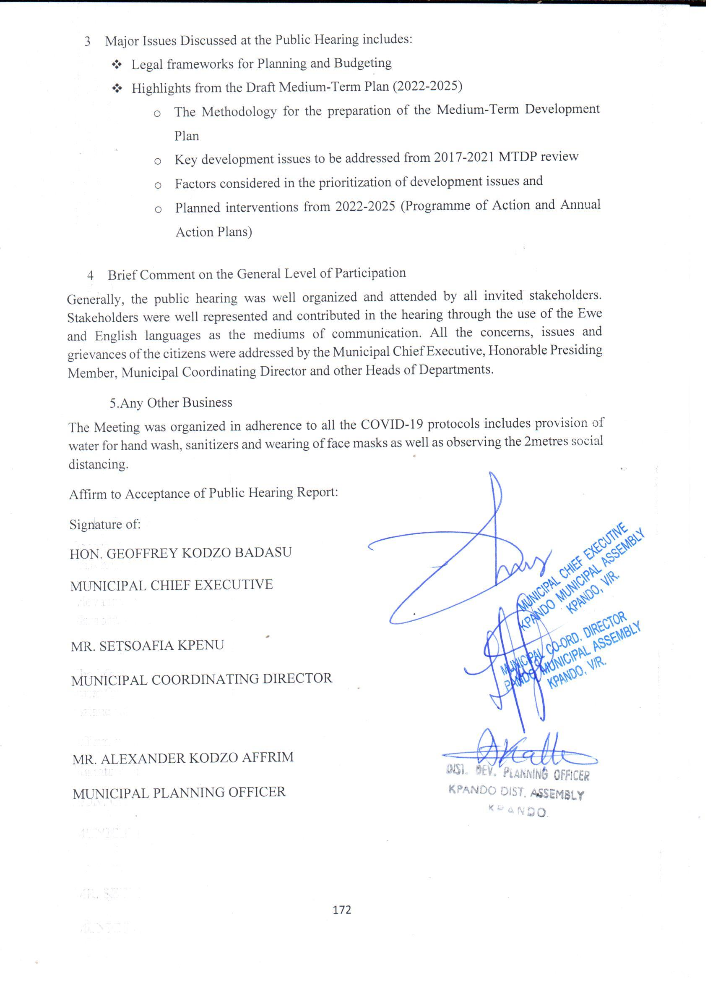
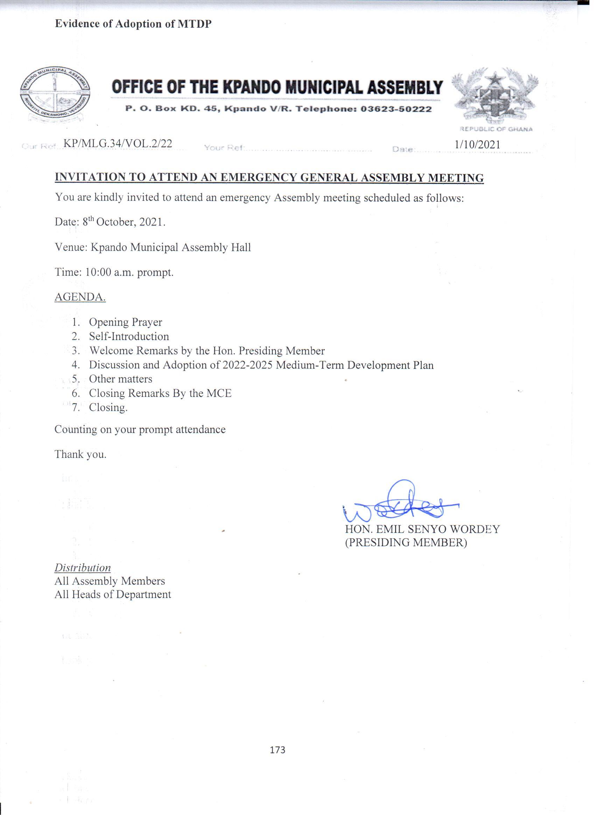

No. | Discussion | Action By
4.0 | DISCUSSION AND ADOPTION OF THE DRAFT 2022-2025 MEDIUM-TERM DEVELOPMENT PLAN (MTDP)  The Municipal Planning Officer had the privileged to read through the draft 2022-2022 MTDP. He took his time to highlighted on the Guideline and the National Development Policy Framework for the preparation of the plan, and also explained the linkage between the framework and SDGs. He stressed on the methodology use to rank the Community needs and aspirations which formed the basis for development agenda as well as a spatial analysis which informed the selection of proposed projects.  He emphasized on key development issues to be addressed in 2022-2025 plan under the budget base programmes. He also outlined the planned interventions from 2022-2025 in the Programme of Action and the Annual Action Plan for the four years to the Committee.  He pleaded on all the stakeholders to come together to ensure that the plan which was prepared in accordance with stakeholders participatory would be implemented, monitored and evaluated with the involvement of all relevant actors.  After a brief discussion and without any further deliberation, Honorable Lawrenda Adiasany moved for the adoption of the Medium-Term Development Plan (2022-2025) subject to the corrections made and was seconded by Togbui Bediaku VIII  The Presiding Member duly declared that the MTDP 2022-2025 has been adopted by the Kpando Municipal Assembly as a working document for the next four-year period.

